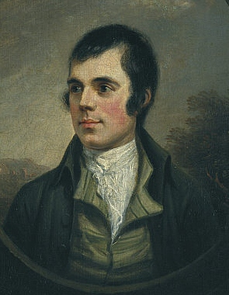
Robert Burns was born on 25th January 1759 and died aged 37 on 21st July 1796.
His early years he spent in Alloway two miles south of Ayr in Ayrshire in a cottage which still exists as a memorial to his life. His parents, Willian Burnes[s] and Agnes Broun, were tenant farmers but they ensured their son received a relatively good education and he began to read avidly. The works of Alexander Pope, Henry Mackenzie and Laurence Sterne fired Burns's poetic impulse and relationships with the opposite sex provided his inspiration.
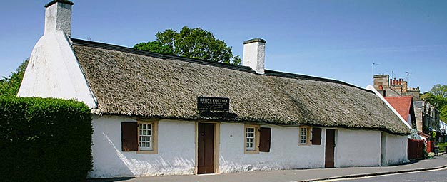
Hard physical labour on the family farm took its toll on the young Burns, who increasingly turned his attentions towards the passions of poetry, nature, drink and women which would characterise the rest of his life. He fathered twins with eventual wife Jean Armour, but a rift in their relationship nearly led to Burns, emigrating to the West Indies with lover Mary Campbell (his Highland Mary). Mary's sudden death and the sensational success of his first published collection of verse kept him in Scotland. At just 27, Burns had already become famous across the country with poems such as To a Louse, To a Mouse and The Cotter's Saturday Night.
Newly hailed as the Ploughman Poet because his poems complemented the growing literary taste for romanticism and pastoral pleasures, Burns arrived in Edinburgh, where he was welcomed by a circle of wealthy and important friends. Illicit relationships and fathering illegitimate children ran parallel to a productive period in his working life. His correspondence with Agnes 'Nancy' McLehose resulted in the classic Ae Fond Kiss. A collaboration with James Johnson led to a long-term involvement in The Scots Musical Museum, which included the likes of Auld Lang Syne.
In just 18 short months, Burns had spent most of the wealth from his published poetry, so in 1789 he began work as an Excise Officer in Dumfries (an irony not lost on him) and resumed his relationship with wife Jean. His increasingly radical political views influenced many of the phenomenal number of poems, songs and letters he continued to pen, including such famous works as For a' that and a' that. The hard work this new job entailed, combined with the toil of his earlier life and dissolute lifestyle began to take their toll on Burns's health. He died on 21 July 1796 aged just 37 and was buried with full civil and military honours on the very day his son Maxwell was born. A memorial edition of his poems was published to raise money for his wife and children.

The Songs and Poems

Ae Fond Kiss
Ae fond kiss, and then we sever;
Ae fareweel, alas, for ever!
Deep in heart-wrung tears I'll pledge thee,
Warring sighs and groans I'll wage thee!

Who shall say that Fortune grieves him
While the star of hope she leaves him?
Me, nae cheerfu' twinkle lights me,
Dark despair around benights me.

I'll ne'er blame my partial fancy;
Naething could resist my Nancy;
For to see her was to love her,
Love but her, and love for ever.

Had we never loved sae kindly,
Had we never loved sae blindly,
Never met—or never parted,
We had ne'er been broken-hearted.

Fare thee weel, thou first and fairest!
Fare thee weel, thou best and dearest!
Thine be ilka joy and treasure,
Peace, enjoyment, love, and pleasure!

Ae fond kiss, and then we sever!
Ae fareweel, alas, for ever!
Deep in heart-wrung tears I'll pledge thee,
Warring sighs and groans I'll wage thee!

Auld Lang Syne
Should auld acquaintance be forgot,
And never brought to mind?
Should auld acquaintance be forgot,
And auld lang syne!
Chorus.-For auld lang syne, my dear,
For auld lang syne.
We'll tak a cup o' kindness yet,
For auld lang syne.
And surely ye'll be your pint stowp!
And surely I'll be mine!
And we'll tak a cup o'kindness yet,
For auld lang syne.
For auld, &c.
We twa hae run about the braes,
And pou'd the gowans fine;
But we've wander'd mony a weary fit,
Sin' auld lang syne.
For auld, &c.
We twa hae paidl'd in the burn,
Frae morning sun till dine;
But seas between us braid hae roar'd
Sin' auld lang syne.
For auld, &c.
And there's a hand, my trusty fere!
And gie's a hand o' thine!
And we'll tak a right gude-willie waught,
For auld lang syne.
For auld, &c.

Red Red Rose

O my Luve's like a red, red rose
That’s newly sprung in june;
O my Luve's like the melodie
That’s sweetly play'd in tune:
As fair art thou, my bonnie lass,
So deep in luve am I:
And I will luve thee still, my dear,
Till a’ the seas gang dry:
Till a’ the seas gang dry, my dear,
And the rocks melt wi’ the sun:
I will luve thee still, my dear,
While the sands o’ life shall run.
And fare thee weel, my only Luve
And fare thee weel, a while!
And I will come again, my Luve,
Tho’ it were ten thousand mile.

A Man’s a Man for a’ that
Is there for honest Poverty
That hings his head, an' a' that;
The coward slave-we pass him by,
We dare be poor for a' that!
For a' that, an' a' that.
Our toils obscure an' a' that,
The rank is but the guinea's stamp,
The Man's the gowd for a' that.
What though on hamely fare we dine,
Wear hoddin grey, an' a that;
Gie fools their silks, and knaves their wine;
A Man's a Man for a' that:
For a' that, and a' that,
Their tinsel show, an' a' that;
The honest man, tho' e'er sae poor,
Is king o' men for a' that.
Ye see yon birkie, ca'd a lord,
Wha struts, an' stares, an' a' that;
Tho' hundreds worship at his word,
He's but a coof for a' that:
For a' that, an' a' that,
His ribband, star, an' a' that:
The man o' independent mind
He looks an' laughs at a' that.
A prince can mak a belted knight,
A marquis, duke, an' a' that;
But an honest man's abon his might,
Gude faith, he maunna fa' that!
For a' that, an' a' that,
Their dignities an' a' that;
The pith o' sense, an' pride o' worth,
Are higher rank than a' that.
Then let us pray that come it may,
(As come it will for a' that,)
That Sense and Worth, o'er a' the earth,
Shall bear the gree, an' a' that.
For a' that, an' a' that,
It's coming yet for a' that,
That Man to Man, the world o'er,
Shall brothers be for a' that.

Ye banks and braes o' bonie Doon,
How can ye bloom sae fresh and fair?
How can ye chant, ye little birds,
And I sae weary fu' o' care!
Thou'll break my heart, thou warbling bird,
That wantons thro' the flowering thorn:
Thou minds me o' departed joys,
Departed never to return.
Aft hae I rov'd by Bonie Doon,
To see the rose and woodbine twine:
And ilka bird sang o' its Luve,
And fondly sae did I o' mine;
Wi' lightsome heart I pu'd a rose,
Fu' sweet upon its thorny tree!
And may fause Luver staw my rose,
But ah! he left the thorn wi' me.

Address to a Haggis
Fair fa' your honest, sonsie face,
Great chieftain o the puddin'-race!
Aboon them a' ye tak your place,
Painch, tripe, or thairm:
Weel are ye worthy o' a grace
As lang's my arm.
The groaning trencher there ye fill,
Your hurdies like a distant hill,
Your pin wad help to mend a mill
In time o need,
While thro your pores the dews distil
Like amber bead.
His knife see rustic Labour dight,
An cut you up wi ready slight,
Trenching your gushing entrails bright,
Like onie ditch;
And then, O what a glorious sight,
Warm-reekin, rich!
Then, horn for horn, they stretch an strive:
Deil tak the hindmost, on they drive,
Till a' their weel-swall'd kytes belyve
Are bent like drums;
The auld Guidman, maist like to rive,
'Bethankit' hums.
Is there that owre his French ragout,
Or olio that wad staw a sow,
Or fricassee wad mak her spew
Wi perfect scunner,
Looks down wi sneering, scornfu view
On sic a dinner?
Poor devil! see him owre his trash,
As feckless as a wither'd rash,
His spindle shank a guid whip-lash,
His nieve a nit;
Thro bloody flood or field to dash,
O how unfit!
But mark the Rustic, haggis-fed,
The trembling earth resounds his tread,
Clap in his walie nieve a blade,
He'll make it whissle;
An legs an arms, an heads will sned,
Like taps o thrissle.
Ye Pow'rs, wha mak mankind your care,
And dish them out their bill o fare,
Auld Scotland wants nae skinking ware
That jaups in luggies:
But, if ye wish her gratefu prayer,
Gie her a Haggis

Address to a Haggis Translation
Good luck to you and your honest, plump face,
Great chieftain of the sausage race!
Above them all you take your place,
Stomach, tripe, or intestines:
Well are you worthy of a grace
As long as my arm.
The groaning trencher there you fill,
Your buttocks like a distant hill,
Your pin would help to mend a mill
In time of need,
While through your pores the dews distill
Like amber bead.
His knife see rustic Labour wipe,
And cut you up with ready slight,
Trenching your gushing entrails bright,
Like any ditch;
And then, O what a glorious sight,
Warm steaming, rich!
Then spoon for spoon, the stretch and strive:
Devil take the hindmost, on they drive,
Till all their well swollen bellies by-and-by
Are bent like drums;
Then old head of the table, most like to burst,
'The grace!' hums.

Is there that over his French ragout,
Or olio that would sicken a sow,
Or fricassee would make her vomit
With perfect disgust,
Looks down with sneering, scornful view
On such a dinner?
Poor devil! see him over his trash,
As feeble as a withered rush,
His thin legs a good whip-lash,
His fist a nut;
Through bloody flood or field to dash,
O how unfit.
But mark the Rustic, haggis-fed,
The trembling earth resounds his tread,
Clap in his ample fist a blade,
He'll make it whistle;
And legs, and arms, and heads will cut off
Like the heads of thistles.
You powers, who make mankind your care,
And dish them out their bill of fare,
Old Scotland wants no watery stuff,
That splashes in small wooden dishes;
But if you wish her grateful prayer,
Give her [Scotland] a Haggis!
Bonnie Doon

Ye banks and braes o' bonnie Doon
How ye can bloom so fresh and fair
How can ye chant ye little birds
And I sae weary fu' o' care
Ye'll break my heart ye warbling birds
That wantons thro' the flowering thorn
Ye mind me o' departed joys
Departed never to return
Oft hae I rov'd by bonnie Doon
To see the rose and woodbine twine
And ilka bird sang o' its love
And fondly sae did I o' mine
Wi' lightsome heart I pu'd a rose
Fu' sweet upon its thorny tree
But my false lover stole my rose
But ah! She left the thorn wi' me

Ca' the yowes
Chorus.-Ca' the yowes to the knowes,
Ca' them where the heather grows,
Ca' them where the burnie rowes,
My bonie dearie
As I gaed down the water-side,
There I met my shepherd lad:
He row'd me sweetly in his plaid,
And he ca'd me his dearie.
Ca' the yowes, &c.
Will ye gang down the water-side,
And see the waves sae sweetly glide
Beneath the hazels spreading wide,
The moon it shines fu' clearly.
Ca' the yowes, &c.
Ye sall get gowns and ribbons meet,
Cauf-leather shoon upon your feet,
And in my arms ye'se lie and sleep,
An' ye sall be my dearie.
Ca' the yowes, &c.
If ye'll but stand to what ye've said,
I'se gang wi' thee, my shepherd lad,
And ye may row me in your plaid,
And I sall be your dearie.
Ca' the yowes, &c.
While waters wimple to the sea,
While day blinks in the lift sae hie,
Till clay-cauld death sall blin' my e'e,
Ye sall be my dearie.
Ca' the yowes, &c.
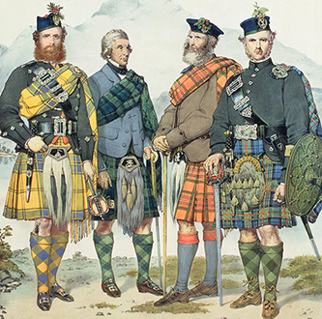

Haggis
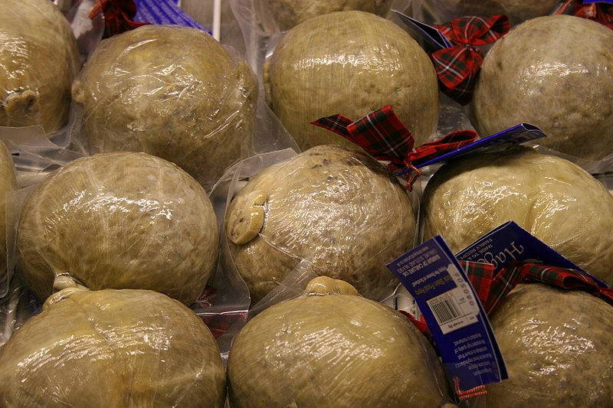
Haggis is a savoury pudding containing sheep's pluck (heart, liver, and lungs); minced with onion, oatmeal, suet, spices, and salt, mixed with stock, traditionally encased in the animal's stomach though now often in an artificial casing instead. According to the 2001 English edition of the Larousse Gastronomique: "Although its description is not immediately appealing, haggis has an excellent nutty texture and delicious savoury flavour".
It is believed that food similar to haggis (though not so named), perishable offal quickly cooked inside an animal's stomach, all conveniently available after a hunt, was eaten from ancient times.
Although the name "hagws" or "hagese" was first recorded in England c. 1430, the dish is considered traditionally of Scottish origin. Even the national dish, as a result of Scots poet Robert Burns' poem Address to a Haggis of 1787. Haggis is traditionally served with "neeps and tatties", boiled and mashed separately, and a dram (a glass of Scotch whisky), especially as the main course of a Burns Supper.

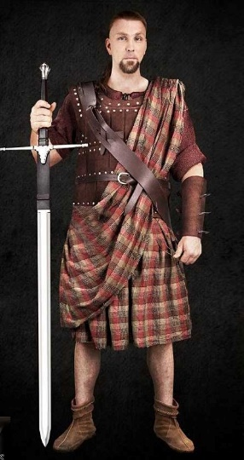
The ancient plaid was a single piece – 6 to 8 metres of woven woollen cloth usually with a tartan weave (weft and warp symmetrical and the same.
The material was ‘kilted’ (gathered) around the waist and then the remainder is thrown around the upper body. Highlanders would be bare footed or would wear animal skin shoes. Often stockings were worn with cross gartering which was common in Britain from Anglo Saxon times.
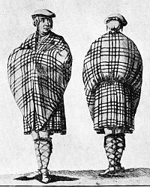
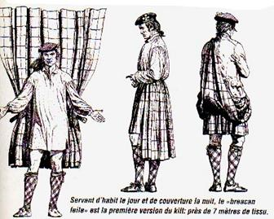

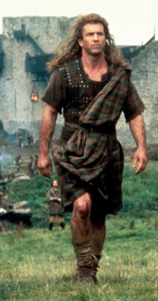
We are used to the image today of the plaid worn in films with the blue die (woad) decoration on face, legs and arms.
The traditional weapon of the highlander was the claymore, a two handed sword
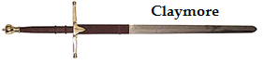
In modern times from around 1840 a standard style of highland dress has been developed. Prior to this date, the wearing of the tartan and highland dress was illegal on pain of death. Modern dress includes the kilt, the Argyll (short) jacket and the sporran. 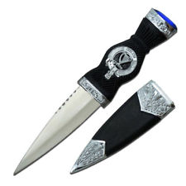
A Scian, skean or dirk is a short dagger normally worn in the top of knee length socks.

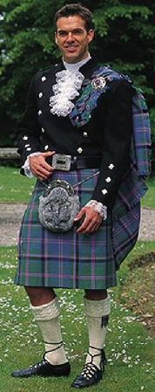
The above is typical modern highland dress. There is the Argyll jacket over a white dress shirt with a tartan kilt and animal skin sporran with tassels and silver or pewter fittings. The kilt is held up by a heavy leather belt with a pewter or silver fastening.
The white wool socks or tartan socks to match the kilt are held up by garters with flashes and the shoes, called brogues, are laced around the lower leg.
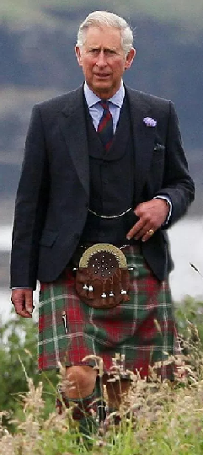
The use of the kilt with modern dress is common in Scotland. The kilt itself is a very practical piece of clothing being warm and not restricting movement, particularly when hunting or stalking.
Here Prince Charles trecks through the long grass near Balmoral, the Royal Estate. There are many thousands of tartans and most families would be able to wear several different ones. With a name like McDonald it does not indicate that you are a member of that clan. The Mc or Mac meaning ‘son of’ simply relates two people. So McDonald simply meant ‘son of Donald’ identifying one person in a small group of people.
When people with any Scottish ancestry, and most British people will have, wish to choose a tartan they will find it difficult to choose. The origin, however, is Celtic, as is the origin of most people in the UK. Few will not have some Scottish, Irish or Welsh ancestry. The right to wear the tartan is the same for all Celts.

