All of the material in this booklet has little or nothing to do with folk music, except that it is good to sing and memorable. In addition songs need to be accompanied on an instrument, the guitar mostly, and these fit very well. So we must not judge them on the same lines as what we term folk music as the cultural elements are clearly different and the music is far more artistic.

Joseph and his Technicolour Dreamcoat

Any Dream will do
In the early 1970s Tim Rice and Andrew Lloyd Webber created a rock opera based on the Bible story of Joseph and his ‘coat of many colours’. This was Joseph and his Technicolour Dreamcoat. There were a number of songs which lent themselves to performance in folk circles. Most people know the story so we can just listen, sing or enjoy them.

I closed my eyes, drew back the curtain
To see for certain what I thought I knew
Far-far away, someone was weeping
But the world was sleeping
Any dream will do
I wore my coat, with golden lining
Bright colours shining, wonderful and new
And in the east, the dawn was breaking
And the world was waking
Any dream will do
A crash of drums, a flash of light
My golden coat flew out of sight
The colours faded into darkness
I was left alone
May I return to the beginning
The light is dimming, and the dream is too
The world and I, we are still waiting
Still hesitating
Any dream will do
A crash of drums, ...

May I return to the beginning ...

Close Every Door

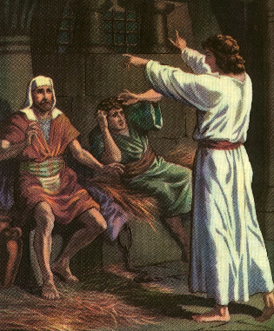
Close every door to me,
Hide all the world from me
Bar all the windows
And shut out the light
Do what you want with me,
Hate me and laugh at me
Darken my daytime
And torture my night
Close every door contd.

Just give me a number
Instead of my name
Forget all about me
And let me decay
I do not matter,
I'm only one person
Destroy me completely
Then throw me away
If my life were important I
Would ask will I live or die
But I know the answers lie
Far from this world

Close every door to me ….

If my life were important I
Would ask will I live or die
But I know the answers lie
Far from this world

Close every door to me,
Keep those I love from me
Children of Israel
Are never alone
For I know I shall find
My own peace of mind
For I have been promised
A land of my own
Above: Joseph interprets dreams while in Potiphar’s jail

The Lion King
Can You Feel the Love Tonight

There's a calm surrender to the rush of day
When the heat of a rolling wind can be turned away
An enchanted moment, and it sees me through
It's enough for this restless warrior just to be with you

And can you feel the love tonight
It is where we are
It's enough for this wide-eyed wanderer
That we got this far
And can you feel the love tonight
How it's laid to rest
It's enough to make kings and vagabonds
Believe the very best
Images from the cartoon film, the LION KING. The song written and performed by Elton John.

There's a time for everyone if they only learn
That the twisting kaleidoscope moves us all in turn
There's a rhyme and reason to the wild outdoors
When the heart of this star-crossed voyager beats in time with yours

Half a Sixpence
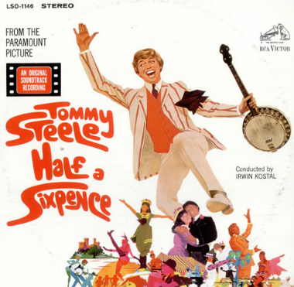
‘Enery the eighth
Tommy Steel was a rock musician of the 60s. Half a Sixpence was a film made featuring many well-known popular songs

I’m ‘Enery the eighth I am
‘Enery the eighth I am I am
I got married to the widow next door
She’s been married seven times before
Now every one was an ‘Enery
She wouldn’t have a Billy or a Sam
I’m her eighth old man named ‘Enery
‘Enery the eighth I am

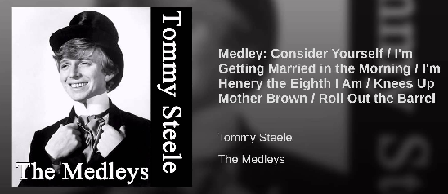

Robin Hood – Prince of Thieves
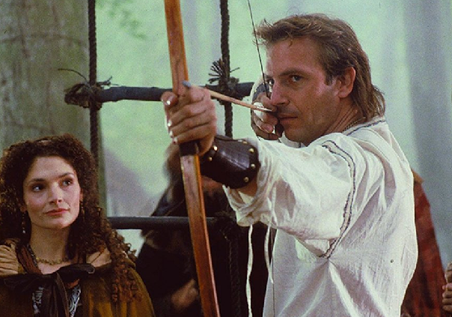
I do it for you

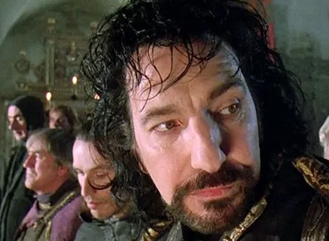
Look into my eyes - you will see
What you mean to me
Search your heart - search your soul
And when you find me there you’ll search no more
Don’t tell me it’s not worth tryin’ for
You can’t tell me it’s not worth dyin’ for
You know it’s true
Everything I do - I do it for you
Look into my heart - you will find
There’s nothin’ there to hide
Take me as I am - take my life
I would give it all I would sacrifice
Don’t tell me it’s not worth fightin’ for
I can’t help it there’s nothin’ I want more
Ya know it’s true
Everything I do - I do it for you

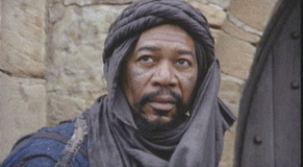
There’s no love - like your love
And no other - could give more love
There’s nowhere - unless you’re there
All the time - all the way
Don’t tell me it’s not worth tryin’ for
I can’t help it there’s nothin’ I want more
I would fight for you - I’d lie for you
Walk the wire for you - ya I’d die for you
Ya know it’s true
Everything I do - I do it for you

A very catchy tune coming from a reasonable film. The tune so stuck in my mind that I had to put guitar chords to it and use it in Singlish. It’s an interesting introduction to the myths of Robin Hood, the name already familiar in the 7th Century.
Mary Elizabeth Mastrantonio – Maid Marian
Kevin Costner – Robin Hood
Morgan Freeman – Azeem
Alan Rickman – Sheriff of Nottingham

Sanders of the River
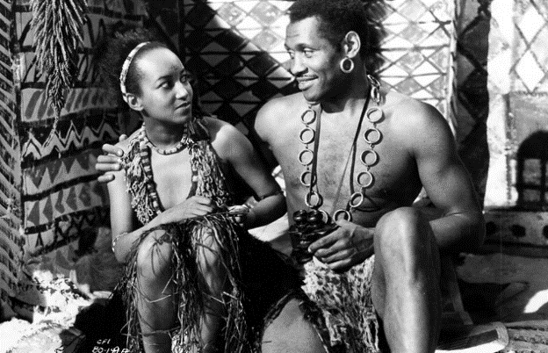
My Little Black Dove

My little black dove, Curl up in your nest of love
The moon is a charm to keep you from harm
Safe here at my breast

The stars all are alive to watch over you all night
The river of sleep flows gentle and deep
To rock you to rest

So sleep little one till darkness is by
Sleep till the sun rises up in the sky
Little Black Dove, sung by Nina Mae McKinney was also from ‘Sanders of the River’ (Alexander and Zoltan Korda 1935). The picture is of Robeson and McKinney from the film.
My little black dove curl up in your nest of love
And go to your rest asleep at my breast

Canoe Song
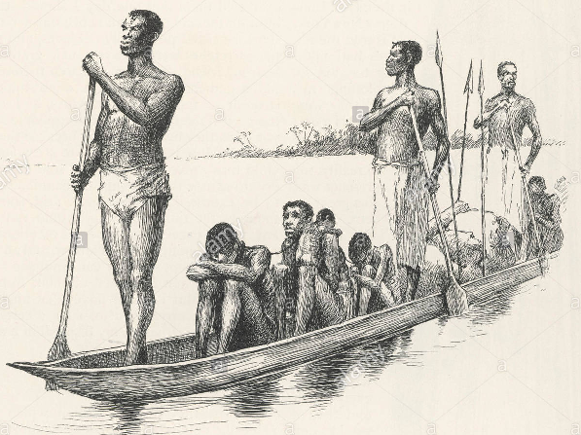
Ayeoko, yegobde (x2)
Ayeoko (x3)
Ayeoko, yegobde (x2)
The current swings, the water sings a river rhyme

Oh, light is the burden of labour
When a man bends his back with his neighbour
So each for a-a-all
We stand or fa-a-all
And each for all until we reach our journey's end

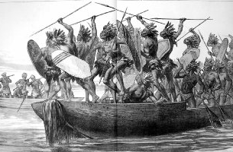
Right top: Congo; slaver’s canoe. This dugout canoe, made from a single tree requires skill to control

Right: Congo; war canoe – tribesmen prepare to hunt for slaves to sell to coastal traders.

Zoltan Korda heard the first part as he travelled through the Congo on location. The second part for the film Sanders of the River was added for the film story. Paul Robeson hated the film and thought the songs degrading.

The verses continue …

‘Sandy the strong, Sandy the wise
Righter of wrongs, hater of lies
Laughed as he fought, fought as he played
As he has loved now let it be made etc.’

The original African version would almost certainly have been the repetition of the first lines only. The words of African songs tend to be repetitive and of little consequence. They are just mouth music.

Sharpe (TV series)

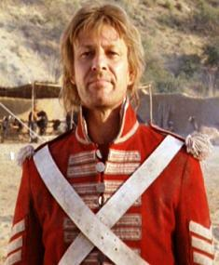
Over the Hills and Far Away

Hark now the drums beat up again
For all true soldier gentlemen
So let us list and march I say
And go over the hills and far away

Chorus:
Over the hills, and o'er the main
To Flanders, Portugal and Spain
King George commands and we obey
And go over the hills and far away

Come gentlemen that have a mind
To serve a king that's good and kind
Come list and enter in to pay
And go over the hills and far away

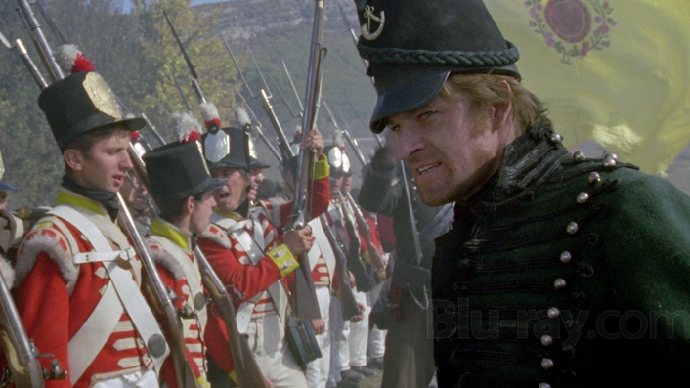
Here's forty shillings on the drum
For those that volunteer to come
With shirts and clothes and present pay
When over the hills and far away

Hear that brave boys, and let us go
Or else we shall be prest you know
Then list and enter in to pay
And go over the hills and far away

The constables they search about
To find such brisk young fellows out
Then let's be volunteers I say
Over the hills and far away

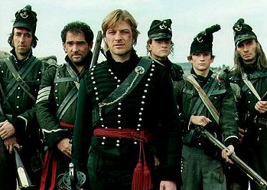
Since now the French so low are brought
And wealth and honour's to be got
Who then behind would sneaking stay?
When over the hills and far away

No more from sound of drum retreat
When Marlborough and Galway beat
The French and Spaniards every day
Over the hills and far away

He that is forced to go and fight
Will never get true honour by't
Whilst volunteers shall win the day
When over the hills and far away

He that is forced to go and fight
Will never get true honour by't
Whilst volunteers shall win the day
When over the hills and far away
Above: Sharpe with the chosen men (men selected for special duties and given special priviliges).
The rifle batallions fought in Europe and North America and acted as skirmishers (sent forwards in pairs to shoot officers of the opposing army and disrupt attacking formations.

What tho' our friends our absence mourn
We all with honours shall return
And then we'll sing both night and day
Over the hills and far away

Prentice Tom may well refuse
To wipe his angry master's shoes
For now he's free to sing and play
Over the hills and far away
Come on then Boys and you shall see
We every one shall Captains be
To Whore and rant as well as they
When o'er the Hills and far away

For if we go 'tis one to Ten
But we return all Gentlemen
All Gentlemen as well as they
When o'er the Hills and far away

Sharpe is first seen as a Sergeant in a regular, line regiment.
He is given a field commission by General Arthur Wellesley, later Duke of Wellington and transfers to the 95th rifles for the rest of his career – see right

Over rivers, bogs and springs
We all shall live as great as kings
And plunder get both night and day
Over the hills and far away

And we shall live more happy lives
Free of squalling brats and wives
Who nag and vex us every day
So it's over the hills and far away

The Graduate

Dustin Hoffman played the lead in a very well-known and liked film, the graduate. The story is of little consequence, however, there are two songs from the film which are very well known. The songs were written and sung by ‘Simon and Garfunkel’ we are told, but one of the songs is clearly not written, only adapted from an old English folk song ‘Scarborough Fair’ The version I perform is one by Martin Carthy, performer in the years prior to the release of the graduate using the same tune. There are other versions with different tunes too.

I call this an ‘unlove’ song as his ‘lover’ is asked to do things which are clearly impossible. In fact he’s saying that he wouldn’t marry her if she were the last person on the planet!

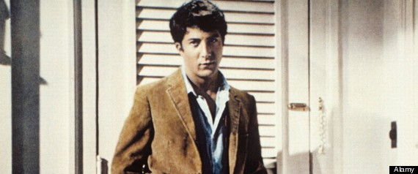

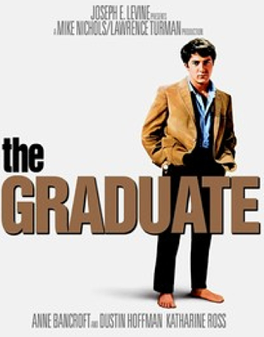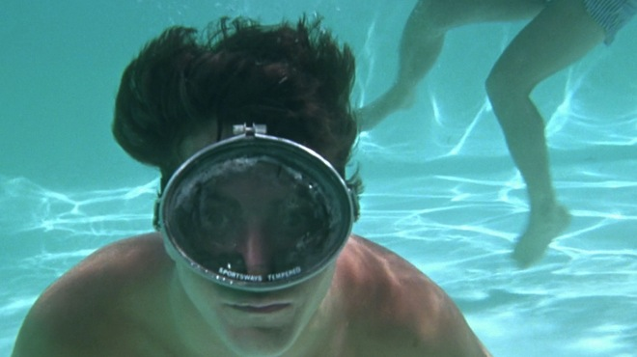
Scarborough Fair

Chorus:
Are you going to Scarborough Fair, Parsley, sage, rosemary and thyme
Remember me to one who lives there, For she once was a true love of mine
- Cambrick – fabric origionally from the French commune of Cambrai, a fine plain woven cloth used to make clothing.
- Washing in a well without water?
- Dried on a thorn bush over 4,000 years old according to some interpretations of the bible?
- Sea strand = beach. There is no land between the beach and the sea!
- Ploughed with a long thorn (or lambs horn?
- A leather sickle? Feather ties?
Tell her to make me a cambrick shirt
Without any seams or needlework

Tell her to wash it in yonder dry well
Where water ne’er sprung nor drop of rain fell

Tell her to dry it on yonder thorn
Which never saw blossom since Adam was born

Tell her to buy me an acre of land:
Between the salt water and the sea strand.

Tell her to plough it with a long thorn
And to sow it all over with one peppercorn

Tell her to reap it with a sickle of leather
And tie it all up with one peacock’s feather

Sounds of Silence
And the people bowed and prayed
To the neon gods they made.
And the sign flashed out its warning,
In the words that it was forming,
It said, "The words of the prophets are written on the subway walls
And tenement halls."
And whispered in the sounds of silence.

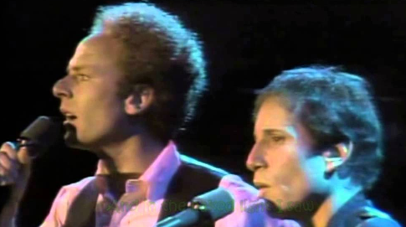
The song was written by Paul Simon over a period of several months in 1963 and 1964. Released in October 1964, the album was a commercial failure and led to the duo breaking up. The single was released in September 1965.
Generally considered a classic folk rock song, the song was added to the National Recording Registry in the Library of Congress for being "culturally, historically, or aesthetically important" in 2013 along with the rest of the Sounds of Silence album.

Hello darkness my old friend,
I've come to talk with you again.
Because a vision softly creeping
Left it's seed while I was sleeping,
And the vision that was planted in my brain
Still remains
Within the sounds of silence.

In restless dreams I walked alone,
Narrow streets of cobble stone.
'Neath the halo of a street lamp,
I turned my collar to the cold and damp,
When my eyes were stabbed by the flash of a neon light
That split the night
And touched the sounds of silence
.
And in the naked light I saw
Ten thousand people, maybe more.
People talking without speaking,
People hearing without listening,
People writing songs that voices never shared,
And no one dared
Disturb the sounds of silence.

"Fools!" said I, "you do not know,
Silence like a cancer grows.
Hear my words that I might teach you,
Take my arms that I might reach you."
But my words like silent raindrops fell...
And echoed in the wells of silence.

Show Boat
Show Boat is a musical in two acts, with music by Jerome Kern and book and lyrics by Oscar Hammerstein II, based on Edna Ferber's best-selling novel of the same name. The musical follows the lives of the performers, stagehands and dock workers on the Cotton Blossom, a Mississippi River show boat, over 40 years from 1887 to 1927. Its themes include racial prejudice and tragic, enduring love. The musical contributed such classic songs as "Ol' Man River", "Make Believe", and "Can't Help Lovin' Dat Man".

Ol Man River
Let me go 'way from the Mississippi,
Let me go 'way from de white man boss;
Show me dat stream called de river Jordan,
Dat's de ol' stream dat I long to cross.
O' man river, Dat ol' man river,
He mus' know sumpin', But don't say nuthin'
He jes' keeps rollin', He keeps on rollin' along.
(Echo: Long ol' river forever keeps rollin' on...)
He don' plant tater, He don' plant cotton,
An' dem dat plants 'em, Is soon forgotten,
but ol' man river, He jes' keeps rollin' along.
(Echo: Long ol' river keeps hearing dat song)
You an' me, we sweat an' strain,
Body all achin an' racked wid pain.
Tote dat barge!, Lif' dat bale!
Git a little drunk, An' you land in jail.
Ah, gits weary, An' sick of tryin'
Ah'm tired of livin', An' skeered of dyin',
But ol' man river, He jes' keeps rollin' along!

Ol' man river, Dat ol' man river
He mus' know sumpin', But don't say nuthin',
He jes keeps rollin', He keeps on rollin' along
He don' plant taters, He don't plant cotton,
An' dem dat plants 'em, is soon forgotten,
But ol' man river, He jes keeps rollin' along.
You an' me, we sweat an' strain,
Body all achin' an' racket wid pain,
Tote dat barge!, Lif' dat bale!
Git a little drunk, An' you land in jail.
Ah gits weary, An' sick of tryin'
Ah'm tired of livin', An' skeered of dyin',
But ol' man river, He jes' keeps rolling' along.
Coloured folks work on de Mississippi,
Coloured folks work while de white folks play,
Pullin' dose boats from de dawn to sunset,
Gittin' no rest till de judgement day.

Don't look up, An' don't look down,
You don' dast make, De white boss frown.
Bend your knees, An' bow your head,
An' pull date rope, Until you' dead.
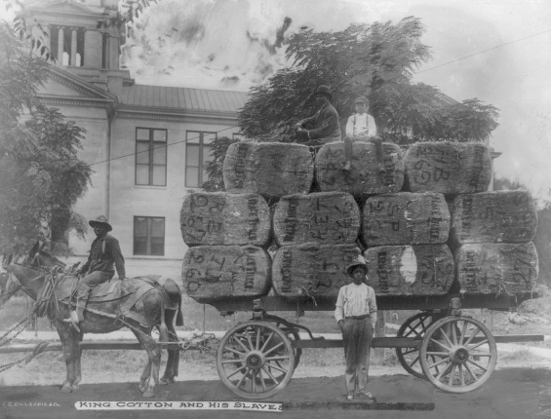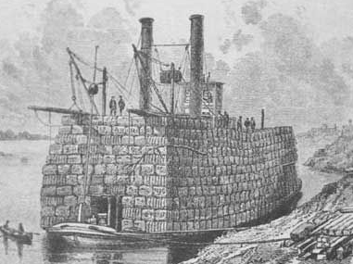
River boat loaded with cotton bales. A cart full of cotton bales

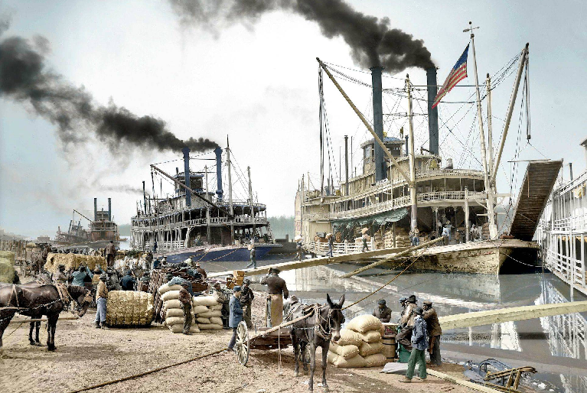

Above: Sternwheeler steam boats at Vicksberg 1907 – taking on a cotton cargo in bales.

Avery Robinson composed Water Boy "a Negro convict song," in 1922. Folklorist Alan Lomax wrote in 1939 "that portions of "Water Boy" were sung before 1922. Robinson wove together material from different sources to make the song. "Water Boy," as it stands, is not a folk-song in the opinion of either John A. Lomax or myself, but if its popularity continues, it may, of course, become one."
Robinson originally wrote it for Roland Hayes, a lyric tenor, the first African American male concert artist to receive wide international acclaim. Later, Robinson worked with Paul Robeson, a deep bass.
The irony of beautiful music arising from prisoners in horrific conditions is astounding.

Waterboy

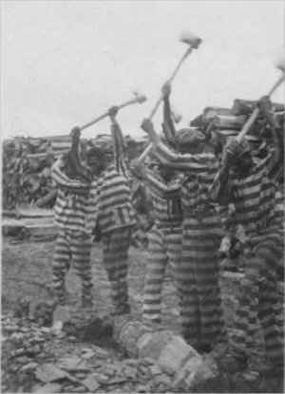
Waterboy, where are you hiding
If you don't come, I’m gonna tell your daddy

There ain't no hammer, that's on a this mountain
That rings like mine boy, that rings like mine
I done bust this rock boy, from here to the Macon
All the way to the jail boy, way back to the jail
You Jack ´o diamond, you Jack ´o diamond
Know you of old boy, I know you of old
You done rob my pocket, you done rob my pocket
Of silver and gold boy, my silver and gold

There ain't no sweat boy, that's on a this mountain
That runs like mine boy, that runs like mine
I done bust this rock boy, from here to the Macon
All the way to the jail boy, way back to the jail

Right: African American convicts working with axes and singing in wood yard, Reed Camp, South Carolina. Photo: Alan Lomax, 1934.

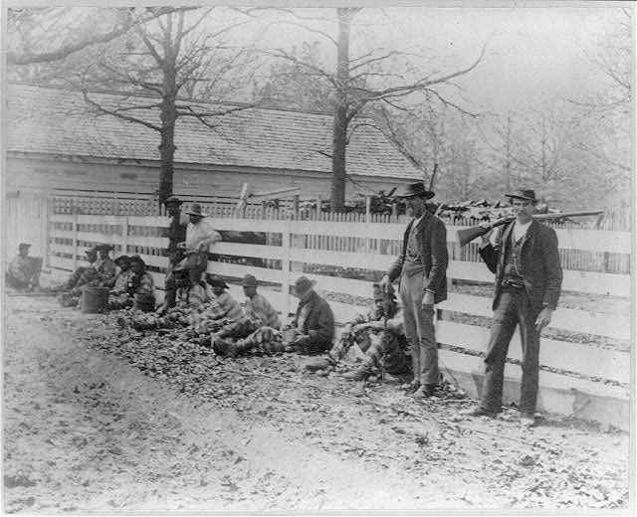
Above: Chain gang prisoners and guards, Thomasville, Georgia. Photo: Joseph John, c 1890. Pictures courtesy of the Library of Congress.

Paul Robeson
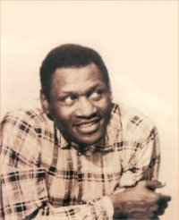
Not all of the songs included in the programs of Paul Robeson's earliest concerts were spirituals. Throughout his concert career, one of his favorite songs was “Water Boy,” a black secular song written by the well-known white composer, Avery Robinson. Some years ago, Robeson says: I found an interesting reference to that song in my father's 1929 diary: “Of course, technique might help me grow... but that might not make me a greater artist. 'Water Boy' is my best record, made when I was untrained.”

Seventeen years later, in 1946, his intuitive affinity for the song was confirmed when he received a letter, accompanied by an African battle axe, from a member of an anthropological expedition to a remote village in southern Angola. Several records had been played on a portable gramophone for the assembled villagers, and one of the songs was my father's rendition of “Water Boy.” As the song ended, the village chief rose, went to his hut, and brought back a ceremonial battle axe which he laid before the gramophone as a gift to "the great chief across the water”. One might wonder how Paul Robeson could speak to the heart of an African chief through a song written by a white composer, but my father was not surprised. By then his search for his African cultural heritage had led him to research the origins of "Water Boy." He discovered that Robinson had heard the song sung by a black Alabama chain gang in a particular county of Alabama where the culture of rural blacks had its origins in southern Angola.

Inn of the Sixth Happiness

film based on the true story of Gladys Aylward, a tenacious British maid, who became a missionary in China during the tumultuous years leading up to the Second World War. The film stars Ingrid Bergman as Aylward and Curt Jürgens as her love interest, Colonel Lin Nan, a Chinese officer with a Dutch father. Robert Donat, who played the mandarin of the town in which Aylward lived, died before the film was released. The musical score was composed and conducted by Malcolm Arnold.
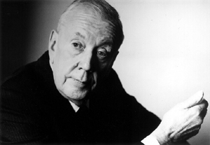
Sir Malcolm Henry Arnold,CBE (21 October 1921 – 23 September 2006) was an English composer. His output of works features music in many genres, including a cycle of nine symphonies, numerous concertos, concert works, chamber music, choral music and music for brass band and wind band. He wrote extensively for the theatre, with five ballets specially commissioned by the Royal Ballet, as well as two operas and a musical. He also produced scores for more than a hundred films, among these The Bridge on the River Kwai (1957), for which he won an Oscar.

The film was shot in Snowdonia, North Wales. Most of the children in the film were Chinese children from Liverpool, home to one of the oldest Chinese communities in Europe.

The film culminates with the column of children, led by Aylward, marching into the town, singing the song "This Old Man" to keep up their spirits.

This Old Man

1. This old man he played one, He played nick-nack on my drum
Chorus:
With a nick-nack paddy-wack give a dog a bone
This old man came rolling home
2. This old man he played two, He played nick-nack on my shoe
3. This old man he played three, He played nick-nack on my knee
4. This old man he played four, He played nick-nack on my door
5. This old man he played five, He played nick-nack on my hive
Below Left: Ingrid Bergman. Below Right (circled) the real Gladys Aylward
6. This old man he played six, He played nick-nack on my sticks
7. This old man he played seven, He played nick-nack up to heaven
8. This old man he played eight, He played nick-nack on my gate
9. This old man he played nine, He played nick-nack on my line
10. This old man he played ten, He played nick-nack on my hen
(alternative: now and then)

