The Industrial Revolution in the mid 18th Century changed the lives of every person living in Britain at the time. Villages began to disappear and even farming became more industrial. Subsistence farming only remained in the remoter parts of the England, Scotland, Wales and Ireland.
Industry developed very quickly with the most prominent being coal mining, mineral extraction and manufacture, including iron work and the processing and weaving of wool and cotton. Most of these developed in the midlands (around Birmingham) and in the north (around Sheffield, Leeds, Halifax, Manchester and Liverpool).
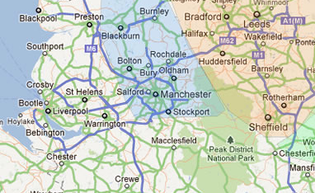
The Cotton Industry
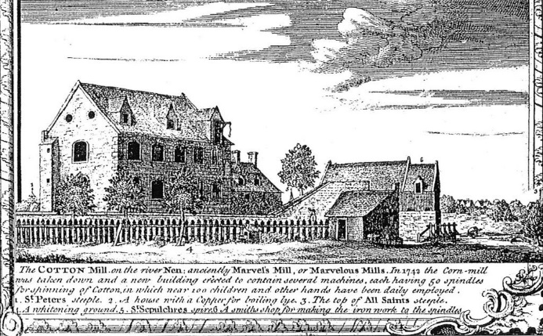
The cotton industry relied on imports of cotton from the new Colonies in America, through the port of Liverpool on the west coast of Britain. So important was the trade that Manchester eventually built a canal to take large ships right into the centre at Salford. This was the Manchester Ship Canal, completed in 1894. Until this was completed the cotton was shipped by road and rail.
Originally the mills were comparatively small, driven by water wheels but as steam took over the driving machinery became larger and larger as did the mills.
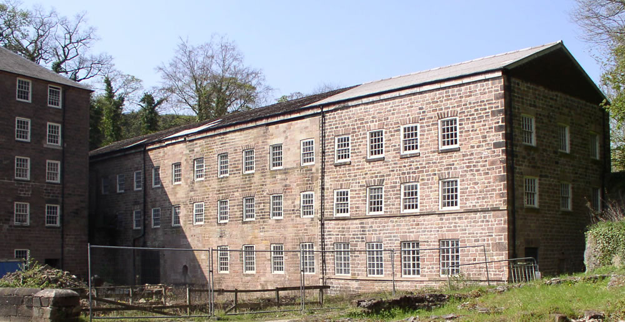
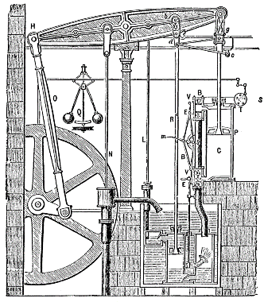
It was the invention of the steam engine by Watt and Boulton in 1784 which initiated the expansion which was very rapid, so within just a few years the whole industry changed. The spinning process was mechanised. The weaving process was automated with card driven machines.
Arkwright’s mill 1771
Ultimately the machines were packed into huge multi-story building, hundreds of machines on each floor all powered by overhead drives from a huge steam engine housed in an engine house at the end of the building.
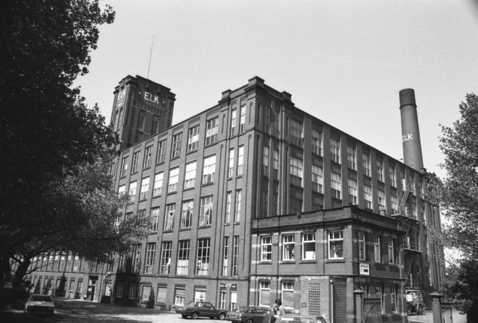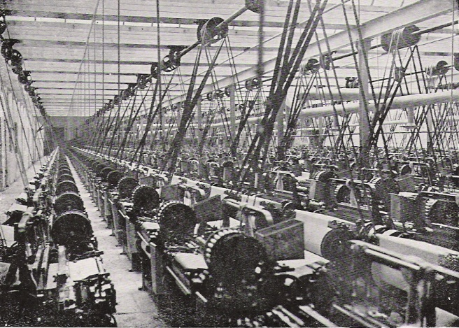

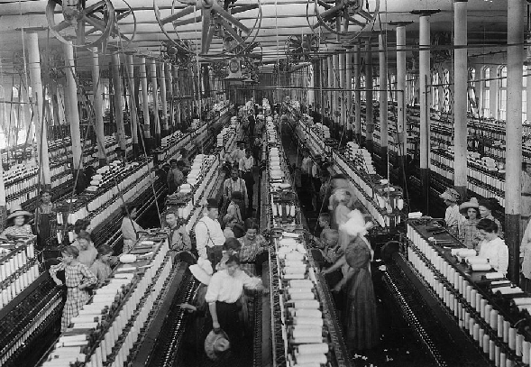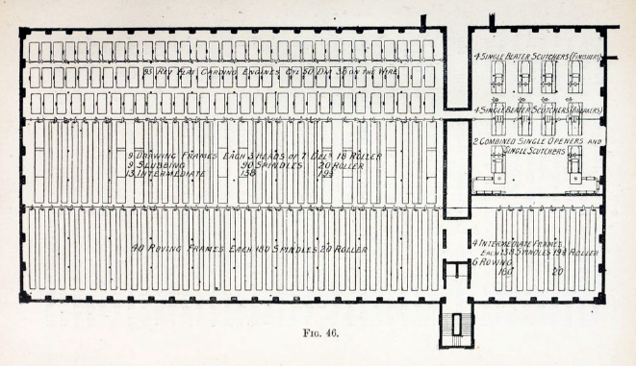
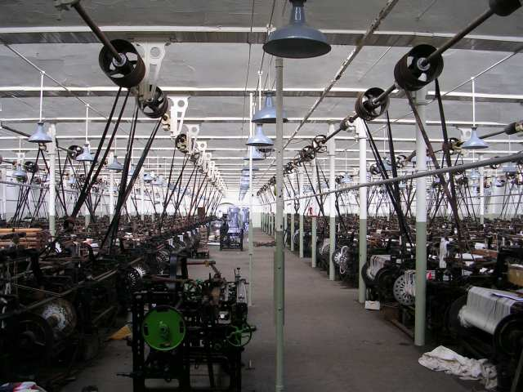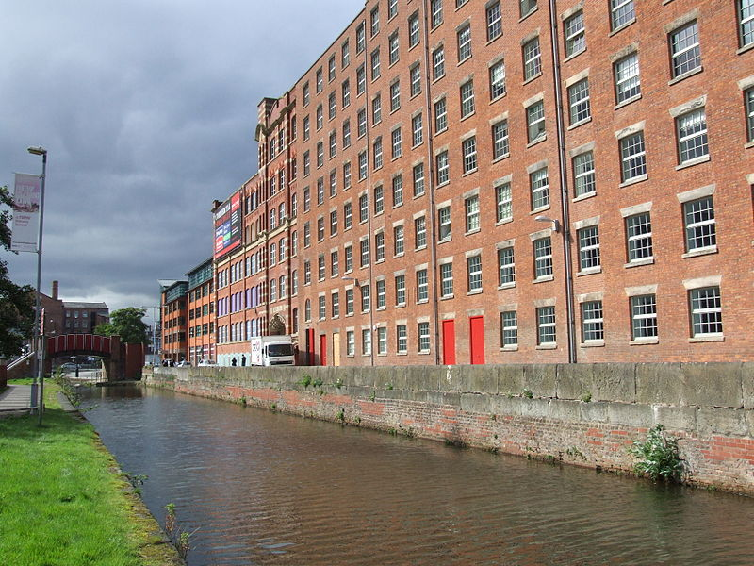

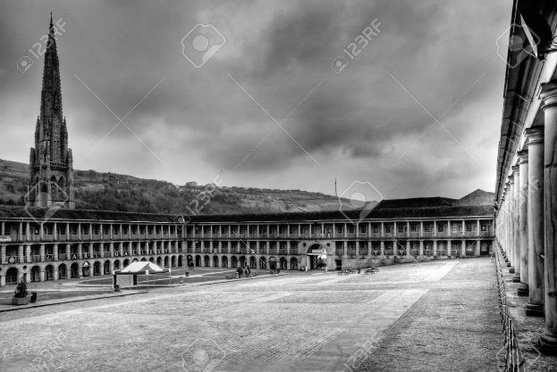
Woollen Mills
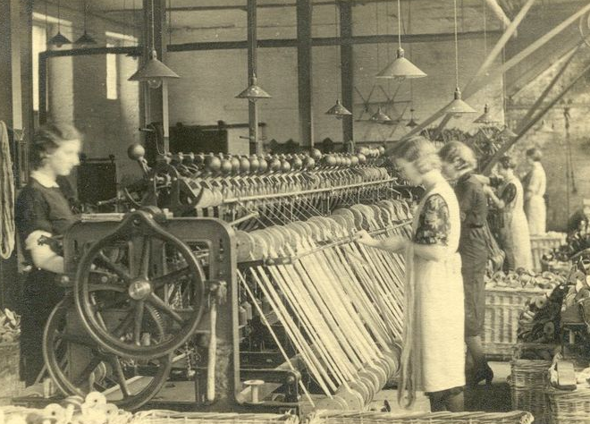
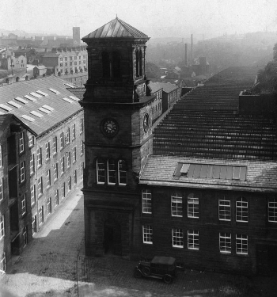
Unlike the cotton mills which were reliant on imports of cotton, woollen mills received wool from local sheep farming in the Pennines, centred on the town of Halifax. The Piece Hall shown here was both the centre of trading and the town. Unlike the flatness of the cotton towns near Manchester, Halifax was built on hills with a good water supply. Halifax was close to the mining areas of Yorkshire and the steel town of Sheffield. The machinery was similar to that in the cotton mills and the mills themselves were very similar by the end of the 19th century.
Above: woollen loom Right and below: Woollen mills, Halifax

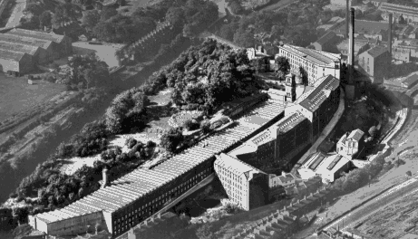
This is how the mills were but what was life like in them. The mills were dusty, noisy, full of danger and crowded. There were men, women and children as young as six years working long hours for very little pay. Although originally the mills were unlit and working hours were daylight hours, the later mills were lit and the hours of work were long.
The songs describe the harsh conditions but with a humour or bitterness typical of Lancashire and Yorkshire people.
The Songs
Poverty Knock
Chorus: 'Poverty poverty knock, ' my loom is a saying all day
Poverty poverty knock, gaffer's too skinny to pay
Poverty poverty knock, keeping one eye on the clock
I know I can guttle when I hear my shuttle go, 'poverty poverty knock'
Verse 1: Up every morning at five, I wonder that we keep alive
Tired and yawning another cold morning
It's back to the dreary old drive.
Verse 2: Oh dear we're going to be late
Gaffer is stood at the gate
We're out of pocket, our wages they'll docket
We'll have to buy grub on the slate
Verse 3: Sometimes a shuttle flies out
And gives some poor bugger a shout
There she lies bleeding, Nobody’s heeding
Who’s going to carry her out

Poverty-knock mimics the sound of the loom as it works. Gaffer = boss, skinny = mean (with money) or very thin (of a person), guttle = mouth words silently (used by the deaf), shuttle = moving part of the loom which holds the thread, grub = food, docket = reduce wages for mistakes etc, ‘on the slate’ = on credit.

King Cotton

See how the lint flies over the moor-land
See how the smoke in the valley clings
See how the slate roofs shine in the drizzle
This is the valley where cotton is king

Sleep is washed from their broken faces
Tattered clothes on the flesh does cling
Dust in the lungs and their bodies twisted
This is the valley where cotton is king

Work all day to the looms hard rhythm
Toil and sweat till your tired bones ring
Crawl back home as the gaslight flickers
This is the valley where cotton is king

This is the land where children labour
Where life and death seem the self same thing
Where many work that a few might prosper
This is the valley where cotton is king

This song was written by Mike Harding in the 1970s but clearly describes the conditions of mill workers. Lint = small pieces of cotton which stay in the air and are breathed in. This was the lung disease that many died of.

Steel Industry
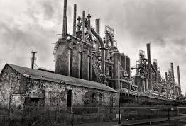
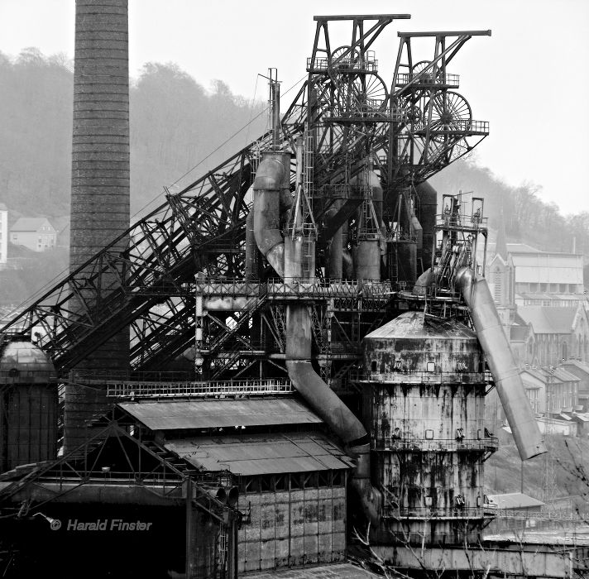
The steel mills dominated cities such as Sheffield and Rotherham. These areas had iron ore, coal and the manpower to use them to produce iron and steel. The work was hard, hot and very dangerous and many workers died of industrially related diseases – just as with the cotton and wool industries.
Sheffield was famous for creating cutlery (knives, forks, spoons) and heavier industry – armaments, bridges, ship engines and other components. Above is an example of one of the steel furnaces with its loading mechanism.
Steel Songs
Sheffield Grinder
To be a Sheffield grinder it is no easy trade.
There's more than you'd imagine in the grinding of a blade.
The strongest man amongst us is old at thirty-two.
There's few who brave such hardships as we poor grinders do.
And every working day, we are breathing dust and steel,
And a broken stone can give us a wound that will not heal.
There's many an honest grinder ground down by such a blow.
There's few that brave such hardships as we poor grinders do.
There's many a poor grinder who's thus been snatched away,
Without a moment's warning to meet his judgement day.
Before his judge he must appear, his final doom to know.
There's few who brave such hardships as we poor grinders do.
There's many a poor grinder whose family is large,
With all his best endeavours cannot his debts discharge.
When children cry for bread, oh, how pitiful the view,
Though few can bear such hardships as we poor grinders do.
Producing scissors and knives it was an essential part of the process to grind the blade to the correct shape. They used stone wheels which could fail and cause horrible injuries. People worked on ‘piece rates’, by the number they produced, so they had to ‘cut corners’ to keep the numbers high and their wages acceptable.
Coal Mining
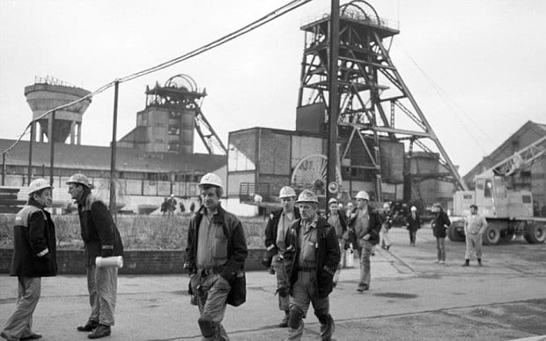
The pithead is shown here with two winding gears for the lifts which take the miners underground. The depth of pits may be thousands of meters. Dangers in mines include rock falls, explosions of gas or coal dust and a slow death from breathing in the dust causing lung disease.

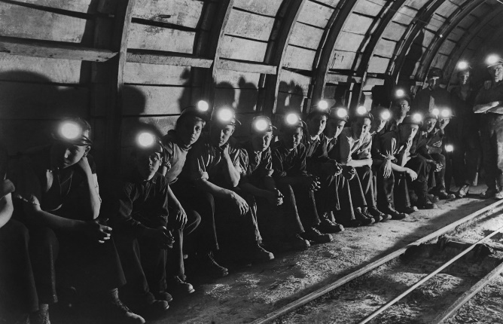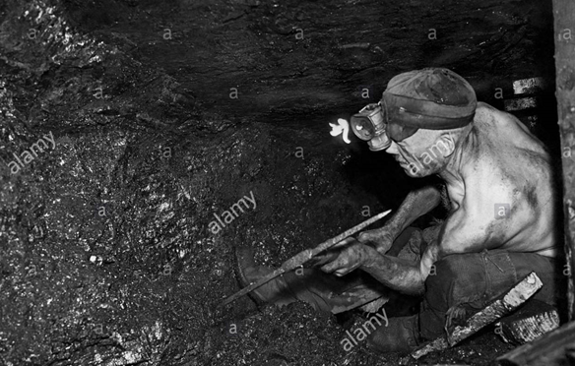
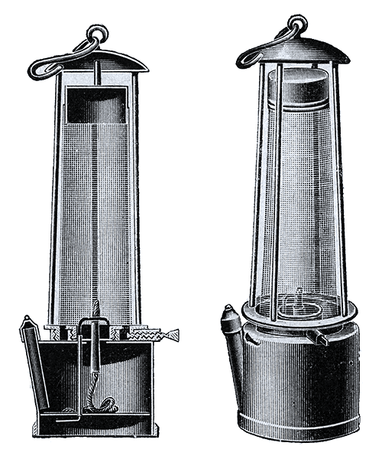
Mines in the 1940s are shown above so we can imagine what the conditions were like before this. Explosions were common in nearly mines where naked lights such as candles were used. The Davey lamp (1815) solved this problem. The flame is protected by a copper gauze with prevents the gas outside being ignited by the flame inside by conducting the heat away.
Even so, explosions could be the result of sparks caused by any number of situations, especially after electrical lighting came into use.Mines were private concerns up to World War 2 but afterwards were nationalised and safety improved.
Mining Songs
Gresford Disaster
You've heard of the Gresford Disaster,
Of the terrible price that was paid;
Two hundred and forty two colliers were lost,
And three of the rescue brigade.

It occurred in the month of September
At three in the morning the pit
Was racked by a violent explosion
In the Dennis where gas lay so thick.

Now the gas in the Dennis deep section
Was heaped there like snow in a drift,
And many a man had to leave the coal-face
Before he had worked out his shift.

Now a fortnight before the explosion,
To the shot-firer Tomlinson cried,
"If you fire that shot we'll be all blown to hell!"
And no one can say that he lied.

Now the fireman’s reports they are missing
The records of forty-two days;
The collier manager had them destroyed
To cover his criminal ways.

Down there in the dark they are lying.
They died for nine shillings a day;
They have worked out their shift and now they must lie
In the darkness until Judgement day.

Now the Lord Mayor of London's collecting
To help out the children and wives;
The owners have sent some white lilies
To pay for the poor colliers' lives.

Farewell all our dear wives and children
Farewell all our comrades as well,
Don't send your sons down the dark dreary pit
They'll be doomed like the sinners in hell.

The song describes the events which occurred in the North Wales pit in 1934 where 265 miners were killed. The miners were working a fault and hit a gas pocket. The subsequent explosion blocked the exit of the miners.

Schooldays over - Ewan McColl
Schooldays over, come on then john
Time to be getting your pit boots on
On with your sack and your moleskin trousers
Time you were on your way
Time you were learning the pitman's job
And earning a pitman's pay.
Come on then jim, it's time to go
Time you were working down below
Time to be handling a pick and shovel
You start at the pits today
Time to be learning the collier's job
And earning a collier's pay.
Come on then Dai, it's nearly light
Time you were off to the anthracite
The morning mist is on the valley
It's time you were on your way
Time you were learning the miner's job
And earning a miner's pay
Pitman = works at a pit, not necessarily underground, Collier = Works in coal mine, Miner = man who works in a mine, normally deep underground but mining coal and other minerals such as copper, lead, gold, silver.

