The songs we describe as Spirituals originate from the African American slaves, transported in the late 18th and early 19th century, mostly from West Africa.
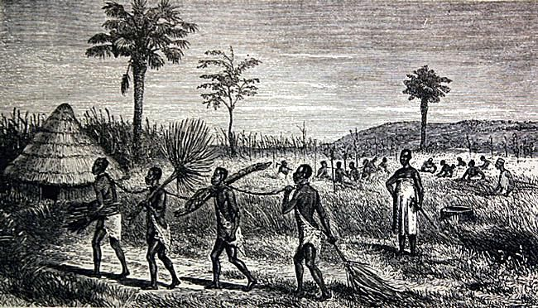
Slavery was not created in Europe. It was known throughout Africa where conquered tribes were made slaves to their conquering masters. It was only a small step to the selling of these slaves to European and American traders and to transport them to the plantations of America and the Carribean.

The transportation of slaves in ships is well documented and is the subject of exhibitions in many former slave trade cities such as Liverpool.
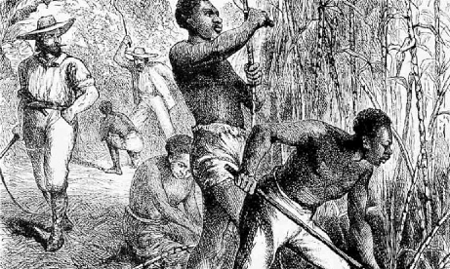
The abolition of the slave trade didn’t end slavery, only the trade itself. Slavery continued well into the 20th century and in a different form into the 21st century.

Right: Slaves work in sugar plantations in the American south.

The American civil war abolished slavery as such but was a starting point for the further emancipation of those slaves who survived. Many former slaves knew no other way of life and died from starvation and disease in the years following the war. The civil rights of slaves were only properly achieved until the late 20th century when the civil rights movement, supported by such entertainers as Paul Robeson and Pete Seeger and by community activists such as Malcolm X and Martin Luther King. Many died to rid the world of the horror of slavery. Many are remembered.

The songs have an element of melancholy which the slave new only too well but that combined with the repetition so familiar in African music. They have subjects which refer to Christian teaching but in a distinctive style.

Steal Away
Swing low

Swing low, sweet Chariot
Comin' for to carry me home
Swing low, sweet Chariot
Comin' for to carry me home

I looked over Jordan and what did I see,
A band of angels comin' after me,

If you get there before I do,
Tell all my friends I'm comin' too.

The brightest day that ever I saw,
When Jesus washed my sins away

I'm sometimes up and sometimes down,
But still my soul feels heavenly bound,

Chorus: Steal away, steal away
Steal away to Jesus
Steal away, steal away home
I ain’t got long to stay here

1. My Lord he calls me
He calls me by the thunder
The trumpet sound within my soul
I ain’t got long to stay here

2. Green trees bending
Poor sinner stands a-trembling
The trumpet sound within my soul
I ain’t got long to stay here

3. My Lord he calls me
He calls me by the lightening
The trumpet sound within my soul
I ain’t got long to stay here
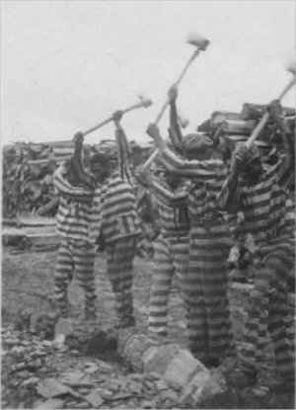
Waterboy

Waterboy, where are you hiding
If you don't come, I’m gonna tell your daddy
There ain't no hammer, that's on a this mountain
That rings like mine boy, that rings like mine
I done bust this rock boy, from here to the Macon
All the way to the jail boy, way back to the jail
You Jack ´o diamond, you Jack ´o diamond
Know you of old boy, I know you of old
You done rob my pocket, you done rob my pocket
Of silver and gold boy, my silver and gold

There ain't no sweat boy, that's on a this mountain
That runs like mine boy, that runs like mine
Above: African American convicts working with axes and singing in wood yard, Reed Camp, South Carolina. Photo: Alan Lomax, 1934.
I done bust this rock boy, from here to the Macon
All the way to the jail boy, way back to the jail

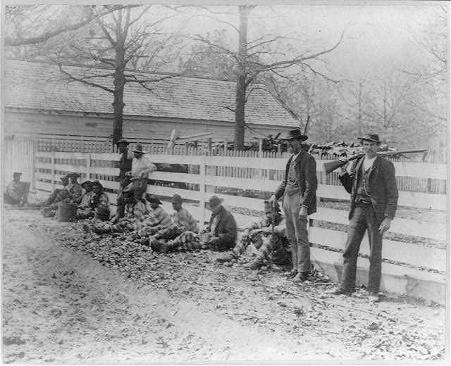
Right: Chain gang prisoners and guards, Thomasville, Georgia. Photo: Joseph John, c 1890. Pictures courtesy of the Library of Congress.

Avery Robinson composed Water Boy "a Negro convict song," in 1922. Folklorist Alan Lomax wrote in 1939 "that portions of "Water Boy" were sung before 1922.... Robinson wove together material from different sources to make the song. "Water Boy," as it stands, is not a folk-song in the opinion of either my father [John A. Lomax] or myself, but if its popularity continues, it may, of course, become one."

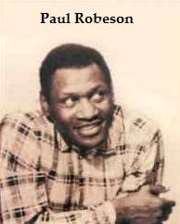
Robinson originally wrote it for Roland Hayes, a lyric tenor, the first African American male concert artist to receive wide international acclaim. Later, Robinson worked with Paul Robeson, a deep bass.
The irony of beautiful music arising from prisoners in horrific conditions is astounding.

Not all of the songs included in the programs of Paul Robeson's earliest concerts were spirituals. Throughout his concert career, one of his favorite songs was “Water Boy,” a black secular song. Some years ago, Robeson writes: I found an interesting reference to that song in my father's 1929 diary: “Of course, technique might help me grow... but that might not make me a greater artist. 'Water Boy' is my best record-made when I was untrained.

Seventeen years later, in 1946, his intuitive affinity for the song was confirmed when he received a letter, accompanied by an African battle axe, from a member of an anthropological expedition to a remote village in southern Angola. Several records had been played on a portable gramophone for the assembled villagers, and one of the songs was my father's rendition of “Water Boy.” As the song ended, the village chief rose, went to his hut, and brought back a ceremonial battle axe which he laid before the gramophone as a gift to "the great chief across the water”.

One might wonder how Paul Robeson could speak to the heart of an African chief through a song written by a white composer, but my father was not surprised. By then his search for his African cultural heritage had led him to research the origins of "Water Boy." He discovered that Robinson had heard the song sung by a black Alabama chain gang in a particular county of Alabama where the culture of rural blacks had its origins in southern Angola.

Michael row the boat ashore
Deep River

Deep river, my home is over Jordan,
Deep river, Lord,
I want to cross over into camp ground.

Oh don’t you want to go to the gospel feast
That promised land where all is peace

Deep river, my home is over Jordan,
Deep river, Lord,
I want to cross over into camp ground.

This song is often sung by choirs but the version I sing comes from an African American singer recorded in the deep south of the USA. It is closer to the African tradition from which it springs.

Chorus:
Michael row the boat ashore, hallelujah
Michael row the boat ashore, hallelujah

1. Sister help to trim the sails
Sister help to trim the sails

2. Jordan’s river is chilly and cold
Chills the body but not the soul

3. Jordan’s river is deep and wide
Milk and honey on the other side

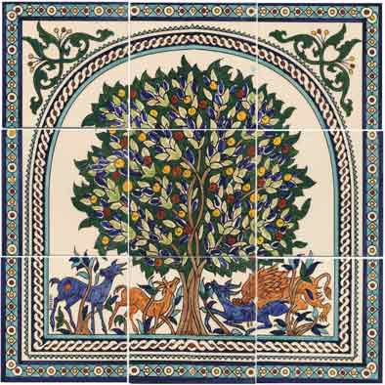
All My Trials

1. Hush little baby don’t you cry
You know your mammy was born to die
All my trials lord soon be over …
Refrain:
Too late my brothers
Too late but never mind
All my trials lord
soon be over

2. The river of Jordan is muddy and cold
Well it chills the body but not the soul
All my trials lord soon be over …

3. I’ve gotta little book with pages three
And every page spells liberty
All my trials lord soon be over …
Above: Muslim image of the ‘Tree of Life’
The singer is going to cross the River Jordan (die) and sings of his trials; the lack of liberty and poverty
4. If livin’ were a thing that money could buy
Well the rich would live and the poor would die
All my trials lord soon be over

5. There grows a tree in paradise
And the pilgrims call it the tree of life
All my trials lord soon be over …

This little light of mine

This little light of mine, I'm gonna let it shine (x3 )
Every day (x4), Let my little light shine
Monday gave me the gift of love,
Tuesday peace came from above,
Wednesday told me to have more faith,
Thursday gave me a little more grace,
Friday told me to watch and pray,
Saturday told me just what to say,
Sunday gave me the power divine
To let my little light shine.
Light that shines is the light of love,
Hides the darkness from above,
Shines on me and it shines on you,
Shows you what the power of love can do.
Shine my light both bright and clear,
Shine my light both far and near,
In every dark corner that I find,
Let my little light shine.

The Carribean – Bananas and Calypsos

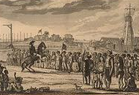
Slavery provided the manpower for landowners and traders to create a paradise for themselves and hell for the slaves. Sugar and bananas were two of the most important crops, exported to the rest of the world. Bread fruit sought by Captain William Bligh was thought to be a possible solution to the feeding of slaves. It wasn’t, as slaves would not eat it. There were many slave revolts.

The St. John's Slave Rebellion is one of the earliest and longest lasting slave rebellions in the Americas.

Above: The most successful slave uprising was the Haitian Revolution, which began in 1791 and was eventually led by Toussaint L'Ouverture, culminating in the independent black republic of Haiti.

Banana Boat Song
Hey Mr.Tally man, tally me banana
Daylight come and I wanna go home“

Day-o, day-o, Daylight come...(x2)

Chop banana til the morning come.
Daylight come...(x2)

A beautiful bunch of ripe banana, Daylight come...
Hide the deadly black tarantula, Daylight come...

Come mister tally man, tally me banana, Daylight …

I pack up all me things and I go to sea, Daylight …
Then all these banana see the last of me. Daylight

Come Mr. tallyman...

Yellow Bird A Banana worker imagines himself to be a ‘Yellow Bird’, preferable to work anyway

Yellow bird, up high in banana tree, Yellow bird, you sit all alone like me.
Did your lady friend leave the nest again?
That is very bad, Makes me feel so sad.
You can fly away, In the sky away, You more lucky than me.
I also have a handsome friend, (he not with me today.)
They all the same, the handsome friends
Make 'em the nest. Then they fly away.

Yellow bird, up high in banana tree, Yellow bird, you sit all alone like me.
Better fly away, In the sky away,
Picker coming soon, Pick from night to noon.
Black and yellow you, Like banana too, They may pick you some day.
Wish that I was a yellow bird, I fly away with you.
But I am not a yellow bird, So I sit, nothing else to do.

