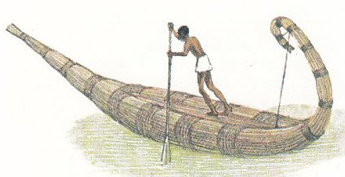
The Dugout, Reed Boat, Coracles and Kayaks
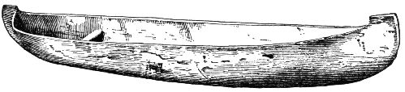
It is thought that the earliest boats were hollowed out logs (dugouts) or boats made of materials which naturally float (eg reed boats)
Left: Dugout canoe. Above: reed boat (Egypt) The ability to make such a boat depended on the availability of the materials required – in Northern Europe wood was plentiful but not in Egypt where reed was the only suitable material.
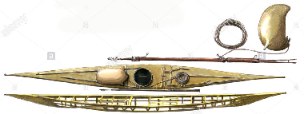
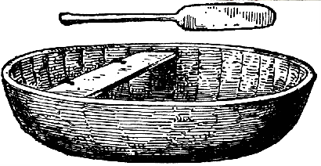
Where no large trees were available and materials to construct frames were, the coracle (Wales) and the Kayak (Inuit – arctic), boats made of skins stretched over frames of wood or whalebone were an alternative and very effective even in the worst conditions.
Above: the Coracle. Right: the Kayak
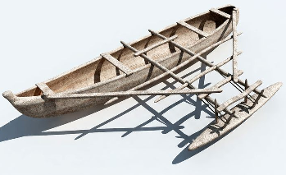
Such boats were designed to take a single or at the most two occupants. To taker larger groups of people boats had to be larger. Some reed boats were very large but dugouts were limited by the size of the tree.
The Outrigger
Canoes can be made more seaworthy by adding an outrigger (see right). Such canoes, particularly in the East Indies, Indonesia area have reached very large sizes, often with over 100 paddlers.
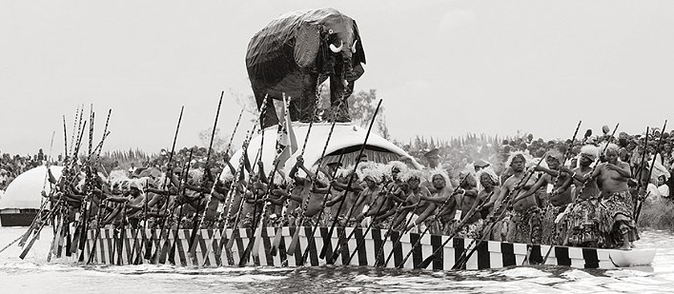
Canoes made of planks also enable the size to exceed that of dugouts. The image below is of an African canoes used in a ceremony called Kuomboka in Western Zambia. The chief of the Lozi ttribe moves to the dry ground at the edge of the Zambezi as the water rises due to the melting snows on the high lands to the north. These are canoes with frames and planking though the smaller canoes are dugouts. Although these are primitive designs they are suitable for the purpose they are intended – on rivers or close to the coast.
Longships
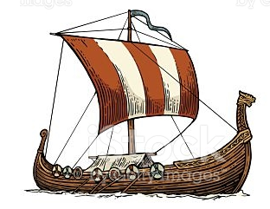
These ships were built to enable groups of men to cross larger bodies of water. Typically they came from Scandinavia but are known to have travelled into the Mediterranean and across the Atlantic, establishing settlements on Iceland, Greenland and the east coast of what is now Canada and the United States. They could be as long as 50 to 60 metres. In general they were open, without decks and were rowed. A single sail could be rigged on a mast allowing the ship to sail, but only in the direction of the wind.
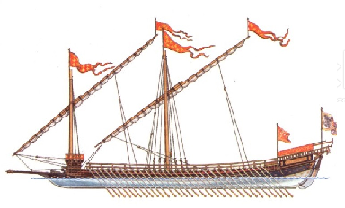
The Mediterranean
2000 years ago, during the Turkish & Greek wars and in Roman times the main warship was the galley. This ship was powered by oars in up to 3 banks with hundreds of men rowing and others on deck to fight.
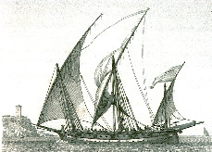
Such ships were fine in the Mediterranean but once they strayed into the Atlantic they were not safe as they were too unstable. A later development in the 1500s onwards called the Galleas was a compromise between the bigger sailing warships and a Galley. Unfortunately they could compete with neither and soon they disappeared.
In the Mediterranean there were also Arab Dhows (see left), mainly built in North Africa. The sails they carried were called lateen – large triangular sails which enabled the ships to sail very efficiently both with and into the wind. These differed from the sails on galleys which were square and used to sail with the wind only.
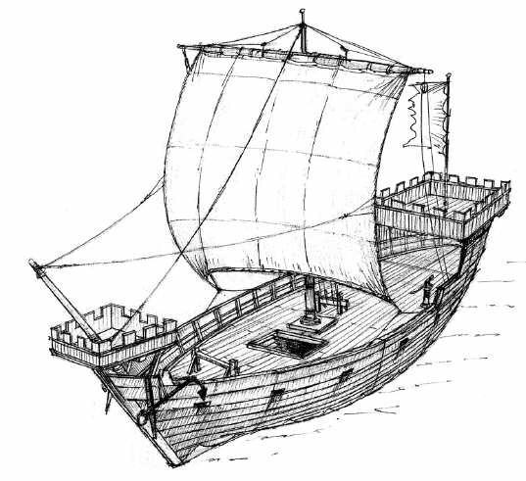
Cargo Ships 1 AD to 1300AD
At this time the most common ship was the Cog (left). These were generally quite short but very wide. They were designed to carry cargos and are similar to the ships which had been used for the previous 1200 years. Their ability to sail was limited as they carried only a lug sail. Sailing against the wind was impossible. These ships would generally sail in sight of land as their navigation was limited.

Exploration 1300 to 1500
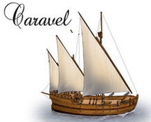
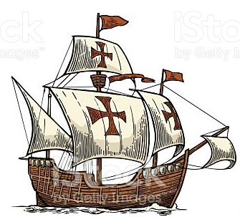
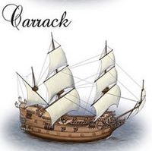
Several types of ship developed as a compromise. The efficient triangular sail was incorporated into ships with a square rigged sail pattern. The Caravel was lateen rigged on all masts (the Nina and Pinta which accompanied the Santa Maria with Columbus were Caravels. The Santa Maria was a very small Carrack.
The Santa Maria (left) is typical, with its high forecastle and after-castle, square sails on the main and foremasts and a lateen sail on the mizzen mast (3rd mast).
The Santa Maria was around 25 to 30m long and the Pinta and Nina much smaller.
Such ships were short lived as ships became bigger and heavier. Eventually they were replaced by the Galleon, bigger, taller and with a greater carrying capacity

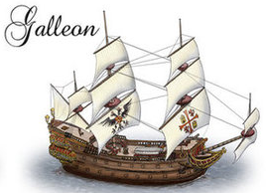
The Galleon and the Race built Galleon 1500 to 1700
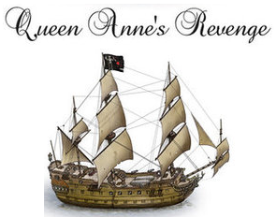
The Galleon retained most of the features of the earlier Carrack. The sail arrangement was the same but with more sails on each mast and additional ‘square’ sails on the top of the mizzen. The ‘Queen Anne’s Revenge’ was the ship of the notorious pirate Blackbeard (Edward Teach).
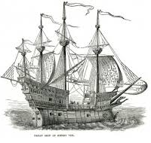
As a pirate ship she was heavily armed, but as pirates tried to capture ships and not sink them it was by boarding – men fighting hand to hand – that ships were taken. Pirate ships were usually fast, small but with a large crew. Most ‘merchant ships’ of the time were not armed very heavily. At this time ‘warships’ did not exist. When ships fought they did so with guns which were carried for protection. It was not until the 16th century, Henry VIII in Britain, that ships were created to fight at sea and such ships were called Race Built Galleons and the Golden Hind of Francis Drake and the Revenge of Walter Raleigh were such ships. A ‘Navy Royal’ was created
Henry VII built several large ships – the ‘Henry Grace A Dieu’ (left) and the Mary Rose which sank in Portsmouth Harbour and was raised in the 1980s. The ships were very high, not ‘race built’ and though powerful, were not very manoeuvrable. In the wind the high sides caused them to drift and become unmanageable.
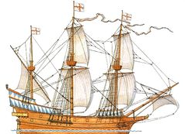
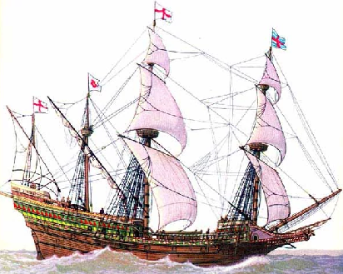
The later ships like the Golden Hind (ex Pelican) and Revenge were race built with much lower fore and after castles. They also carried guns with a greater range as they were much lower in the ship.
The two ships on the right are both race built. Some of the larger ships had four masts but this made little difference except that the sails were easier to handle.
The Ship of the Line
Ships from 1550 onwards could be defined as either warships or merchant ships. Merchant ships would be ‘convoyed’ in time of war and therefore needed only as much protection or speed as required to fight off or run away from pirates. Convoys would be protected by smaller warships such as frigates or sloops, both faster than the much heavier armed ship of the line (at least 64 guns). Frigates would be armed with 24 to 40 guns in rows along each side of size 8 pounds (3.5 kg) to 32 pounds (14kg) - the size of the ball used.
A ship of the line would have the heaviest guns (32, 28 pounders) on the lowest deck and lighter guns on the higher decks. These guns were generally of bronze or iron (bronze was better) and the ball was loaded through the muzzle (where the ball is shot from).
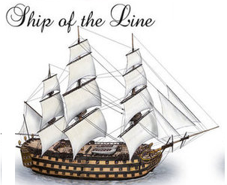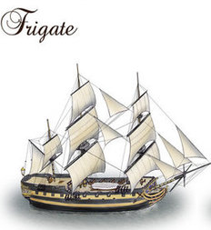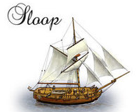
Ships fought in line, broadside to broadside, very often doing little damage unless, as in the case of Collingwood or Nelson, the line of one of the protagonists cut through the line of the other. Then it would be a very destructive event. Nelson’s 27 ships at Trafalgar captured 22 French and Spanish ships (of the 33) and destroyed 4 more.

Merchant Ships
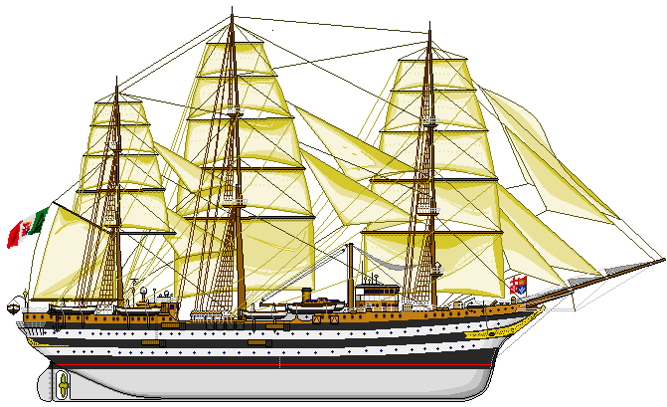
Merchant ships developed in size and the materials of which they were built changed. The last cargo carrying sailing ships were very similar to those of 200 years earlier. It was the need for speed in the 19th century which demanded a change in construction.
Iron and steel frames replaced wood and the hull shape became much finer. These ships could reach speeds of 24 knots – 40km/h whilst the fastest warships of the same century could manage less than half that speed.
Why? Cargoes such as tea (China) and wool (Australia) needed to reach the market as soon as possible to get the best price. Hence the tea clippers etc.
Schooner Rig
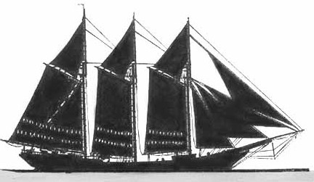
A schooner has sails which are all fore and aft – no square sails. The sails are also bigger and need more effort to rig them but this can be done from the deck. Square sails must be rigged by seamen climbing the masts in all weathers and releasing or tying them by hand.
When ‘donkey engines’ (steam engines) came on board they could be used to raise the gaffs to rig the sail and a smaller crew was needed.
Schooners were also very fast, particularly in variable conditions and could sail much nearer to the wind (into the wind).
Capstan
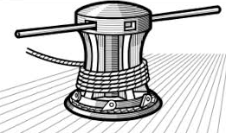
A capstan is a large rotating drum around which a rope can be wrapped to haul large heavy loads up the masts. With the larger capstans over 40 people can push at once, pulling, for example a 10 ton crosstree high up above the deck onto the topmast.
It is also used to raise the anchor.

Parts of a sailing ship
