The Royal Navy in the mid 19th century had a huge fleet of ships which looked little different from those of 200 years before. Steam propulsion and iron and steel construction were only introduced slowly. This slow change came for several reasons:
- Ships could not carry enough fuel for journeys of more than a few days. Then they would need to find a source of fuel.
- Ships stationed a long way from home could be independent as they didn’t require a fuel supply.
- In fighting ships the biggest danger of injury was splinters from a hit by a cannon ball or shell. Iron ships produced far worse splinters than wooden ones when hit.
- The cost of replacing such a huge navy would be crippling and would take time. Sailing ships were still as fast on long journey’s (say 2 months or more) as steam ships and a lot more reliable.
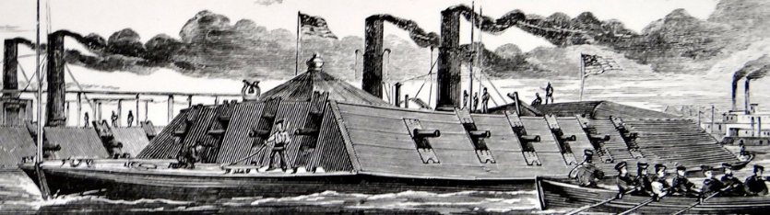
During the American Civil War both sides tried to gain superiority using ‘iron clad’ warships. These usually led to a stalemate unless the iron-clad engaged an old fashioned wooden ship, in which case there was no contest. Unreliability was the drawback. These iron-clad warships with traditional cannon as found on earlier wooden warships could do little damage to each other.
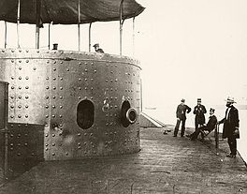
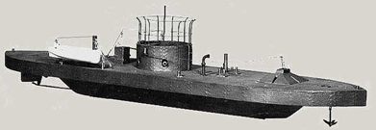
These pictures below and right are of the USS Monitor, (American Civil War – 1860s) built entirely of iron. The design was not a success as it was very low in the water and was unstable when the gun was fired. The gun itself was in a rotating case called a turret. Eventually the Monitor was wrecked after running aground.
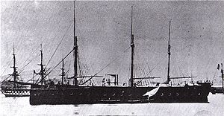
The French iron clad ‘Gloire’
In the 1860s the French built an iron-clad the ‘Gloire’. The ship had both steam and sail propulsion and made earlier wooden warships semi-redundant.
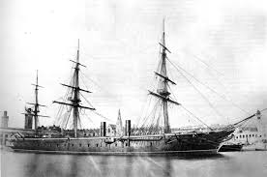
HMS Warrior 1860
Britain’s answer to the ‘Gloire’ was the warrior, built entirely of iron and steel. Even so, the Royal Navy retained sails for some time to come. The Warrior is now preserved in Portsmouth dockyard in the South of England. Such ships were dominant for only a couple of decades as newer weapons required new designs.
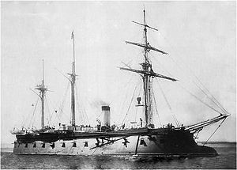
Other nations followed the British lead, Germany, Russia, Italy, the United States and Japan. They too abandoned the design very quickly as impractical.
The ship shown here is the Russian ‘Pervenets’. By 1880 they had disappeared to be replaced by what we consider a more modern design of ‘battleship’ with guns in turrets (or barbettes) and steam propulsion driving a screw propellor or paddle wheels. In competition it was found that the screw propellor was more powerful and more efficient in battle than paddle wheels, which were easily damaged.
Advantages and Disadvantages of Steam Driven Vessels
Advantages
- These vessels are independent of wind, wind direction.
- They need a smaller crew as there are no sails to handle
- Their speed does not depend on conditions beyond their control

Disadvantages

- The ship needs to carry fuel – coal or oil - which is bulky and refuelling stations are essential (Great Eastern would have carried 8,000 tons of coal for the journey to Australia. She had a capacity of 20,000 tons altogether)
- Carrying fuel reduces a ship’s carrying capacity
- Steam engines tended to be unreliable generating the need for repair stations and experts in engine maintenance and repair.
- Fuel is expensive; the wind is free

Merchant ships

Building ships from steel had huge advantages
- Ships could be built bigger as steel structures were stronger (wooden ships were a maximum of 70m long)
- The steel structure took up less cargo space
- Steel ships withstood the vibrations of engines very much better than wood
- Steel was less flammable than wood. Fire was always a major hazard in wooden ships
- Crews were much smaller as machines such as winches (mechanical capstans) took over from manpower.
- Steamships could guarantee a schedule where sailing ships were subject to wind conditions

Great Eastern – Isambard Kingdom Brunel
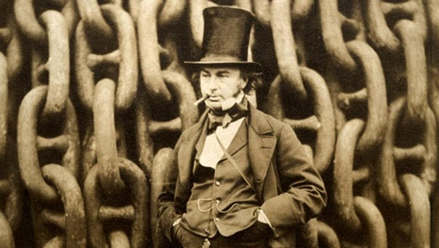
The Great Eastern, completed in 1859, was designed by Isambard Kingdom Brunel to travel to Australia and back without the need to refuel. The steam engines installed used coal.
With a displacement around 20,000 tons it needed to carry 8,000 tons of coal. Unfortunately it was completed too late to make a profit.
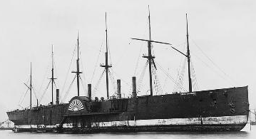
It was eventually used to lay submarine telephone cables (the huge cables required a huge ship) under the oceans but was scrapped on Liverpool foreshore in 1889 to 1890. It was not until the following century that ships began to exceed its size.

The Great Eastern had both paddle wheels and a screw propeller. A ship with paddle wheels has the advantage of being able to manoever at slow speeds. A ship with a screw must have ‘stearage way’ – it must be travelling at greater than 3 or 4 knots (8 km/hour) to stear properly.

The Dvelopment of the Battleship
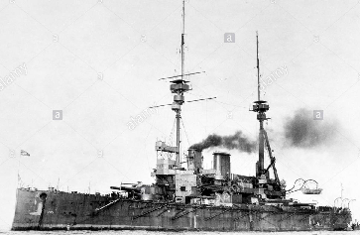
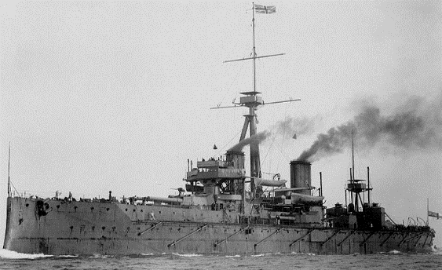
By the 1890s what is called the pre-Dreadnought Battleship was the commonest of the major large warships. The main armament was four 12inch guns in two turrets. They also had a secondary armament of 8 or 9 inch guns. This was not very satisfactory as the splashes from a 12 inch and 9 inch gun were similar and spotting which was which was impossible. Eventually the main armament was increased and the secondary armament was reduced in calibre and increased in number (for defence against smaller faster ships).
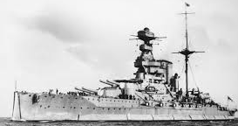
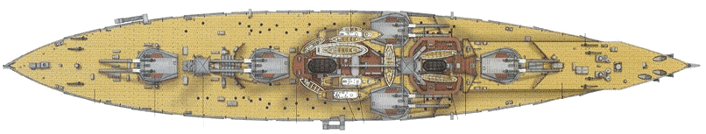
HMS Dreadnought of 1905 had a main armament of ten 12” guns (5 turrets) on one level, three on the centre line and two on the beam amidships. This was a standard arrangement for battleships for about ten years until the introduction of the ‘super Dreadnoughts’ of the Queen Elizabeth class (1915). The ship illustrated here is the battleship Warspite (Queen Elizabeth class) 1916. With a main armament of eight 15” guns, superimposed in four turrets it had a broadside of 8 guns, the same as the Dreadnought with one turret less and larger guns. Warspite was modified several times and served until 1950 after which she was scrapped.
The final development of the battleship came at the end of the 1930s with the Japanese battleships Yamato and Musashi. These two ships had a displacement of 60,000 tons with a main armament of nine 18” guns in three turrets. They were the most powerful battleships ever built.
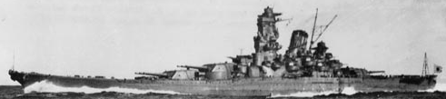

The Aircraft Carrier – Four HMS Ark Royals
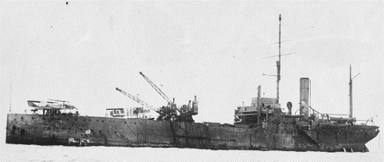
The development of the aircraft carrier began during the first World War. Early attempts were simply seaplane carriers where seaplanes were launched from the deck and retried by crane from the sea after landing.
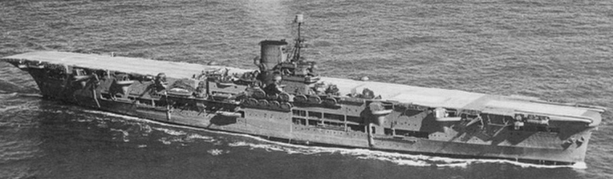
The need for a true aircraft carrier which could handle planes with wheels came in time for the Second World War. The Ark Royal of 1938 carried Swordfish torpedo planes and was involved in the Bismarck action in May 1941 The German battleship Bismarck was crippled by a torpedo from one of Ark Royal’s planes. She was eventually sunk in 1942 in the Mediterranean. At this time aircraft carriers had Straight through flight decks.
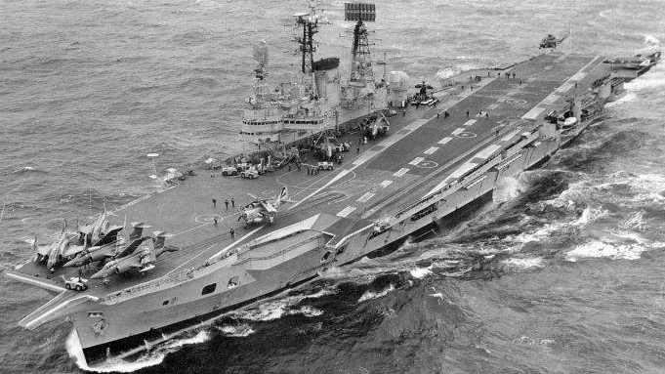
Many accidents occurred when aircraft landing crashed into parked aircraft on the deck. To solve this problem the flight deck was angled, The new Ark Royal of 1955 (27,000 tons) was fitted with an angled deck enabling aircraft to land and take off safely at the same time. This has become the standard for carriers ever since the 1950s and angle decks can be seen on carrirs all over the world.
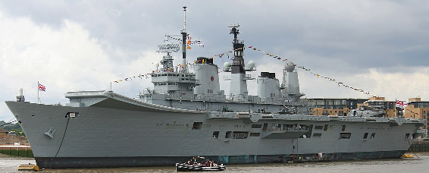
With the development in the UK of VTOL planes (Vertical Take Off and Landing) the need for large carriers disappeared as these planes could land on a much smaller ship, only 22,000 tons, whereas the US was building carriers of 70,000 to 110,000 tons with angled decks. The Ark Royal of 1970 had a straight deck and was a great success in the Falklands War in 1982. The aircraft carrier took over the prime role in navies from 1940 alongside the developing attack submarine.
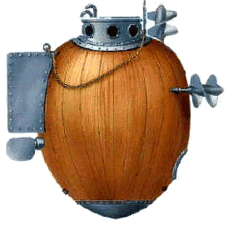
The Submarine
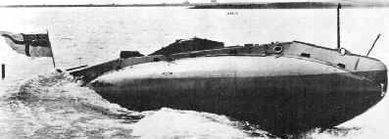
In 1776 the Turtle attacked British ships in New York harbour during the American War of Independence. The expolsives failed to go off and the Turtle was wrecked but the idea was not.
Royal Navy’s submarine Holland No 1 1900
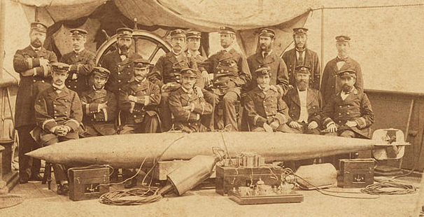
A small ship was now able to attack something much larger due to an invention by an RN officer called Robert Whitehead.
This weapon could be delivered by a small ship and could sink the largest of ships. Smaller navies began to create ships to carry the weapon, including submarines.
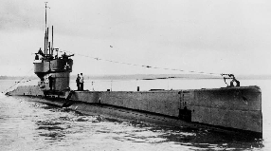
By the start of the First World War, submarines had developed into a shape we recognise. The ‘L’ class submarine, 1916, (right) was the most numerous in the Royal Navy. The long sleek hull and conning tower are features we expect to see. In submarines up to the 1950s a gun was mounted in front of the conning tower and there were often ainti-aircraft guns on the conning tower itself.
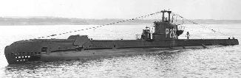
The ‘S’ class submarine, the most numerous British design of World War 2, looks very similar to the ‘L’ class boat of 1916. They were asimilar size but had additions such as radar and sonar.
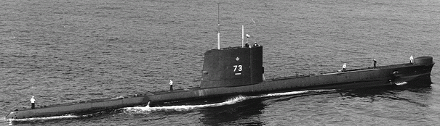
The ‘Oberon’ class of the 1950s was clearly designed to work under water with torpedoes and didn’t carry a deck gun or anti-aircraft armament. It was streamlined, sleek to give it speed under water. More battery power and less diesel power enabled it to work as a submarine, not a submersible surface ship.
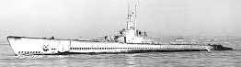
The submarine became the main offensive weapon of the German Navy in both World Wars. The US navy also used it ti great effect against Japanese merchantmen throughout the years 1941 to 1945. They destroyed well over half of the Japanese merchant fleet, crippling the Japanese economy. American submarines were much bigger as the distances they had to travel were much larger. Coastal submarines where generally around 60 to 70 metres long whereas the American boats of the Balao class (above) were over 100 metres long.
Nuclear Power
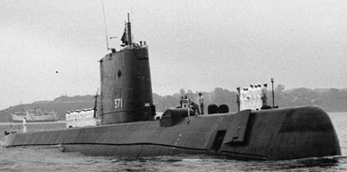
By 1945 the world had entered the nuclear age. Creating an energy source suitable for ships took some years and the first nuclear powered ships appeared in the 1950s.
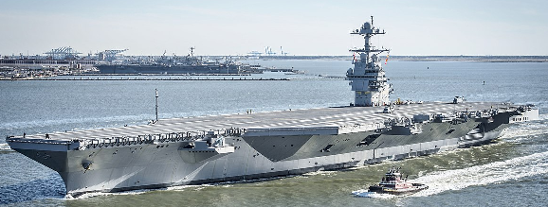
USS Nautilus (named after the Jules Verne submarine in 20,000 leagues under the Sea) was completed in 1955 as the first nuclear submarine. Since then the US Navy, and other navies too, have built ever larger nuclear vessels. The US Navy has based its surface fleet on a series of huge (110,000 ton – 350 metre) aircraft carriers which are nuclear powered. This enables them to remain at sea for 18 months supplied by a fleet train which supplies food, ammunition etc.
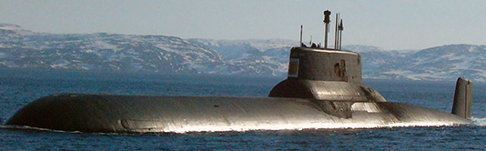
The Russian ‘Typhoon’ class submarine of 20,000 tons, built in 1980 is the largest ever built, carrying 20 Inter Continental Ballistic Missiles and powered by 2 nuclear reactors.
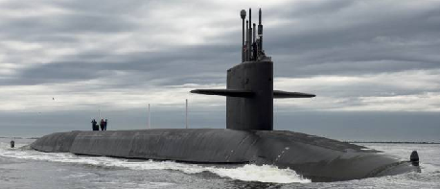
USS Tennessee, 16,000 tons built in the 1980s carryies 24 Trident ICBMs and is powered by a single nuclear reactor. Such ships can remain submerged for months as air, and water within the boat are recycled using energy from the nuclear reactor.
Such vessels as the Typhoon and Ohio class (Tennessee) are associated with the politics of deterrence and are not true naval weapons, though they do carry conventional torpedos for conventional situations.
The Destroyer
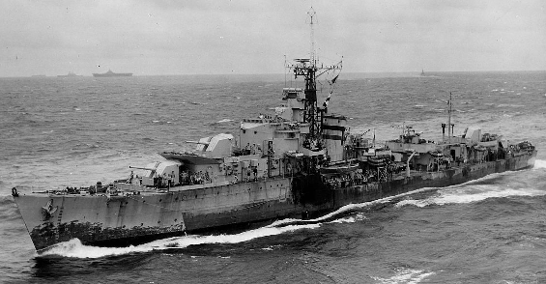
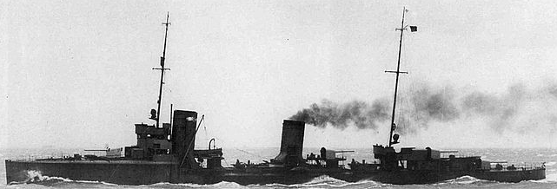
The invention of the torpedo caused large navies to think of ways of protecting their bigger ships from ‘torpedo boats’, small fast ships armed with torpedoes. Naturally the answer was the ‘torpedo boat destroyer’ or destroyer’, equally fast and heavily armed. Eventually the destroyer was also armed with torpedoes, replacing the ship it was supposed to counteract.
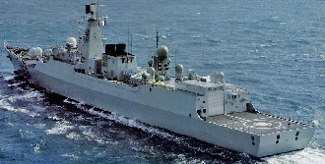
Above is a WW1 German destroyer and right is a WW2 British destroyer, both very successful designs. The destroyer was a very flexible ship and versions were created for the anti-submarine and anti-aircraft roles, then, armed with guided missiles such as exocet they can become part of the front line strike capability.
The modern destroyer (left) is heavily armed with guns and missiles but also has a flight deck to land a helicopter which will have anti-submarine capabilities.
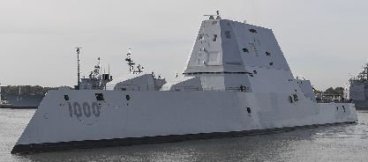
Ships like this will be found in most large navies.
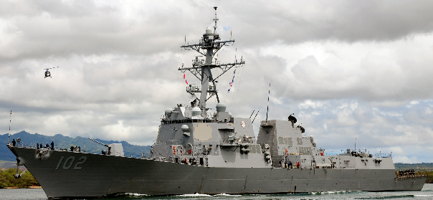
New developments lead to strange looking ships such as USS Zumweldt (right) where the design makes it difficult to detect with radar. The other design here is USS Arleigh-Burke with AEGIS systems and everything you could want in a destroyer. These systems are found in ships of all NATO navies.

Nuclear Powerd Merchant Ships
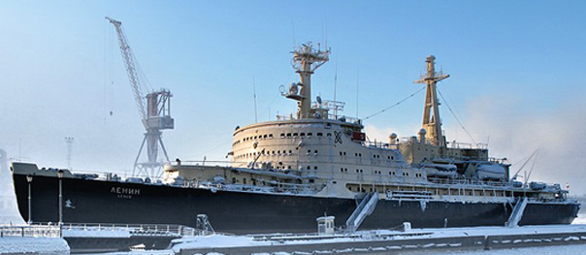
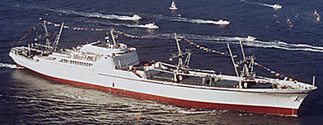
Nuclear power is expensive so nuclear powered merchant ships are rare. NS Savannah, complted in1962 was an experimental nuclear powered merchant ship. There is little commercial advantage in creating such ships and security also becomes an issue.
Nuclear Icebreaker Lenin
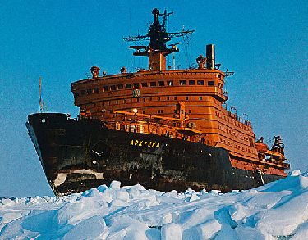
The arctic is a perfect place to use nuclear power. The first Russian nuclear powered icebreaker Lenin was completed in 1950. Ships of this type are usually large (Lenin is around 12,000 tons) and is now preserved in Murmansk.
Nuclear Ice Breaker Arktika
Arktika is the one of the largest of Russia’s nuclear powered icebreakers. It was also the first to reach the North Pole that in 1977. To keep the sea lanes open to Murmansk there is a whole fleet of these nuclear powered 25,000 ton monsters.
A fleet of six or seven are maintained, under government ownership. Such technology causes anxiety and it is important that such vessels are regularly maintained and kept in good condition.

Merchant Ships from 1860 to 2018
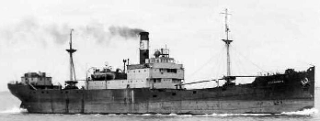
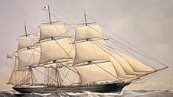
Sailing ships like the City of Adelaide, built in 1864 were common on the Oceans, carrying passengers and goods to all parts of the globe. Such ships carried cargo in barrels or sacks and passengers in some discomfort between the UK and America, Australia, India and many other distant destinations. They used sail power only on voyages of up to six months duration .
By 1900 small cargo ships like the Stanhope (right), powered by an oil engine, without sails, were plying their trade atround Europe and the Americas
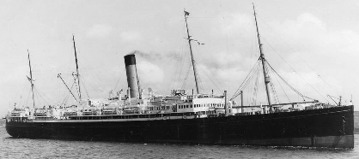
The steamer ‘Yorkshire’ a mixed passenger and cargo ship, built in – 1920, with oil fuelled engines, were trading around the world.
Passengers had a more comfortable journey and freight was loaded into holds through deck hatches, well away from the passengers.
Jervis Bay
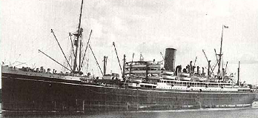
Jervis Bay was a large passenger liner working on the route out to the far East. It was requisitioned by the Admiralty as an armed merchant cruise and, armed with several small guns. The ship was sunk in 1940 while defending a convoy from the German battlecruisers Scharnhorst and Gneisenau. Her captain won the VC.
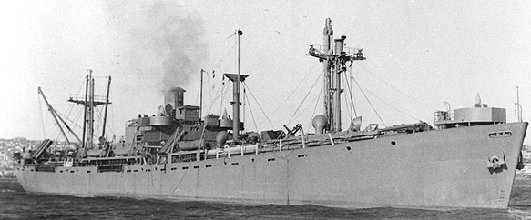
Liberty Ships – 1940s.
As ships were being sunk by U-Boats in the Battle of the Atlantic, it was essential to replace the losses. These ships were mass produced from parts made in factories all over the USA. One of these ships was built in just over FOUR days. Normally it took 42.
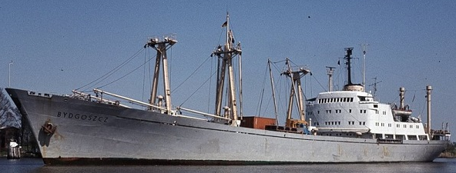
Shown to the right is A Polish cargo ship built around 1970. There were thousands of these diesel engine ships built after World War 2. The superstructure placed aft was a preferred option in smaller ships.
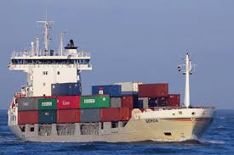
Coastal container ships like this one completed in 2010 have been seen around the coast of Europe, daily, for the past 30 years. The containers are a standard size but the ships can carry from a few hundred to around 20,000 40 tonne containers.
If it can be put in a container it can be transported this way. Cargos which cannot will be transported in bulk carriers which may be up to half a million tons.

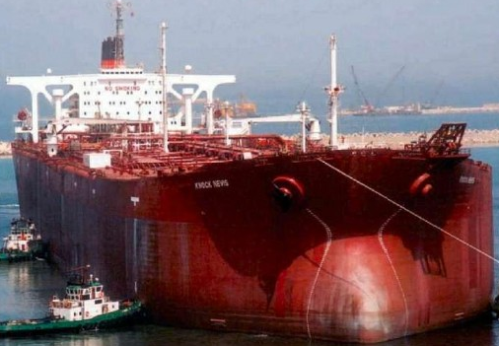
Cargoes in Bulk
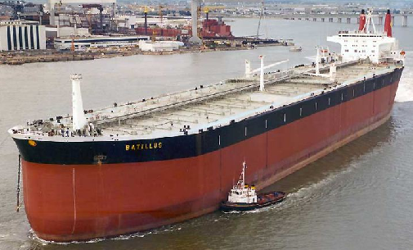
Knock Ness was the World’s largest tanker at 564,000 tons. The VLCC – very large crude carrier - ‘Batillus’ below was of 555,000 tons. Such ships are so large that they cannot dock in normal harbours. Smaller tankers either off load directly from the VLCC or collect a cargo froma special terminal capable of taking the VLCC.
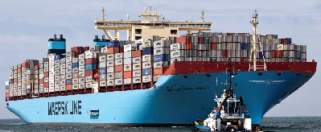
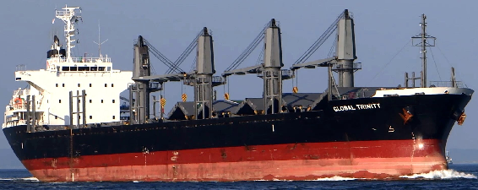
The most common ship seen in all ports is the medium sized bulk carrier of around 30,000 tons. These ships also have cranes so they can handle a variety of cargoes – grain, scrap metal, bio-mass etc.
The Maersk ‘E’ type container ship of 360,000 tons is a common site around the larger container ports in Europe. Carrying up to 18,000 containers they can offload into special container terminals where smaller ships , trains or articulated lorries can take them on to their destinations.
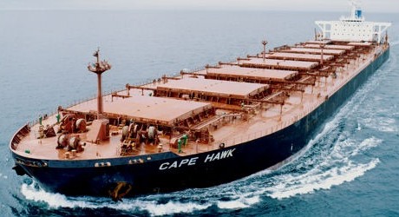
The Bulk Carrier ‘Cape Hawk’ of 364,000 tons collects a cargo in South America and delivers it to Europe. Such ships are built for a particular trade – coal, bio-mass, potash etc. – and will seldom remain in port for longer than required to load or unload.

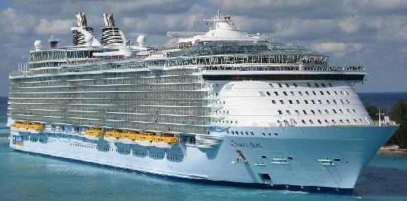
Oasis of the Seas
The cruise liner ‘Oasis of the Seas’ of 228,000 gross tons carries 6,300 passengers and crew.
Such ships are designed for Carribean conditions with air conditioning and everything required for leisure on board. It is like a City on the Sea.
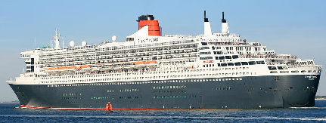
Queen Mary 2
Cruise liner ‘Queen Mary 2’ of 140,000 tons is one of the three Queens (Mary 2, Elizabeth and Victoria), built for Cunard. They are not just cruise ships but are designed for more difficult conditions in the Atlantic.
The are many cruise ships being built. The Carribean is the most popular destination, particularly from Florida. This market unfortunately leads to the over crowding of the islands they visit, destroying their economies and beauty.
Ships seem to have reached the biggest they can, until conditions change. Some suggest we will live in cities on the sea.
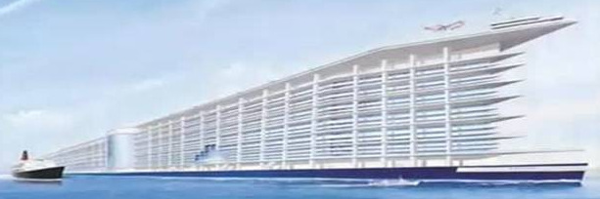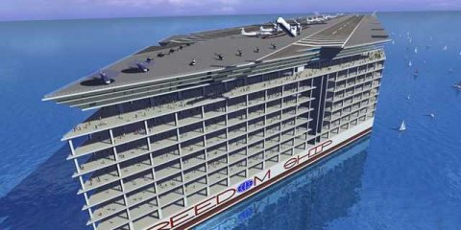
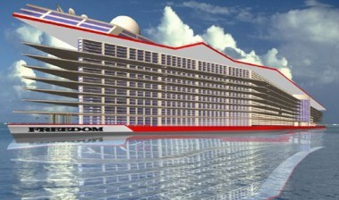
The 1500 metre long ‘Freedom Ship’ a design for the future.
Airport on the top deck with ma city of 20,000 people or more with every facility.
Is this the future?
We will see.

