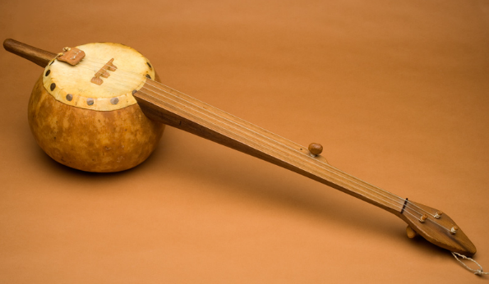
The Banjo
The banjo (left) is thought to have originated in Africa, transported to America with the slaves in the 18th/19th centuries. The first American adaptations of the instrument retained the skin stretched over a round base – a gourd or wood – with gut strings. The number of strings varies from 4 to 6 normally with one of the strings being shorter (the thumb string or 5th string – which is used as a drone (same note all the time).
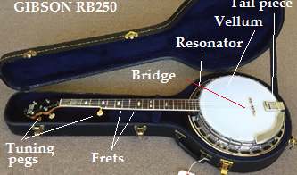
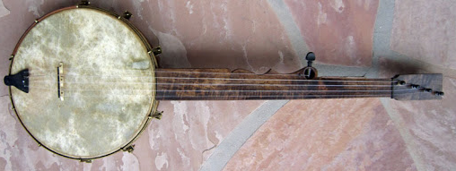
This developed into a five string fretless banjo (right). Frets are metal bands placed across the finger board to enable an exact note to be played. The fretless sound is more like a plucked violin and lacks resonance so the music would be fast, continuous single notes.
The ultimate banjo is the Gibson RB250 (left) which has a coated, plastic vellum, 5 strings (4 long, 1 short), a resonator, tuning pegs, frets and tail piece.
Pete Seeger, needing a banjo with a lower register created the long necked banjo which has an extra 3 frets and when played at the third fret is just like the standard 5 string banjo.
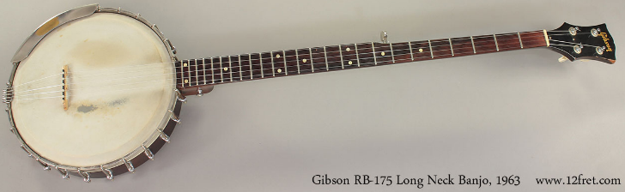
The banjo is played with fingers or finger ‘picks’ which enable a single note to be played. The 5th string, or thumb string, is played at the end of every ‘strum’. A strum is a sequence of notes played in a set form.
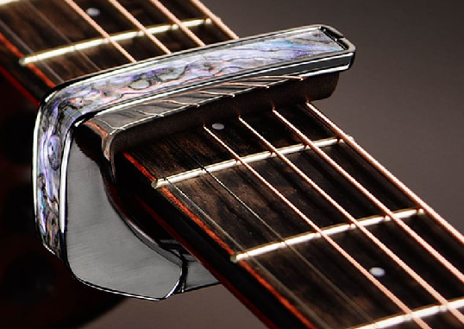
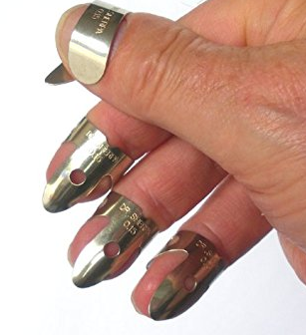
Extra notes are added using the left hand by slapping a finger down (hammering on) or by plucking the string as a finger is removed (pulling off). The result is a very fast sequence of rhythmic notes suitable for dancing. If the fingers of the right hand pluck down on the strings all the time we have a style called ‘frailing’ or ‘framing’ the banjo, used particularly in the mountain music of Kentucky, USA.
Capos and finger picks
To adjust the pitch of the instrument to the singing voice we use a capo. Then the same shape of chords can be used. Finger picks make playing louder easier and is more precise once the player gets used to them.
John Henry

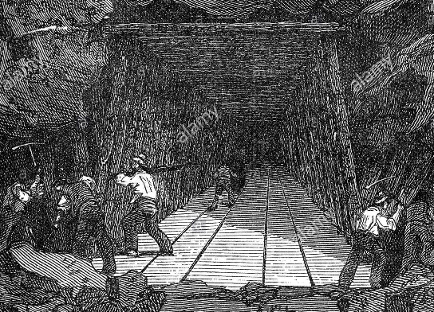
1. When John Henry was a little baby
You could hold him in the palm of your hand
He gave a long and a lonesome sight
Said going to be a steel driving man Lord, Lord
Going to be a steel driving man

2. Well they put John Henry in the tunnel
And they put him in the lead to drive
The rock was so tall and John Henry so small
He laid down his hammer and he cried, Lord, Lord

3. Well John Henry started on the right hand
The steam drill started on the left
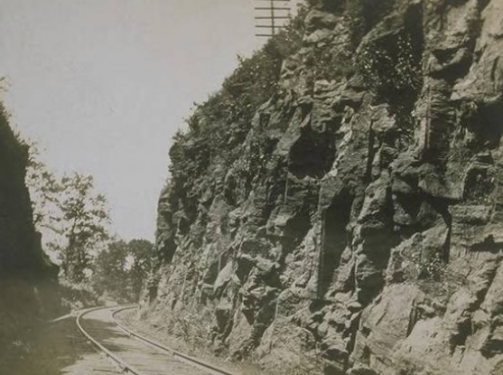
Before I’ll let that steam drill beat me down
I’ll hammer my fool self to death, Lord, Lord

4. The Captain said to John Henry
I think my tunnel’s sinkin’ in
Stand back Captain and don’t you be afraid
It’s only my hammer catchin’ wind, Lord, Lord

5. Well John Henry hammered in the mountain
Till the handle of his hammer caught fire
He drove so hard that he broke his poor heart
And he laid down his hammer and he died, Lord, Lord
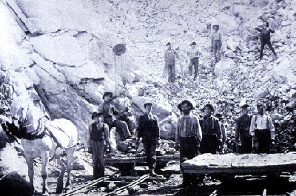
John Henry was a 19th century ‘hammer man’, who used a hammer to drill holes with a bit held by the ‘shaker’ when building cuts and tunnels. The ‘bit’ was a steel bar around 2 metres long and had to be rotated as it was struck by the hammer.
The hole was for explosives. ‘dynamite’ – a new, safe explosive was invented by Alfred Nobel 1867.

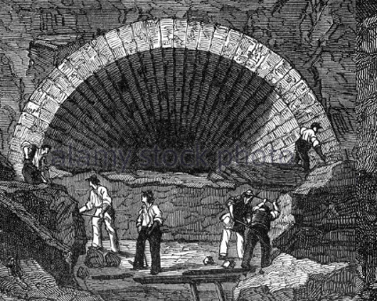
Top right: Tunnel, hand worked, shored up with wooden beams
Middle right: A ‘cut’ or ‘cutting’ through rock. Railway lines should not be too steep.
Bottom right: Men working in the cut

Left: Men work in a hand cut tunnel installing a stone roof as they proceed.
Sourwood Mountain
Charlie

Chorus:
Charlie he’s a fine young man
Charlie he’s a dandy
Loves to hug and kiss the girls
And feed ‘em on sweet candy

1. Step her to your weevily wheat
Step her to your barley
Step her to your weevily wheat
And beg a cake for Charlie

2. My pretty little pink who would think
That you and I would marry
Now I've lost all hope of you
And I've no time to tarry

3. My pretty little pink who would think
I care but little about you
Let you know before I go
I cannot do without you

1. Chickens a crowin’ on Sourwood Mountain
Hey de ding dang diddle um a day
Too many pretty gals I can’t count them
Hey de ding dang diddle um a day

Refrain:
I’ve got a girl at the head o’ the holler
Hey de ding dang diddle um a day
She won’t come and I won’t foller
Hey de ding dang diddle um a day

2. I’ve got a gal a blue eyed daisy
She won’t come and I’ll go crazy

3. I’ve got a gal across the river
Two more jumps and I’ll be with her

Young Man who wouldn’t hoe his Corn

1. Gonna sing you a song and it ain’t very long
About a young man who wouldn’t hoe his corn
The reason why I cannot tell
That young man was always well
Trouble on my Mind
1. Once I had an old banjo, And it was strung with twine
The only song that I could sing, Trouble on my mind
Trouble on my mind, boys, trouble on my mind

Chorus: Trouble, trouble, trouble on my mind
If trouble it don’t kill me boys I’ll live a long, long time
Live a long, long time boys, Live a long, long time

2. I went down to Ginsburg, To get me a bottle of wine
They tied me to the whippin’ post and give me ninety nine
Give me ninety nine, boys, give me ninety nine

3. I went down to Ginsburg to get me a bottle of gin
They tied me to the whippin’ post and give me hell again
Give me hell again, boys, give me hell again

4. It’s rainin’ it’s hailin’ it’s fallin’ from the sky
My true love’s gone back on me an’ surely I will die
Surely I will die, boys, surely I will die

2. He planted his corn in the month of June
By July it was knee high
First of September come a great frost
All that poor man’s corn was lost

3. He went to the fence and there peeped in
Weeds and grass grew up to his chin
Weeds and grass they grew so high
Caused that poor young man to sigh

4. So he went down to his neighbours door
Where he had often been before
Pretty little miss will you marry me
Pretty little miss what do you say

5. Here you are a wantin’ for to wed
Cannot bake your own corn bread
Single I am and single I remain
A lazy man I’ll not maintain

6. You go down to that pretty little widow
And hope like the heck that you don’t get hurt
She gave him the hint and sure as you’re born
All because he wouldn’t hoe his corn

Willie Moore
1. Willie Moore was a king he’s aged 21
He courted a maiden fair
Her eyes was bright as diamonds in the night
And raven black was her hair

2. He courted he both night and day
Till to marry they did agree
But when they went to get their parent’s consent
They said it would never be

3. She threw herself in Willy Moore’s arms
As oft she had done before
And as he left her that very night
Young Anna he would see no more

4. Young Ann was known all far and wide
Her friends were all about
And in the brook down by the cottage door
Chilly Winds

I’m going where those chilly winds don’t blow, darlin’ baby
I’m going where those chilly winds don’t blow
I’m goin’ to my long lonesome home

1. Way down in jail on my knees, darlin’ baby
Way down in jail on my knees
Where they feed me on corn bread and beans

2. Make me a pallet on you floor, darlin’ baby
Make me a pallet on you floor
For I’m goin’ to my long lonesome home

Cindy

1. You ought to see my Cindy, She lives away down south
She’s so sweet the honey bees, Swarm around her mouth

Chorus:
Get along home Cindy, Cindy, Get along home
Get along home Cindy, Cindy, I’ll marry you some day

2. Cindy is a pretty girl, Cindy is a peach
She threw her arms around my neck, And hung on like a leach

3. I kissed my Cindy the other night, An’ I had to do it sneaky
I missed and kissed her on the nose, An’ the goddam thing was leaky

The body of sweet Ann was found

5. She was taken by her weeping friends
And laid in her parent’s room
And there was dressed in a shroud of snowy white
And laid in a lonely tomb

6. Willy Moore never spoke that anyone knew
Till at length from his friends did part
And the last I heard of him he was in Montreal
Where he died of a broken heart

Cripple Creek
1. Cripple Creek’s wide and Cripple Creek’s deep
I’ll wade Cripple Creek as I sleep
American mountain men lived rough and were familiar with the native population. They lived and died a solitary life.
Roll my breechers to my knees
I’ll wade Cripple Creek as I please

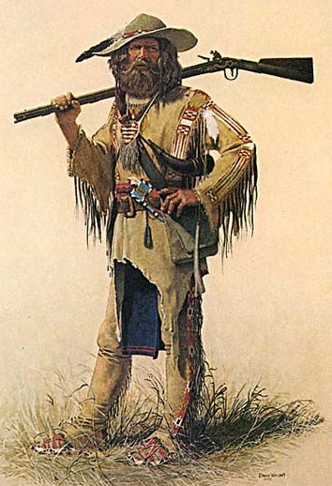
Chorus:
Goin’ down Cripple Creek goin’ in a run
Goin’ down Cripple Creek to have a little fun
Goin’ down Cripple Creek I’m goin’ in a whorl
Goin’ down Cripple Creek to find my girl

2. I’ve got a gal and she loves me
She’s as sweet as sweet can be
She’s got eyes of baby blue
Makes my gun shoot straight and true

3. I went down to cripple creek
See what the boys were havin’ to drink
I got drunk and fell against the wall
Old corn liquor was the cause of it all

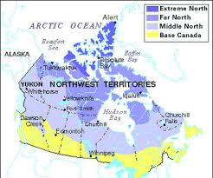
Land of the Muskeg

1. Well there’s girls in the village and there’s girls in the town
And it’s a long time, a very long time
When a man is after being out on his own, out on his own
With the whisky-jacks whistling so cheerful and free
In the land of the muskeg and the shining birch tree
The shining birch tree

2. It’s all very well in the full of the day
When there’s no time, not very much time
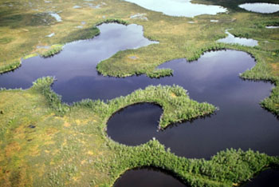
For a man to keep thinkin’ of the things that don’t pay, things that don’t pay
And the rapids are rushin’ so grand and so free
In the land of the muskeg and the shining birch tree
The shining birch tree

3. At the end of the day when the camp settles down
And the night is cold, so very cold
And old Rory-Bory is shifting around, shifting around
You’ll think of the warm ups and laughter so free
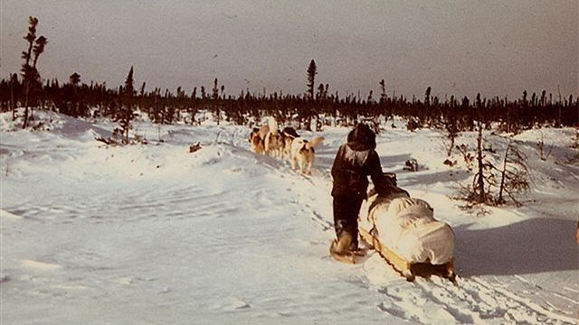
In the land of the muskeg and the shining birch tree
The shining birch tree

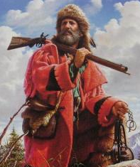
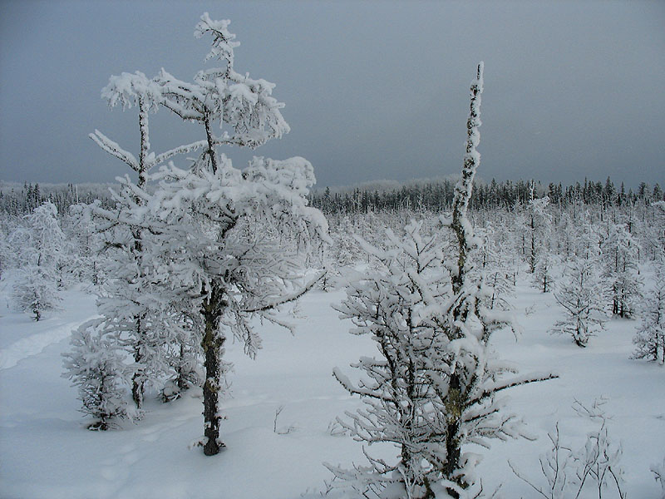
4. Come the in-between seasons of the freeze-up or the thaw,
And it's let's go - hey, look out let's go,
For we're off for some fun with the girls of the town-
The girls in the town.
He's a popular guy when his money flows free
In the land of the muskeg and the shining birch tree,
The muskeg and the shining birch tree.
Above:
1 Map of the tundra
2 Tundra in summer
3 Dog sled in tundra

Left:
Tundra in winter

Below:
Mountain man
Going across the Mountains
Going across the mountains, oh fare thee well
Going across the mountains, don’t you hear my banjo tell
Got my rations on my back, my powder it is dry
Going across the mountains, Crissy don’t you cry

Long before its good daylight, if nothing happens to me
I’ll be way down yonder, in old Tennessee
Going across the mountains, to join the boys in blue
When this fighting’s over, I’ll come back to you

Going across the mountains if I have to fall
To give ol’ Jeff’s men a little ‘ma rifle ball
Going across the mountains oh fare thee well
Going across the mountains Crissy fare thee well

Going across the mountains, oh fare thee well
Going across the mountains, don’t you hear my banjo tell
Got my rations on my back, my powder it is dry
Going across the mountains, Crissy don’t you cry

When the civil war started (1861-1865) mountain men, skilled in the arts of hunting, were excellent recruits for both the Union (North) and the Confederates (South). They exchanged their ‘buckskins’ for jeans (Levis were invented in 1823) and dark blue (North) or grey (South) jackets.

The picture depicts the Union army on the left, with the ‘stars and stripes’ and on the right, the Confederates, with their flag with its 13 stars (13 states).

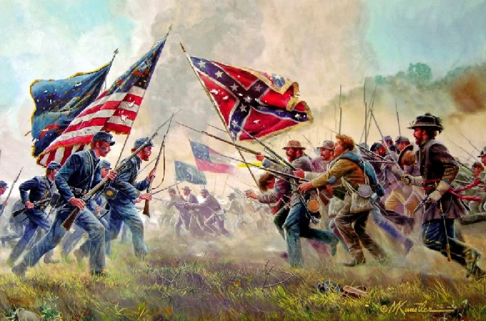

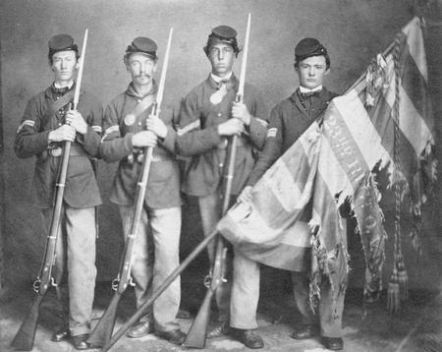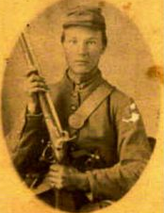
Top left: Ohio infantrymen
Above: Union infantryman
Left: Confederate cavalryman
Near left: Union soldiers relaxing before a battle

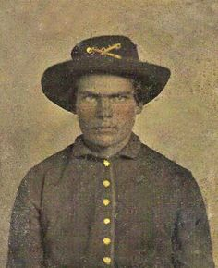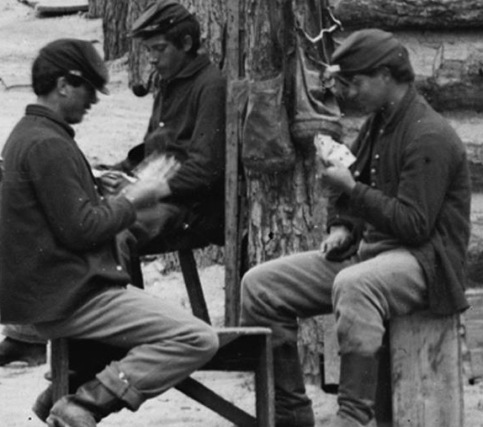
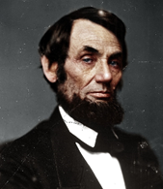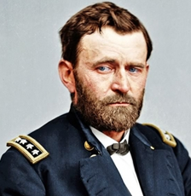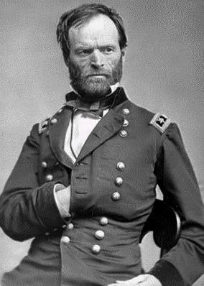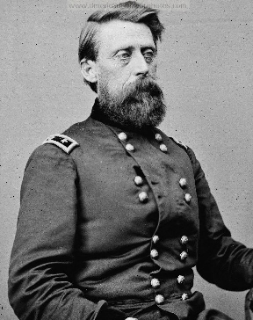
Left to right: Abraham Lincoln, Ulysses S Grant, William Tecumseh Sherman, Jefferson Davis
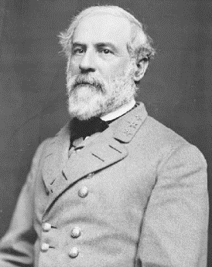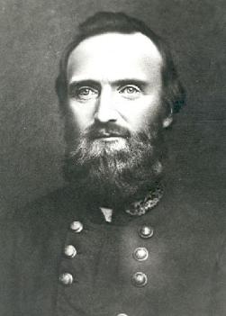
Famous Union leaders above and famous Confederate Generals left
Left to right: Robert E Lee, ‘Stonewall’ Jackson
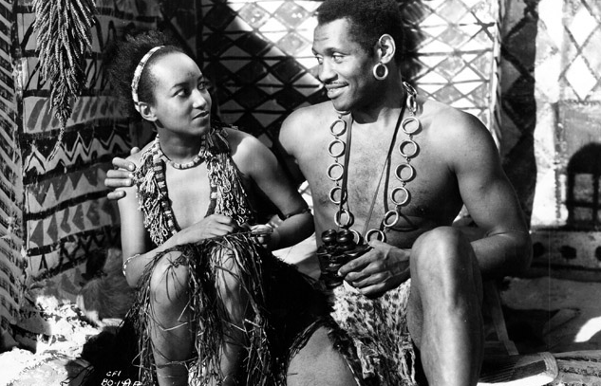
My little black dove
My little black dove
Curl up in your nest of love
The moon is a charm
To keep you from harm
Here at my breast
The stars all are alive
To watch over you all night
The river of sleep
Blows gentle and deep
To rock you to rest
So sleep little one
Till darkness is by
Sleep till the sun
Rises up in the sky
My little black dove
Curl up in your nest of love
And go to your rest
Asleep at my breast
My little black dove
sung by Nina Mae McKinney shown above with Paul Robeson in ‘Sanders of the River’ (Alexander and Zoltan Korda 1935)

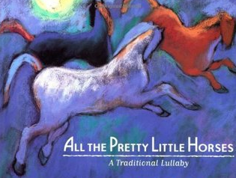
All the pretty little horses

Hush a bye, don’t you cry
Go to sleep-a-little baby
When you awaken you shall have cake
And all the pretty little horses

Blacks and bays, dapples and greys
Coach and six-a-little horses

Way down yonder, down in the meander
There’s a poor little lambie
The birds and the butterflies peckin’ out its eyes
Poor little thing cried mammie

Hush a bye, don’t you cry
Go to sleep-a-little baby
When you awaken you shall have cake
And all the pretty little horses

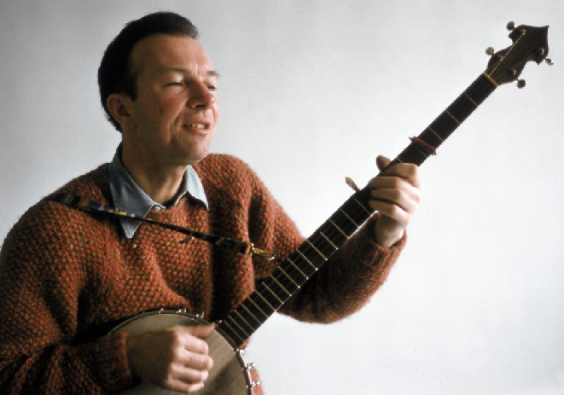
Left: Pete Seeger playing his extended necked banjo.

All the Pretty Little Horses was the title of one of his banjo music publications in the 1950s and the inspiration for Steve’s version of the song.

