Fleetopoly
Contents
The SHORT GAME (60 to 90 minutes) 2
1. During PREPARATION 2
2. You need only three first class decks (instead of four) 2
3. If you land in the Graving Dock 2
4. The penalty for landing on “Harbour Duties” 2
5. END OF GAME 2
The FULL GAME 2
OBJECT 2
EQUIPMENT 3
PREPARATION 3
BANKER 3
THE BANK 3
THE PLAY 3
“WEIGH ANCHOR” 3
BUYING VESSELS 4
PAYING HIRE CHARGES 4
“CHANCE” AND “COMMUNITY CHEST” 4
“HARBOUR DUTIES” 4
“GRAVING DOCK” 4
“FREE MOORING” 5
FIRST CLASS DECKS 5
SUITES 5
Ist CLASS DECK, SUITE SHORTAGES 5
SELLING VESSELS 5
MORTGAGES 5
BANKRUPTCY 6
MISCELLANEOUS 6

The SHORT GAME (60 to 90 minutes) There are five changed rules for this first Short Game. (See illustrations below)
1. During PREPARATION, the players throw dice, the highest score chooses the first set of title deeds, the second highest the second set etc. until each has one set. If there are four players or less, they then choose a second set but in reverse order, lowest score to highest. If there are more than four players each receives only one set. These are free— no payment to the Bank is required.
2. You need only three first class decks (instead of four) on each lot of a complete colour-group before you may buy a suite. Suite hire charge remains the same. The turn-in value is still one-half the purchase price, which in this game is one first class deck less than in the regular game.
3. If you land in the Graving Dock you must exit on your next turn by 1) using a “Get Out of Graving Dock Free” card if you have one; or 2) rolling doubles; or 3) paying $50. You lose one turn.
4. The penalty for landing on “Harbour Duties” is a flat $200.
5. END OF GAME: The game ends when one player goes bankrupt. The remaining players value their vessels: (1) cash in hand; (2) ships, tankers and tugs owned, at the price printed on the board; (3) any mortgaged vessel owned, at one-half the price printed on the board; (4) first class decks, valued at the purchase price; (5) suites, valued at purchase price including the value of the three first class decks turned in. The richest player wins!

The FULL GAME
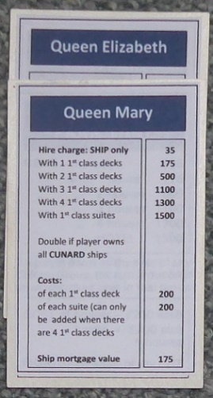
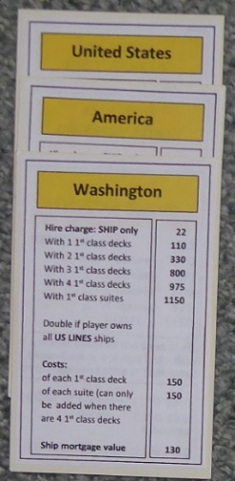
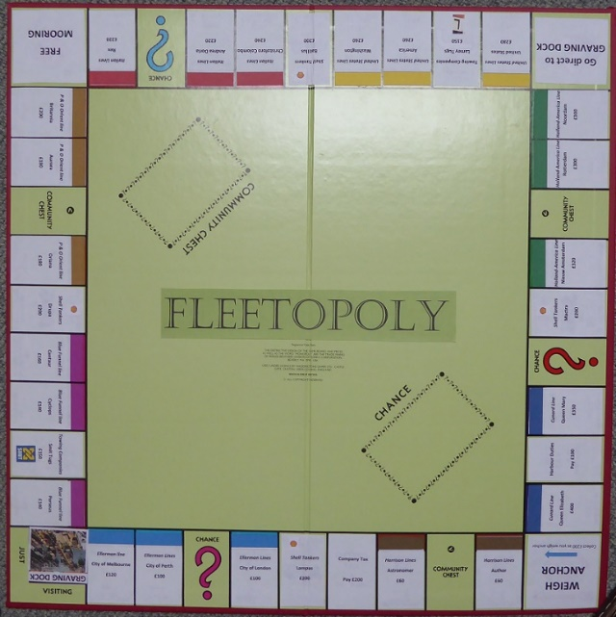
OBJECT… The object of the game is to become the wealthiest player through buying, hire charging and selling vessels.

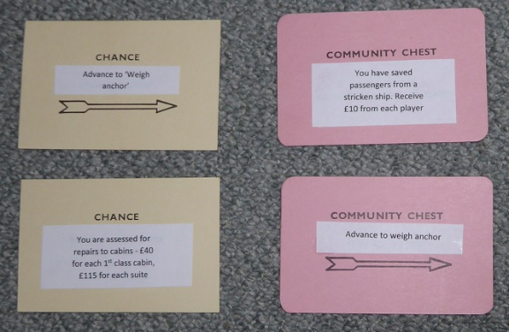

Above: The board and Title Deeds (Cunard and United States Lines).

Left: Chance & Community Chest cards

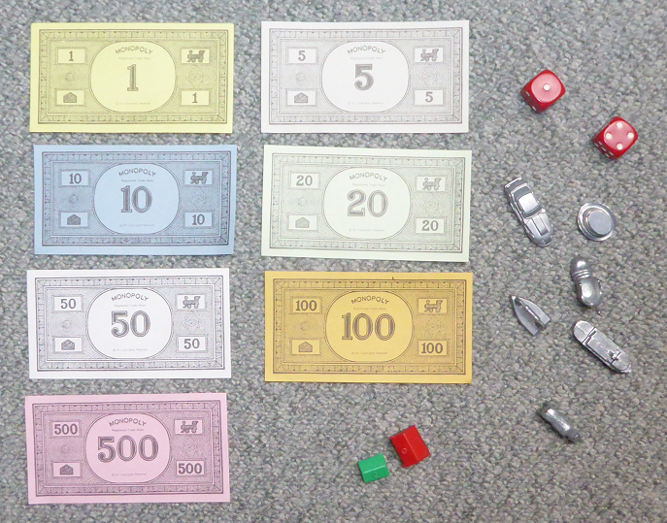
Left: Money, dice, counters, 1st class decks, suites
EQUIPMENT… The equipment consists of a board, 2 dice, tokens, 32 first class decks and 12 suites. There are Chance and Community Chest cards, a Title Deed card for each vessel and play money.
PREPARATION… Place the board on a table and put the Chance and Community Chest cards face down on their allotted spaces on the board. Each player chooses one token to represent him/her while traveling around the board. Each player is given $1500 divided as follows: 2 each of $500’s, $100’s and $50’s; 6 $20’s; 5 each of $10’s, $5’s and $1’s. All remaining money and other equipment go to the Bank.
BANKER… Select as Banker a player who will also make a good Auctioneer. A Banker who plays in the game must keep his/her personal funds separate from those of the Bank. When more than five persons play, the Banker may elect to act only as Banker and Auctioneer.
THE BANK… Besides the Bank’s money, the Bank holds the Title Deed cards, first class decks and suites prior to purchase and use by the players. The Bank pays salaries and bonuses. It sells and auctions vessels and hands out their proper Title Deed cards; it sells first class decks and suites to the players and loans money when required on mortgages. The Bank collects all taxes, fines, loans and interest, and the price of all vessels which it sells and auctions. The Bank never goes broke. If the Bank runs out of money, the Banker may issue as much more as may be needed by writing on any ordinary paper.
THE PLAY… Starting with the Banker, each player in turn throws the dice. The player with the highest total starts the play: Place your token on the corner marked “WEIGH ANCHOR,” throw the dice and move your token in the direction of the arrow the number of spaces indicated by the dice. After you have completed your play, the turn passes to the left. The tokens remain on the spaces occupied and proceed from that point on the player’s next turn. Two or more tokens may rest on the same space at the same time. According to the space your token reaches, you may be entitled to buy First class decks, Suites or other vessels — or obliged to pay hire charge, pay taxes, draw a Chance or Community Chest card, “GO TO GRAVING DOCK ,” etc. If you throw doubles, you move your token as usual, the sum of the two dice, and are subject to any privileges or penalties pertaining to the space on which you land. Retaining the dice, throw again and move your token as before. If you throw doubles three times in succession, move your token immediately to the space marked “IN GRAVING DOCK” (see GRAVING DOCK).
“WEIGH ANCHOR”… Each time a player’s token lands on or passes over WEIGH ANCHOR, whether by throwing the dice or drawing a card, the Banker pays him/her a $200 salary. The $200 is paid only once each time around the board. However, if a player passing WEIGH ANCHOR on the throw of the dice lands 2 spaces beyond it on Community Chest, or 7 spaces beyond it on Chance, and draws the “Advance to WEIGH ANCHOR” card, he/she collects $200 for passing WEIGH ANCHOR the first time and another $200 for reaching it the second time by instructions on the card.
BUYING VESSELS… Whenever you land on an unowned vessel you may buy that vessel from the Bank at its printed price. You receive the Title Deed card showing ownership; place it face up in front of you. If you do not wish to buy the vessel, the Banker sells it at auction to the highest bidder. The buyer pays the Bank the amount of the bid in cash and receives the Title Deed card for that vessel. Any player, including the one who declined the option to buy it at the printed price, may bid. Bidding may start at any price.
PAYING HIRE CHARGES… When you land on vessel owned by another player, the owner collects hire charge from you in accordance with the list printed on its Title Deed card. If the vessel is mortgaged, no hire charge can be collected. When a vessel is mortgaged, its Title Deed card is placed face down in front of the owner. It is an advantage to hold all the Title Deed cards in a colour-group (e.g., Boardwalk and Park Place; or Connecticut, Vermont and Oriental Avenues) because the owner may then charge double hire charge for unimproved vessels in that colour-group. This rule applies to unmortgaged vessels even if another vessel in that colour-group is mortgaged. It is even more advantageous to have first class decks or suites on vessels because hire charges are much higher than for unimproved vessels. The owner may not collect the hire charge if he/she fails to ask for it before the second player following throws the dice.
“CHANCE” AND “COMMUNITY CHEST”… When you land on either of these spaces, take the top card from the deck indicated, follow the instructions and return the card face down to the bottom of the deck. The “Get Out of Graving Dock” card is held until used and then returned to the bottom of the deck. If the player who draws it does not wish to use it, he/she may sell it, at any time, to another player at a price agreeable to both.
“HARBOUR DUTIES”… If you land here you have two options: You may estimate your duty at $200 and pay the Bank, or you may pay 10% of your total worth to the Bank. Your total worth is all your cash on hand, printed prices of mortgaged and unmortgaged vessels and cost price of all buildings you own. You must decide which option you will take before you add up your total worth.
“GRAVING DOCK”… You go to the Graving Dock when… (1) your token lands on the space marked “Go to Graving Dock”; (2) you draw a card marked “Go to Graving Dock”; or (3) you throw doubles three times in succession. When you are sent to the Graving Dock you cannot collect your $200 salary in that move since, regardless of where your token is on the board, you must move it directly into the Graving Dock. Yours turn ends when you are sent to the graving Dock. If you are not “sent” to the Graving Dock but in the ordinary course of play land on that space, you are “Just Visiting,” you incur no penalty, and you move ahead in the usual manner on your next turn. You get out of the Graving Dock by… (1) throwing doubles on any of your next three turns; if you succeed in doing this you immediately move forward the number of spaces shown by your doubles throw; even though you had thrown doubles, you do not take another turn; (2) using the “Get Out of Graving Dock” card if you have it; (3) purchasing the “Get Out of Graving Dock” card from another player and playing it; (4) paying a fine of $50 before you roll the dice on either of your next two turns. If you do not throw doubles by your third turn, you must pay the $50 fine. You then get out of Jail and immediately move forward the number of spaces shown by your throw. Even though you are in the Graving Dock, you may buy and sell vessels, buy and sell first class decks and suites and collect hire charges.
“FREE MOORING”… A player landing on this place does not receive any money, vessel or reward of any kind. This is just a “free” resting place.
FIRST CLASS DECKS… When you own all the vessels in a colour-group you may buy first class decks from the Bank and fit them on those vessels. If you buy one first class deck, you may put it on any one of those vessels. The next first class deck you buy must be erected on one of the unimproved vessels of this or any other complete colour-group you may own. The price you must pay the Bank for each first class deck is shown on your Title Deed card for the vessel on which you erect the first class deck. The owner still collects double hire charge from an opponent who lands on the unimproved vessels of his/her complete colour-group. Following the above rules, you may buy and erect at any time as many first class decks as your judgement and financial standing will allow. But you must build evenly, i.e., you cannot erect more than one first class deck on any one vessel of any colour-group until you have built one first class deck on every vessel of that group. You may then begin on the second row of first class decks, and so on, up to a limit of four first class decks to a vessel. For example, you cannot build three first class decks on one vessel if you have only one first class deck on another vessel of that group. As you build evenly, you must also break down evenly if you sell first class decks back to the Bank (see SELLING VESSELS).
SUITES… When a player has four first class decks on each vessel of a complete colour-group, he/she may buy a suite from the Bank and erect it on any vessel of the colour-group. He/she returns the four first class decks from that vessel to the Bank and pays the price for the suite as shown on the Title Deed card. Only one suite may be fitted on any one vessel.
Ist CLASS DECK, SUITE SHORTAGES… When the Bank has no first class decks to sell, players wishing to fit one must wait for some player to return or sell his/her first class decks to the Bank before building. If there are a limited number of first class decks and suites available and two or more players wish to buy more than the Bank has, the first class decks or suites must be sold at auction to the highest bidder.
SELLING VESSELS… Unimproved vessels, tankers and tugs (but not first class decks or suites) may be sold to any player as a private transaction for any amount the owner can get; however, no vessel can be sold to another player if any vessels of that colour-group have been improved. Any improvements so located must be sold back to the Bank before the owner can sell any vessel of that colour-group. First class decks and suites may be sold back to the Bank at any time for one-half the price paid for them. All first class decks on one colour-group must be sold one by one, evenly, in reverse of the manner in which they were erected. All suites on one colour-group may be sold at once, or they may be sold one first class deck at a time (one suite equals five first class decks), evenly, in reverse of the manner in which they were erected.
MORTGAGES… Unimproved vessels can be mortgaged through the Bank at any time. Before an improved vessel can be mortgaged, all the improvements on all the vessels of its colour-group must be sold back to the Bank at half price. The mortgage value is printed on each Title Deed card. No hire charge can be collected on mortgaged vessels, but hire charges can be collected on unmortgaged vessels in the same group. In order to lift the mortgage, the owner must pay the Bank the amount of the mortgage plus 10% interest. When all the vessels of a colour-group are no longer mortgaged, the owner may begin to buy back first class decks at full price. The player who mortgages a vessel retains possession of it and no other player may secure it by lifting the mortgage from the Bank. However, the owner may sell this mortgaged vessel to another player at any agreed price. If you are the new owner, you may lift the mortgage at once if you wish by paying off the mortgage plus 10% interest to the Bank. If the mortgage is not lifted at once, you must pay the Bank 10% interest when you buy the vessel and if you lift the mortgage later you must pay the Bank an additional 10% interest as well as the amount of the mortgage.
BANKRUPTCY… You are declared bankrupt if you owe more than you can pay either to another player or to the Bank. If your debt is to another player, you must turn over to that player all that you have of value and retire from the game. In making this settlement, if you own first class decks or suites, you must return these to the Bank in exchange for money to the extent of one-half the amount paid for them; this cash is given to the creditor. If you have mortgaged a vessel you also turn this vessel over to your creditor but the new owner must at once pay the Bank the amount of interest on the loan, which is 10% of the value of the vessel. The new owner who does this may then, at his/her option, pay the principal or hold the vessel until some later turn, then lift the mortgage. If he/she holds vessel in this way until a later turn, he/she must pay the interest again upon lifting the mortgage. Should you owe the Bank, instead of another player, more than you can pay (because of taxes or penalties) even by selling off buildings and mortgaging vessel, you must turn over all assets to the Bank. In this case, the Bank immediately sells by auction all vessel so taken, without improvements. A bankrupt player must immediately retire from the game. The last player left in the game wins.
MISCELLANEOUS… Money can be loaned to a player only by the Bank and then only by mortgaging a vessel. No player may borrow from or lend money to another player.

