American Folk Music

These cover a wide variety of subjects some of which are:

- Work songs, including sea shanties
- Lifestyle Ballads which vary from the amusing and trivial to those with a very serious message including songs of war
- Hobo & Railroad songs such as Freight Train, 900 miles which describe the trials of life for the less fortunate
- Religious songs which include spirituals and gospel songs
- Songs full of humour which have no purpose other than to entertain.

Many songs are found in other sections – shanties, spirituals, banjo songs, songs of war - and are therefore not repeated here. Many of the songs here are therefore songs for entertainment and have no greater meaning. We will try to deal with differences of ideas and expression so that we understand what such songs may try to express.

We remember that the origin of many American songs is the traditions of their immigrant populations. There are clear areas of the USA where the immigrant population is predominantly of one nationality – English, Scottish, Irish, Welsh, French, Spanish – but the predominant language is English.

The native American population did not produce any body of songs which could easily transfer across racial or religious lines. Perhaps had the immigrant populations treated the native population in a more rational way such cross fertilisation might have occurred.

Many of the tunes of songs and whole songs have their origins in Europe. There are adaptations where styles of music popular in one area or state absorb tunes and lyrics from another.
The culture of the USA, however, remains an offshoot of European culture and retains the better and worse qualities of their origins.

The cowboy culture, which developed in both America and Australia, offers very different subjects for songs and we have trapping, herding and fighting (with or without guns) as a constant background of life in the young, developing Continent.

There is a whole history of war songs from the Indian Wars, the Civil War and other foreign wars. These do not, however, feature strongly in the folk song culture, only their aftermaths – the situations of poverty, homelessness – suffered by the displaced populations. There are many songs on tramps and hobos, on those looking for a better life.

Folk singers have tended to be concerned about inequality and civil rights, particularly for the black population. Names such as Pete Seeger, Woody Guthrie and Paul Robeson come to the fore. Folk music has done much for these causes and will continue to do so.

Blood on the Saddle

The tale of a dying cowboy crushed by his horse as he falls, not the hero of the ‘Wild West’ gunfight or the fighter for peace and justice.

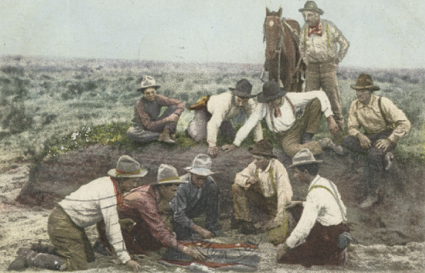
Chorus:
There's blood on the saddle and blood all around,
And a great great big puddle of blood on the ground;
A cowboy lay in it all covered with gore
And he never will ride on his bronco no more.

Oh, pity the cowboy all bloody and red,
A bronco fell on him and smashed in his head.
There was blood on the saddle and blood all around,
A great big puddle of blood on the ground.

Bye Baby Bye

This is said to be a compilation of two songs

Left: Traditional mail boat

Chorus:
Bye o baby bye o, Bye o baby bye
Poppa’s gone to the mailboat (x2),
Bye o bye
(all twice)

Stars shining number number 1, number 2, number 3 good Lord
Bye ‘n bye, bye ‘n bye, good Lord, Bye ‘n bye
Stars shining number number 4, number 5, number 6 good Lord
Bye ‘n bye, bye ‘n bye, good Lord, Bye ‘n bye

Close your weary eyes o, Close your weary eyes
Poppa’s gone to the mailboat (x2), Bye o bye
(all twice)

Stars shining number number 7, number 8, number 9 good Lord
Bye ‘n bye, bye ‘n bye, good Lord, Bye ‘n bye
Stars shining number number 10, number 11, number 12 good Lord
Bye ‘n bye, bye ‘n bye, good Lord, Bye ‘n bye

Chorus:
Bye o baby bye o, Bye o baby bye etc.

Cat Came Back

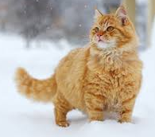
1. Well old Mr. Johnstone had troubles all his own
Had an old yellow cat that wouldn’t stay home
Tried everything he knew to get the cat to stay away
Even took him up to Canada and told him for to stay

Chorus:
But the cat came back the very next day
Thought he was a gonner but the cat came back
‘Cause he wouldn’t stay away

2. Well the farmer on the corner said he’d shoot the cat on sight
A cat uses every one of his nine lives but always comes back
He loaded up his gun full of rocks and dynamite
The gun went off heard all over town
And little pieces of the man was all that they found

3. Well they gave him to a man goin’ up in a balloon
Told him for to leave him with the man in the moon
The balloon got busted and back to earth it sped
And seven miles away they picked the man up dead

4. Well they took him to Cape Canaverel* and they put him in a place
Put him in a US rocket goin’ way out in space
Finally thought the cat was out of human reach
Next day got a call from Miami Beach (* now Cape Kennedy)

Freight Train
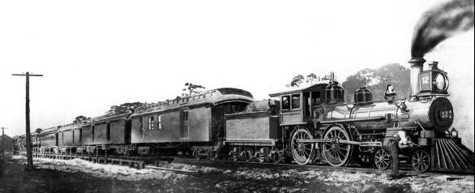
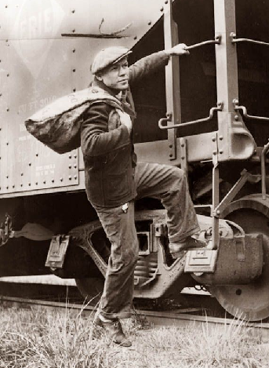
1. Freight train, freight train goin’ so fast
Above: An American 19th Century freight train
Right: Hobo hops a freight train in 1930s
Below: Hobos hopping moving train 1930s
Freight train, freight train goin’ so fast
Please don’t tell ‘em what train I’m on
So they won’t know where I’ve gone

2. When I die just bury me deep
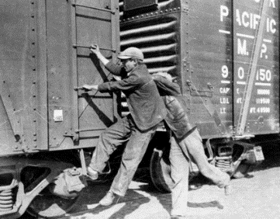
Down at the end of old Chestnut Street
Lay this stone at my head and my feet
And tell ‘em all I’ve gone to sleep

3. When I die just bury me deep
Down at the end of old Chestnut Street
So I can’t hear old number nine
As he goes rollin’ on by

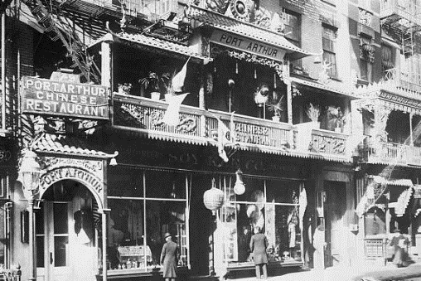
House of the Rising Sun

1. There is a house in New Orleans
They call the Rising Sun
It’s been the ruin of many a poor boy
In god, I know I’m one

2. My mother was a tailor
Sewed my new blue jeans
My father was a gamblin’ man
Down in New Orleans
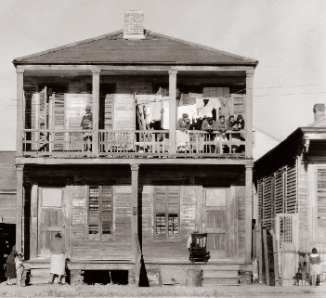
Right and above:
New Orleans Houses of Entertainment in the 19th Century
3. One foot on the platform
The other on the train
I’m going back to New Orleans
To wear that ball and chain

4. If I’d have listened to what my mother said
I’d have been at home today
But I was young and foolish Oh lord
Let a gambler lead me astray
6. I’m going back to New Orleans
My race is almost run
I’m going back to spend my life
Beneath that Rising Sun
5. Go tell my baby sister
Not to do what I have done
To shun that house in New Orleans
They call the Rising Sun

I gave my love a cherry
Sometimes called ‘the riddle song’.

The last verse gives the solution:
The Cherry tree before it bears fruit
The chicken’s egg before it is fertilised
A ring rolling!

All put to one of the melodies which seems to be from ancient times.
1. I gave my love a cherry that had no stone
I gave my love a chicken that had no bone
I gave my love a ring that had no end
I gave my love a baby with no cryin’

2. How can there be a cherry that has no stone
How can there be a chicken that has no bone
How can there be a ring that has no end
How can there be a baby with no cryin’

3. A cherry when its bloomin’ it has no stone
A chicken when its pippin’ it has no bone
A ring when it’s rollin’ it has no end
And a baby when it’s sleepin’ there’s no cryin’

John Brown’s Body
"John Brown's Body" (originally known as "John Brown's Song") is a United States marching song about the abolitionist John Brown. The song was popular in the Union during the American Civil War. The tune arose out of the folk hymn tradition of the American camp meeting movement of the late 18th and early 19th century. According to an 1890 account, the original John Brown lyrics were a collective effort by a group of Union soldiers who were referring both to the famous John Brown and also, humorously, to a Sergeant John Brown of their own battalion.
The familiar "Glory, glory, hallelujah" chorus—a notable feature of both the "John Brown Song", the "Battle Hymn of the Republic", and many other texts that used this tune—developed out of the oral camp meeting tradition some time between 1808 and the 1850s.
On Dec. 2, 1859, the abolitionist, John Brown, was executed in Virginia for leading an uprising against slavery.
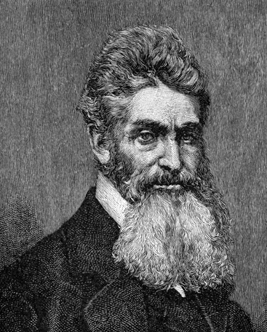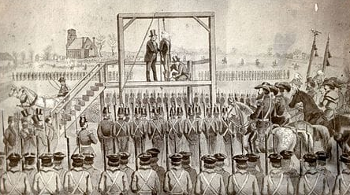

John Brown’s Body lies a mouldering in the grave (3x)
And his soul is marching on

Chorus:
Glory, glory hallelujah (3x)
And his soul is marching on

The stars above in heaven are looking kindly down (3x)
On the grave of Old John Brown

He’s gone to be a soldier in the army of the Lord (3x)
And his soul is marching on

Lakes of Pontchartrain

The ‘Lakes of Pontchartrain’ is a US ballad about a man who is given shelter by a beautiful Louisiana Creole woman. He falls in love with her and asks her to marry him, but she is already promised to a sailor and declines. Creole is a French based language found in the former French region around New Orleans.
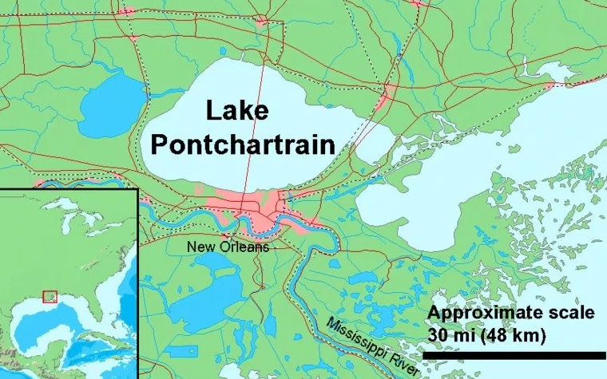
The song is set in the time after the Civil War, when former Confederate soldiers were hunted down and came to the inhospitable, swampy area around New Orleans with its lakes, the largest being Lake Pontchartrain. The flooding of the City of New Orleans stems from the damming of the Mississippi as it carves its way through the swamps to the Gulf of Mexico. Originally the lakes and swamps would have absorbed the water of the Mississippi in flood.

1. It was one fine march morning, I bid you all adieu
I took the road to Jackson town my fortune to review
I cast out foreign money no credit could I gain
Which filled my heart with longing for the Lakes of Pontchartrain

2. I stepped on board of a railroad car beneath the morning sun
I roamed the roads till evening then I laid me down again
All strangers were no friend to me till a dark girl t’wards me came
And I fell in love with a Creole girl by the Lakes of Pontchartrain
A young Creole girl in the 19th Century

3. I said my pretty Creole girl my money here’s no good
If it weren’t for the alligators I’d live down in the wood
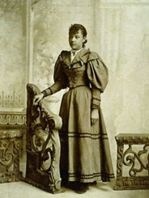
You’re welcome here kind stranger our house is very plain
But we never turn a stranger out by the Lakes of Pontchartrain

4. She took me to her mammy’s house and treated me right well
The hair upon her shoulders in jet black ringlets fell
To try to paint her beauty I’m sure ‘t would be in vain
So handsome was that Creole girl by the Lakes of Pontchartrain

5. I asked her if she’d marry me she said that ne’er could be
For she had got a lover and he was far at sea
She said that she would wait for him and true she would remain
Till he returned to his Creole girl by the Lakes of Pontchartrain

6. Farewell my pretty Creole girl I’ll ne’er see you no more
And I won’t forget your kindness in that cabin by the shore
And at each social gathering I’ll throw a glance and grin
And I’ll drink a toast to that Creole girl by the Lakes of Pontchartrain

Man of Constant Sorrow

Another Hobo song where the man is riding the railroad from town to town looking for casual work, somewhere to stay, something to eat. Nine Hundred Miles is the same kind of song with the same sort of feelings expressed.
3. It’s fare thee well my own true lover
I never expect to see you again
For I’m bound to ride this old Northern Railroad
Where I’ll die on its train

4. You can bury me in some dark valley
For many years where I may lay
Then you will learn to love another
While I am sleepin’ in my grave
1. I am a man of constant sorrow
I’ve been in trouble all my days
I’ve bid farewell to old Kentucky
The place where I was born and raised

2. It’s six long years I’ve been in trouble
No pleasures yet on earth I’ve found
But from this room I’m bound to ramble
I have no fiends to help me now

Nine Hundred Miles

1. I'm ridin that train with tears in my eyes
Tryin' to read a letter from my home
If that train runs me right
I'll be home Saturday night
I'm nine hundred miles from my home
And I hate to hear that lonesome whistle blow
And that long lonesome train awaits me now

2. Now that train I ride on is a hundred coaches long
You can hear the whistle blow a hundred miles
Well that long whistle's callin'
It's a long long way to go
I'm nine hundred miles from my home
And I hate to hear that lonesome whistle blow
And that long lonesome train awaits me now

3. I'm ridin that train with tears in my eyes
Tryin' to read a letter from my home
If that train runs me right
I'll be home Saturday night
I'm nine hundred miles from my home
And I hate to hear that lonesome whistle blow
And that long lonesome train awaits me now

Railroad Bill

Railroad Bill seems to have murdered his mother and is moving from town to town robbing and murdering. He seems to have no concern for the lives of others.

Chorus: Railroad Bill, Railroad Bill
He’s never worked and he never will
And it’s ride old Railroad Bill
3. Railroad Bill is a very bad man
Killed his momma shot her round at his dad’s
And its ride old Railroad Bill

4. Railroad Bill is a very bad man
Took all the chickens that poor farmer had
And its ride old Railroad Bill
1. Railroad Bill comin’ down the hill
Lightin cigars with a ten dollar bill
And its ride old Railroad Bill

2. Buy me a chicken you can send me the wing
They think I’m workin’ but I ain’t done a thing
And its ride old Railroad Bill

Roll Alabama Roll
5. To Cherbourg port she sailed one day,
To take her count of prize money,

6. Many a sailor lad he saw his doom,
When the Kearsarge it hove in view,

7. Till a ball from the forward pivot that day,
Shot the Alabama's stern away,

8. Off the three-mile limit in sixty-five
The Alabama went to her grave,
1. When the Alabama's keel was laid,
Roll, Alabama, roll,
'Twas laid in the yard of Jonathan Laird,
Oh, roll Alabama, roll.

2. 'Twas laid in the yard of Jonathan Laird,
'Twas laid in the town of Birkenhead,

3. Down by the Mersey ways she rolled then,
Liverpool fitted her with guns and men,

4. From the Western Isles she sailed forth,
To destroy the commerce of the North,
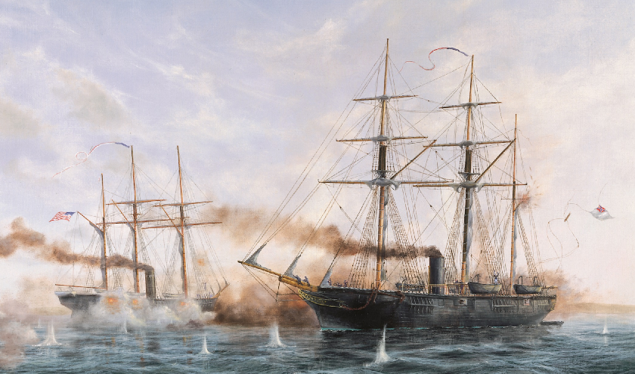

CSS Alabama was a screw sloop-of-war built in 1862 for the Confederate States Navy at Birkenhead on the River Mersey opposite Liverpool, England by John Laird Sons and Company. Alabama served as a successful commerce raider, attacking Union merchant and naval ships over the course of her two-year career, during which she never docked at a Southern port. She was sunk in June 1864 by USS Kearsarge at the Battle of Cherbourg outside the port of Cherbourg, France.
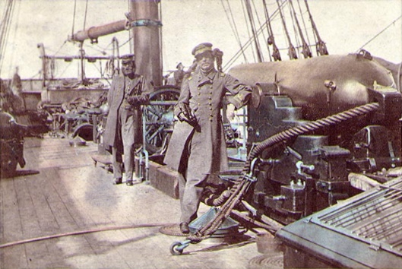

Captain Raphael Semmes, Alabama's commanding officer, standing aft of the mainsail by his ship's aft 8-inch smooth bore gun during her visit to Cape Town in August 1863. His executive officer, First Lieutenant John M. Kell, is in the background, standing by the ship's wheel

Shanendoah
Charles Deas' The Trapper and his Family (1845) depicts a voyageur and his Native American wife and children
1. Oh Shenandoah I long to hear you
Away you rollin’ river
Oh Shenandoah I long to hear you
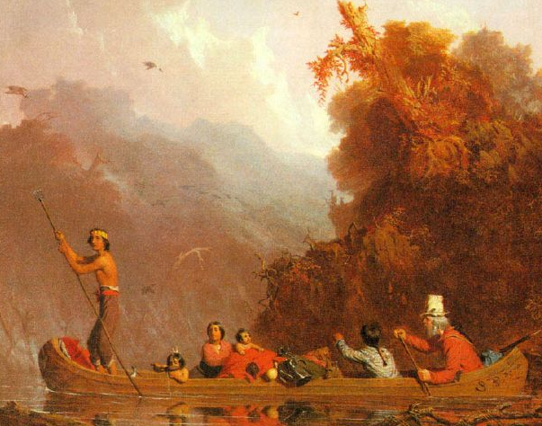
Away I’m bound to go, cross the wide Missouri

2. Oh Shenandoah I love your daughter
Away you rollin’ river
She sent me sailing ‘cross the water
Away I’m bound to go, cross the wide Missouri

3. Oh Shenandoah I took a notion
Away you rollin’ river
To sail across the briny ocean
Away I’m bound to go, cross the wide Missouri

The song appears to have originated with Canadian and American voyageurs or fur traders traveling down the Missouri River in canoes, and has developed several different sets of lyrics. Some lyrics refer to the Oneida chief Shenandoah and a canoe-going trader who wants to marry his daughter. By the mid 1800s versions of the song had become a sea shanty heard or sung by sailors in various parts of the world. The song is number 324 in the Roud Folk Song Index.

Silver Dagger

“Silver Dagger", with variants such as "Katy Dear", "Molly Dear", "The Green Fields and Meadows", "Awake, Awake, Ye Drowsy Sleepers" and others (Laws M4 & G21, Roud 2260 & 2261), is an American folk ballad, whose origins lie possibly in Britain. These songs of different titles are closely related, and two strands in particular became popular in commercial Country music and Folk music recordings of the twentieth century: the "Silver Dagger" version popularised by Joan Baez.
In "Silver Dagger", the female narrator turns away a potential suitor, as her mother has warned her to avoid the advances of men in an attempt to spare her daughter the heartbreak that she herself has endured. The 1960 recording by Joan Baez features only a fragment of the full ballad "Katy Dear" uses the same melody but different lyrics, telling a similar story from a male perspective
1. Don’t sing love songs you’ll wake my mother
She’s sleeping here right by my side
And in her right hand a silver dagger
To say that I won’t be your bride
3. Go court another handsome maiden
And hope that she will be your wife
For I have been warned and I’ve decided
To sleep alone all of my life
2. My father was a handsome devil
He had a chain five miles long
On every link a heart did dangle
Of another maid he loved and wronged

Turtle Dove

Pretty little turtle dove,
Sitting in the pines
Mourning for your own true love
Like I my dear for mine, for mine (x2)
But I’m just a poor little country boy,
Money I have none
But there is silver in the sky
And gold in the morning sun, Oh Boy (x2)

I went up to the mountain top,
To give my horn a blow
Thought I heard my little girl say
Yonder goes my beau, my beau (x2)

Now you’ve gone and left me,
Crying in the rain
Mournin’ for my own true love
That’s never going to come again, again (x2)

If she were a lazy girl, Sure as I was born
I’d take her down to New Orleans
And trade her all for corn for corn (x2)
The song Turtle Dove clearly has its origins in the UK. [ Roud 422 ; Ballad Index Wa097 , R793 ; trad.]

Around 1770, leaflets bearing the words of this song were being hawked about the fairgrounds of England and Scotland. Milkmaids and horse-handlers would paste such leaflets on the walls of dairy and stable to learn the songs as they worked. Now and then, the place would get a new coat of whitewash and a fresh layer of song sheets.

Robert Burns obtained one of the Turtle Dove leaflets (it still exists, with his name scrawled on it in a boyish hand). Years later, he remade the song into his famous lyric, My Love Is Like a Red Red Rose. Beautiful as Burns' song is, it is no better than the present version, evolved by country singers in Dorset.
VERY UNFORTUNATE MAN
(Jimmy Driftwood's reworking of an older song – highlighted parts deleted.)
There was a lawyer, his name was Clay
He had but two clients and they wouldn't pay
At last, of starvation, he grew so afraid
He courted and married a wealthy old maid.
At the wedding this lawyer made one big mistake
'Twas not in omitting the wine or the cake
The ring was well chosen, they had a big feed
But the lawyer did not get a warranty deed
He's a very unfortunate, very unfortunate,
very unfortunate man
He's a very unfortunate, very unfortunate,
very unfortunate man
At night in their chamber, this lady arose
And began to prepare to retire and repose
Her husband sat near her admiring her charms
That gave him such pleasure to hold in his arms
She went to the washstand to bathe her fair face
And thus she destroyed all her beauty and grace
The rose on her cheek quickly grew very faint
And he saw on the towel, 'twas nothing but paint
She went to the mirror to take down her hair
And when she got done, her scalp was all bare
Said she, don't be frightened to see my bald head
I'll put on my cap when I get into bed
She hung her false hair on the wall on a peg
And then she proceeded to take off her leg
Her trembling husband got quite a surprise
When she asked him to come and take out her glass eye
The husband stood watching, with trembling lips,
While she unfastened her counterfeit hips;
Just then her false nose clattered down on the floor
And the poor lawyer, screaming, ran out of the door.
Now all you young men who would marry for life,
Be sure in examine your intended wife.
Remember the lawyer who trusted his eyes
And a little while later got quite a surprise.
Unfortunate Man

Jimmy Driftwood created this version of the song. There are many songs with a similar line of content but this version is one of the best.

1. There once was a lawyer they called Mr. Clay
He had but few clients and they wouldn’t pay
At last of starvation he grew so afraid
That he courted and married a wealthy old maid

Chorus:
He’s a very unfortunate, very unfortunate,
very unfortunate man (2x)

2. Well she went to the wash stand to bathe her fair face
Thus she destroyed all her beauty and grace
The rose in her cheeks soon grew very faint
And he saw on the towel twas nothing but paint

3. She went to the mirror to take down her hair
When she had done so her scalp was all bare
She said don’t be frightened to see my bald head
I’ll put on my cap when I get into bed

4. She hung her false hair on the wall on a peg
Then she proceeded to take off a leg
The trembling husband thought he would die
When she asked him to come and take out her glass eye

5. The husband was biting his quivering lips
Whilst she was removing her counterfeit hips
Just then her false nose clattered down on the floor
And the poor lawyer screamed and ran out at the door

6. So all you young men who would marry for life
Be sure to examine your intended wife
Remember the lawyer who trusted his eyes
And a little bit later got quite a surprise

Wayfaring Stranger
I'm going there to meet my mother,
She said she'd meet me when I come;
I'm only going over Jordan,
I'm only going over home.

I want to wear a crown of glory,
When I get home to that bright land;
I want to shout Salvation's story,
In concert with that bloodwashed band.

I'm going there to meet my Saviour,
To sing His praises for evermore;
I'm only going over Jordan,
I'm only going over home

I'm just a poor wayfaring stranger,
A-traveling through this world of woe;
But there's no sickness no toil nor danger,
In that bright world to which I go.
I'm going there to see my father,
I'm going there no more to roam,
I'm just a-going over Jordan,
I'm just a-going over home

I know dark clouds will gather 'round me,
I know my way is steep and rough,
But beauteous fields lie just beyond me,
Where souls redeemed their vigil keep.

"The Wayfaring Stranger” (also known as "Poor Wayfaring Stranger” or "I Am a Poor Wayfaring Stranger"), Roud 3339, is a well-known American folk and gospel song likely originating in the early 19th century about a plaintive soul on the journey through life. As with most folk songs, many variations of the lyrics exist. Members of the Western Writers of America chose it as one of the Top 100 Western songs of all time.

When I first came to this land
[ Roud 16813 ; Ballad Index PSAFB013 ; trad.] When I First Came to This Land is an immigration song that Oscar Brand translated in 1957 from a Pennsylvania Dutch song.
When I first came to this land, I was not a wealthy man.
So I got myself a shack, I did what I could.
And I called my shack "Break my back,"
Shack … Break my back

Cow… No milk now

Wife ... run for your life

Duck ... out of luck

Son ... my work's done
But the land was sweet and good,
And I did what I could.

When I first came to this land, etc.
So I got myself a cow, etc.
Called my cow "No milk now,"
And I called my shack "Break. my back,"
But the land was sweet and good,
And I did what I could.

Who's gonna shoe your pretty little foot

This appears to be a ‘blue grass’ song – more for the melody than the lyrics. It contains elements of songs which do not seem to gel as part of a single idea. Kentucky is the ‘blue grass’ state and was the 15th state to join the Union.
2. The only train I ever did see
Was a hundred coaches long
The only boy I ever did love
Was on that train and gone
On that train and gone
On that train and gone
The only boy I ever did love
Was on that train and gone
1. Who's gonna shoe your pretty little foot
Who's gonna glove your hand
Who's gonna kiss your red rosy lips
Who's gonna be your man
I don't need no man
I don't need no man
Pa's gonna shoe my pretty little foot
I don't need no man

