British Army
The British Army in the 18th and 19th centuries was made up of a core of Scots, Welsh and Irish, some English, though fewer than would be expected, and a huge contingent of Indian troops.
Most wore the red coat though the Scots wore kilts rather than trousers. These troops used the smooth bore musket called ‘Brown Bess’ which was accurate only at very short range and was designed to be used with massed troops in volley fire. Most could fire 2 to 3 shots a minute including reloading.
There were troops in green who used rifles which were accurate at a much greater range but were much harder to reload. The barrels of rifles have spiral grooves which spin the bullet keeping it flying straight. To get the spin the bullet needs to be tight in the barrel and was normally wrapped in soft leather before being rammed into the barrel. Often they needed to use a wooden mallet to force the bullet down.
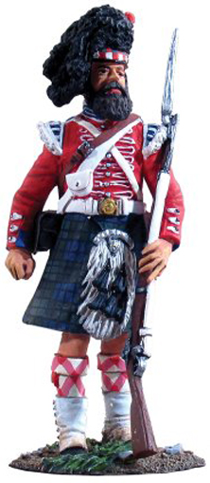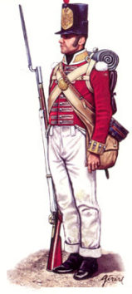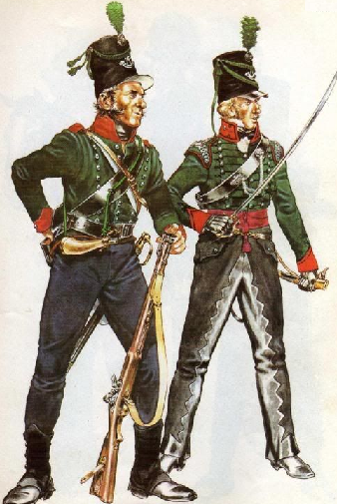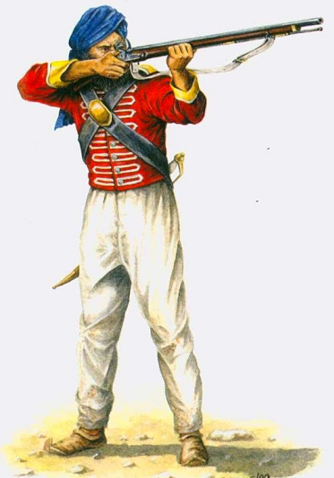
The King’s Shilling
When recruiting the army paid recruits a shilling (a larger sum later) but from this a sum was extracted for ‘necessaries’ (tea, boot black, whitening for cross belts, etc.)
Punishment could be fierce, the lash being the worst, and obviously there was no pension for those wounded and nothing at all for those killed. Infection was a greater killer than the war itself and for every one killed in battle 10 were killed from disease.
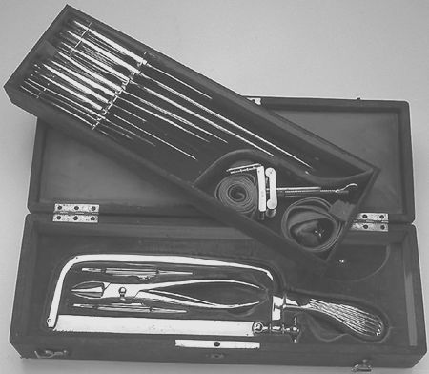
Surgery was primitive as there were no antibiotics, anaesthetics and the conditions were far from sterile. Surgery was quick, painful and often fatal. Amputations were often successful though infection often killed the patient slowly afterwards.
The conditions for officers were somewhat better though not with surgery, though they might have had cleaner conditions to recover in as officers came from the gentry and had to buy their commissions. Officers led their men in battle so a high proportion of officers died as they often became prime targets.
Songs
This song is from earlier wars – Queen Ann ruled from 1702 to 1714. The song however was used and added to throughout, which is why there are so many verses. It is a good marching song but the rest of the songs used by soldiers would be the folk tunes of the day, with modified words perhaps. Because they mixed with other nationalities there would also be a smattering of songs in other languages including Welsh, Gaelic (Scots and Irish), Spanish, Portuguese etc.

The most common subject of songs was women, love etc. Note how the gun is called ‘Brown Bess’ – female – something to love and look after.

Over the Hills and Far Away

Hark! now the Drums beat up again,
For all true Soldiers Gentlemen,
Then let us list, and march I say,
Over the Hills and far away;

Chorus: Over the Hills and o'er the Main,
To Flanders, Portugal and Spain,
Queen Ann commands, and we'll obey,
Over the Hills and far away.

All Gentlemen that have a Mind,
To serve the Queen that's good and kind;
Come list and enter into Pay,
Then o'er the Hills and far away;
Here's Forty Shillings on the Drum,
For those that Volunteers do come,
With Shirts, and Cloaths, and present Pay,
When o'er the Hills and far away;
Hear that brave Boys, and let us go,
Or else we shall be prest you know;
Then list and enter into Pay,
And o'er the Hills and far away;
The Constables they search about,
To find such brisk young Fellows out;
Then let's be Volunteers I say,
Over the Hills and far away;
Since now the French so low are brought,
And Wealth and Honour's to be got,
Who then behind wou'd sneaking stay?
When o'er the Hills and far away;
No more from sound of Drum retreat,
While Marlborough, and Gallaway beat,*
The French and Spaniards every Day,
When o'er the Hills and far away;
He that is forc'd to go and fight,
Will never get true Honour by't,
While Volunteers shall win the Day,
When o'er the Hills and far away;
What tho' our Friends our Absense mourn,
We all with Honour shall return,
And then we'll sing both Night and Day,
Over the Hills and far away;
The[n] Prentice Tom he may refuse,
To wipe his angry Master's Shoes;
For then he's free to sing and play,
Over the Hills and far away;
Over Rivers, Bogs, and Springs,
We all shall live as great as Kings,
And Plunder get both Night and Day,
When o'er the Hills and far away;
We then shall lead more happy Lives,
By getting rid of Brats and Wives,
That Scold on both Night and Day,
When o'er the Hills and far away;
Come on then Boys and you shall see,
We every one shall Captains be,
To Whore and rant as well as they,
When o'er the Hills and far away;
For if we go 'tis one to Ten,
But we return all Gentlemen,
All Gentlemen as well as they,
When o'er the Hills and far away;

High Germany

O Polly love, O Polly, the rout has now begun
And we must go a marching at the beating of the drum
Go dress yourself all in your best and come along with me
I'll take you to the war me love in High Germany
Willy love, o Willy come list' what I do say
My feet they are so tender, I cannot march away
And besides my dearest Willy I am with child by thee
Not fitted for the war me love in High Germany
I'll buy for you a horse me love And on it you shall ride
And all my life shall I be riding by your side
We'll stop at every alehouse and drink when we are dry
We'll be true to one another Get married bye and bye
O cursed be them cruel wars that ever they should rise
And out of merry England press many a man likewise
They pressed my true love from me Likewise my brothers three
And sent them to the wars me love in High Germany
My friends I do not value nor my foes I do not fear
Now my love has left me I wander far and near
And when my baby it is born and smiling on my knee
I will think of lovely Willy in High Germany
O Polly love, O Polly, the road has now begun
And we must go a marching at the beating of the drum
Go dress yourself all in your best and come along with me
I'll take you to the war me love in High Germany

As I roved Out

Some word meanings change – ‘I own I gave you’ means ‘I admit I gave you’ in verse 3.

As I roved out on a bright May morning
To view the flowers and meadows gay,
Who did I spy but my own true-lover
As she sat under yon willow tree.

I took off my hat and I did salute her,
I did salute her courageously.
But she turned around and the tears fell from her,
Saying, “False young man, you have deluded me!”

“A diamond ring I own I gave you,
A diamond ring to wear on your right hand.”
“But the vows you made, love, you went and broke them
And married the lassie that had the land.”

“If I married the lassie that had the land, my love,
It's that I'll rue until the day I die.
When this fortune falls, sure, no man can shun it;
I was blindfolded I'll ne'er deny.”

For at night when I go to my silent slumber
The thoughts of my true-love run in my mind.
When I turn around to embrace my darling,
Instead of gold, sure, it's brass I find.

But I wish the Queen would call home her armies
From the West Indies, Americay and Spain.
And every man to his wedded woman
In hopes that you and I may meet again

