The Gypsy Lover

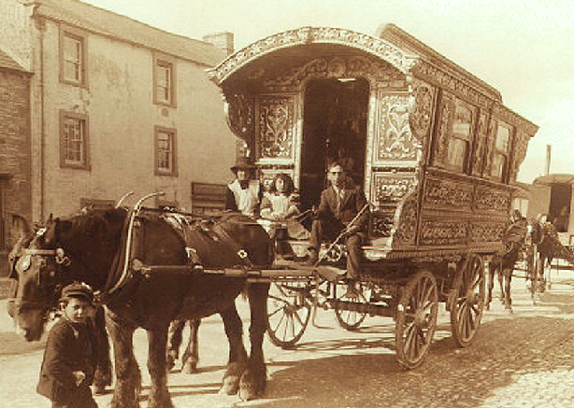
People who moved around the country doing casual work were not unusual throughout the centuries, especially when farming was one of the main occupations. From small holdings there was always a need for labour, particularly at harvest time, but there were always itinerant artisans, mending tools and machinery and peddling their own products – herbs, flowers, carved objects etc. The dark skinned gypsy was one of these and the lifestyle appealed to young women who were restrained from travelling and never met anyone else.

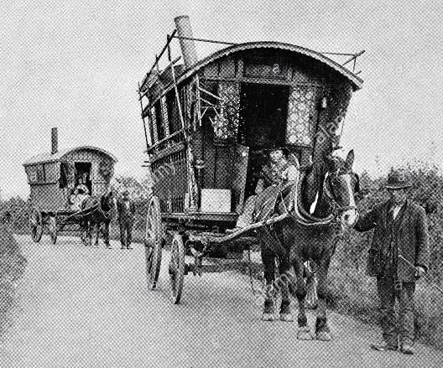
Left and above: Gypsy caravans on the road.
The lifestyle must have been appealing to a young girl working in the fields or confined to a house or even a castle with no freedom and no company other than that of other women.
The farmer’s daughter in ‘Bogie’s Bonnie Belle’ and the King’s daughter in ‘Willy o’ Winsbury’ are both ‘victims’ or are they ‘beneficiaries’?
‘Freeborn Man’ by Ewan McColl is a commentary on Gypsy life.

Bogie’s Bonnie Belle

1. As I ga’ed in by Huntley town one mornin’ for tae fae
I fell in with Bogie in Caerney and with him I did agree
Tak’ o’er his twa best horses or cart or harrow or plough
Or do anythin’ about farm work I very well could do

2. Now Bogie had a daughter her name was Isabel
She was the flower o’ the mountain and the primrose o’ the dell
And when she went out walkin’ she chose me for her guide
Down by the burn Nakerny to watch small fishes glide

3. When seven long months were past and gone this lassy lost her bloom
The red fell from her rosy cheeks and her eyes began to swoon
When nine long months were past and o’er she brought forth to me a son
And I was curtly called for to see what could be done

4. I said that I would marry her but no that would na do
For you’re no a match for ma bonny belle and she’s no a match for you
And now she’s married to a tinkler chap abides in Huntley town
He sells pots and pans and paraffin lamps and scours the country round

Freeborn Man

1. I’m a freeborn man of the travelling people
Got no fixed abode with nomads I am numbered
Country lanes and by-ways were always my ways
I never fancied being numbered
4. Sometimes we’d meet up with other people
Stay and talk a while as time was not our master
Then along we’d plod with our horse and dog
Nice and easy no need to go faster

5. Now ye freeborn men of the travellin’ people
Be ye tinker, rolling stone or gypsy rover
New ways are growing old ways are going
Your travellin’ days will soon be over

2. Oh we knew the woods and the resting places
Where small birds sang when winter time was over
Then we’d pack our loads and be on the road
These were good old times for the rover

3. Oh we kent life hard and we kent life easy
And kent the life when winter time was drawing
At the summer fair we'd be meeting there
Till the summer sun sets in the morning

Willy o’ Winsbury

1. The king has been a prisoner and a prisoner long in Spain
And Willy o’ the Winsbury has laid long with his daughter at home

2. What ails thee, what ails thee my daughter Janet you look so pale and wan
Oh have you had any sore sickness or yet been sleeping with a man

3. I have not had any sore sickness nor yet been sleeping with a man
It is for you my father dear for biding so long in Spain

4. Cast off cast off your berry brown gown you stand naked upon the stone
That I may know you by your shape whether you be a maiden or no

5. And she’s cast off her berry brown gown she’s stood naked upon the stone
Her apron hung low and her haunches were round her face was pale and wan

6. Was it with a lord or a duke or a knight or a man of birth and fame
Or was it with one of my serving men that’s lately come out of Spain

7. It wasn’t with a lord or a duke or a knight or a man of birth and fame
It was with Willy o’ Winsbury I could bide no longer alone

8. And the king’s called in his merry men all by thirty and by three
Fetch me this Willy o’ Winsbury for hanged he shall be

9. And when he came the king before he was clad all in the red silk
His hair was like the strands of gold and his skin was as white as milk

10. It is no wonder said the king that my daughter’s love you did win
If I were a woman as I am a man my bedfellow you would have been

11. And will you marry my daughter Janet by the truth of your right hand
Oh will you marry my daughter Janet I’ll make you the lord of my lands

12. Oh I will marry your daughter Janet by the truth of my right hand
Oh I will marry your daughter Janet but I’ll not be the lord of your lands

13. He’s mounted her on a milk white steed and himself on a dappled grey
And he’s made her the lady of as much land as she’ll ride on a long summer’s day

Love – Girls
It is the girls here who lament their lost love.
Seeds of Love

1. Oh I sowed the seeds of love
It was in all the spring
In April, May or sunny June
When small birds they do sing

2. Oh the willow tree will twist
And the willow tree will twine
And would I were in a young man’s arms
That ever had this heart of mine

3. The gardener as he passed by
He bid me take great care
For if I gathered the rose so red
There groweth a sharp thorn there

4. I said I’d take no care
Till I did feel the smart
And still did press the rose so dear
Till the thorn did pierce my heart

5. My garden is now run wild
When I must plant anew
And the beds that once were full of thyme
Are all o’er run with rue

Bobby Shafto

1. Bobby Shafto’s gone to sea
Silver buckles on his knee
He’ll come back and marry me
Bonny Bobby Shafto

2. Bobby Shafto’s bright and fair
Combing down his yellow hair
He’s my ain for ever mair
Bonny Bobby Shafto

3. Bobby Shafto’s tall and slim
Always dressed so neat and trim
Lassies they all keek at him
Bonny Bobby Shafto

Come all ye fair and tender girls

1. Come all ye fair and tender girls
Who flourish in your prime, prime
Beware, beware keep your gardens fair
Let no man steal your thyme, thyme
Let no man steal your thyme

2. And when your thyme is past and gone
He’ll care no more for you, you
And every place where your thyme was waste
Early One Morning

1. Early one morning just as the sun was rising
I heard a maiden sing in the valley below
Oh don’t deceive me
Oh never leave me
How could you use such a poor maiden so

2. Gay is the garland and fresh are the roses
I’ve culled from the garden to bind on your brow
Oh don’t deceive me
Oh never leave me
How could you use such a poor maiden so

3. Thus sang the maiden her sorrows thus bewailing
Thus sang the poor maiden in the valley below
Oh don’t deceive me
Oh never leave me
How could you use such a poor maiden so

Will all spread all way through, through
Will all spread all way through

3. A gardener’s son was passing by
Three flowers he gave to me, me
The pink the blue and the violet true
And the red, red rosy tree, tree
And the red, red rosy tree,

4. But I refused the red rose bush
And gained the willow tree, tree
So all the world could plainly see
How my love slighted me, me
How my love slighted me

Love is likened to the garden – the Rose represents love, the Thorn a pain of lost love. The garden represents life and the family, love and lost love.
The gardener is the person who controls and tends the garden – a God figure, nature.

Tam Lin - Child Ballad number 39

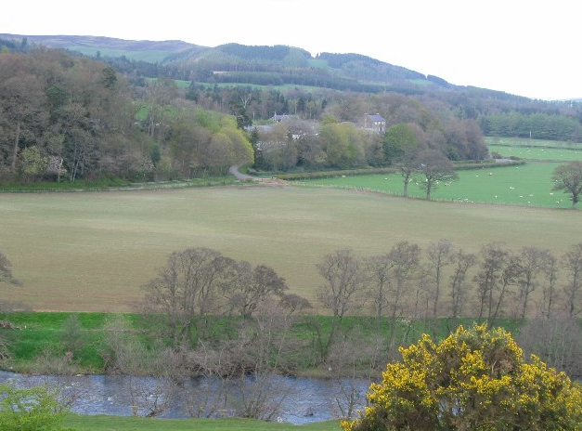
Left: Carterhaugh - near the confluence of the Yarrow Water and the Ettrick Water on the Scottish Border.
There is a warning that Tam Lin collects the virginity of any maiden who passes through the forest of Carterhaugh. The young woman, usually called Janet or Margaret, goes to Carterhaugh and plucks a double rose, Tam appears and asks her why she has come without his leave and taken what is his. She says that she owns Carterhaugh as her father has given it to her.
Janet goes home and discovers that she is pregnant; She declares that her baby's father is an elf whom she will not forsake. When she returns to Carterhaugh Tam reappears and challenges her.
She asks him whether he was ever human, He reveals that he was a mortal man, who, falling from his horse, was caught and captured by the Queen of Fairies. Every seven years, the fairies give one of their people as a tithe to Hell and Tam fears he will become the tithe that night, which is Hallowe'en. He is to ride as part of a company of elven knights. Janet will recognise him by the white horse upon which he rides. He instructs her to rescue him by pulling him down from the white horse - so Janet "catches" him this time - and holding him tightly. He warns her that the fairies will attempt to make her drop him by turning him into all manner of beasts, but that he will do her no harm. When he is finally turned into a burning coal, she is to throw him into a well, whereupon he will reappear as a naked man, and she must hide him. (in this version he is just turned into a naked knight) Janet does as she is asked and wins her knight. The Queen of Fairies is angry but acknowledges defeat.
I forbid you maidens all that wear gold in your hair
To travel to Carter Haugh, for young Tam Lin is there.
Them that go by Carter Haugh, but they leave him a pledge
Either their mantels of green or else their maidenhead.
Janet tied her kirtle green a bit above her knee
And she's gone to Carter Haugh as fast as go can she.
She doth pull the double rose, a rose but only two
And up then came young Tam Lin, says lady pull no more.
And why come you to Carter Haugh without command from me
I'll come and go, young Janet said, and ask no leave of thee.
Janet tied her kirtle green a little bit above her knee
And she's gone to her father as fast as go can she.
Then up spoke her father dear, and he spoke meek and mild
Well alas Janet, he said, I think you go with child.
Well if that be so, Janet said, myself shall bear the blame
There's not a knight in all your halls shall get the baby's name.

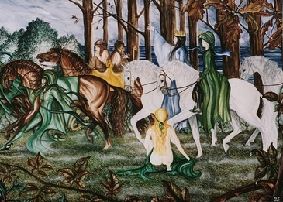
For if my love were an earthly knight, as he is an elfin grey
I'll not change my own true love for any knight you have.
Janet tied her kirtle green a bit above her knee
And she's gone to Carter Haugh as fast as go can she.
Oh tell to me Tam Lin she said, why came you here to dwell
The Queen of Fairy's caught me when from my horse I fell.
And at the end of seven years she pays a tithe to hell
I so fair and full of flesh am feared it is myself.
But tonight is Halloween and the fairy court rides
Those that would let true love win, At Miles' Cross they must hide.
First let pass the horses black and let pass the brown
Quickly run to the white steed and pull the rider down.
For I ride on the white steed, the nearest to the town
For I was an earthly knight, they give me that renown.
They will turn me in your arms to a newt or a snake
Hold me tight and fear not, I am your baby's father.

And they will turn me in your arms into a lion bold
Hold me tight and fear not and you will love your child.
And they will turn me in your arms into a naked knight
Cloak me in your mantle and keep me out of sight.
And in the middle of the night she heard the bridle ring
She heeded what he did say and young Tam Lin did win.
Then up spoke the fairy queen, an angry queen was she
Who betide her ill-farr'd face, an ill death may she die.
Oh had I known Tam Lin, she said, what this night I did see
I'd have looked him in the eye and turned him to a tree.

Trees they do grow high
Marriage took place as soon as a woman was of child bearing age. Life was hard and people didn’t live long lives. Forty years would have been old. Families were large and death in child-birth very common. This song comes from Scotland though there are versions from throughout Britain.

1. Oh the trees they do grow high and the leaves they do grow green
And there’s many the cold winter night my love and I have seen
On a cold winter’s night my love while I alone have been
And my bonnie lad is young but he’s growing, growing, growing
And my bonnie lad is young but he’s growing

2. At the age of fifteen he was a married man
At the age of seventeen the father of a son
And at the age of eighteen the grass grew o’er him
And that put an end to his growing, growing, growing
And that put an end to his growing

3. But now my love is dead and in his grave does lie
The green grass grows all o’er him so very very high
I’ll just sit here and mourn his death until the day I die
And I’ll watch all o’er his child as he’s growing, growing, growing
And I’ll watch all o’er his child as he’s growing

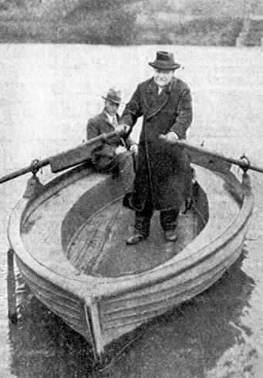
Water of Tyne

I cannot get to my love, if I would dee,
The water of Tyne runs between him and me;
And here I must stand with a tear in my e'e,
Both sighing and sickly my sweetheart to see.
O where is the boatman? my bonny hinny!
O where is the boatman? bring him to me,—
To ferry me over the Tyne to my honey,
And I will remember the boatman and thee.
O bring me a boatman, I'll give any money,
And you for your trouble rewarded shall be,—
To ferry me over the Tyne to my honey,
Or scull him across that rough river to me.
Boatman

Hinny – some say a corruption of ‘honey’ but it is applied to both sexes and all ages. It is used in the family as a familiar form. I cannot get to my love, if I would dee, Means …I cannot get to my love for the life of me, or I cannot get to my love however hard I try

Love - Boys
It is the boy here who laments his lost love

Country Boy
3. I’m gonna buy us our own farm
When I’ve put by some money
We’ll put bees in sacks of corn
And they’ll make us bread and honey
We’ll have oats in all the fields
And a big ost house to dry ‘em
We’ll brew the best ale in the land
A country boy like I am

4. Now Mary her wants family
And I will not oppose it
She's got one of 'em on the way
And I don't think that she knows it
We'll get married in a church
Before its lambing time
And settle down to raise some girls
And country boys like I am

1. Now do I be a fair young country boy
My father came from Fareham
He had another six just like I
By Christ how he could rare 'em
Now do my mum makes dumplings nice
I'd bet you'd like to try 'em
I've never found me a better one
A country boy like I am

Chorus:
I can plough and milk a cow,
I can reap and sow
I'm fresh as a daisy which grows in the fields
And they calls I Buttercup Joe

2. Now there's a pretty girl that I love
They calls her our Mary
Her works busy as a bumble bee
Down in old Jones's dairy
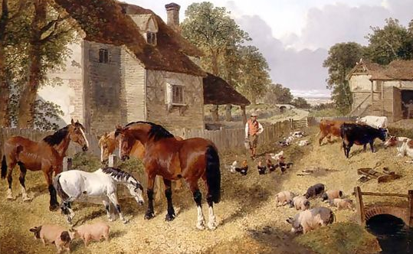
Now her can cook and her can sew
And use a smoothing iron
I'm gonna take for a wife
A country boy like I am

Crazy Man Michael

Michael is deceived by a vision into stabbing his lover.
He took out his dagger of fire and of steel,
And struck down the raven through the heart-o.
The bird fluttered long and the sky it did spin,
And the cold earth did wonder and start-o.
“Oh, where is the raven that I struck down dead,
That here did lie on the ground-o?
I see but my true love with a wound so red,
Where her lover's heart it did pound-o.'‘

Crazy Man Michael, he wanders alone,
And he talks to the night and the day-o.
But his eyes they are sane and his voice it is clear
And he longs to be far away-o.
Michael he whistles the simplest of tunes,
And begs of the wild wolves their pardon.
For his love is flown and to every flower grown,
And Michael must be keeper of the garden.

Within the forest and out upon the sea,
Crazy Man Michael was walking.
He met with a raven with eyes black as coals,
And presently they were a-talking
“Your future, your future, I will tell to you.
Your future, you often have asked me.
Your true love will die by your own right hand.
And Crazy Man Michael will cursed be.'‘

Michael he ranted and Michael he raved,
And beat at the four winds with his fists-o.
He laughed and he cried, he shouted and he swore,
For his mad mind had trapped him with a kiss-o.
“You speak with an evil, you speak with a hate,
You speak for the devil that haunts me
For is she not the fairest in all these broad lands,
Your sorcerer's words are to taunt me.''

Farewell She

1. Oh fare thee well cold winter and fare thee well cold frost
Nothing have I gained and my own true love I’ve lost
I’ll rest when I am weary I’ll drink when I’m dry
But before I’d humble to my love I’d lay me down and die

2. Last night I met my true love in yonder shady grove
I met her with a smile and she gave to me a blush
I said that I would wait for her as she did pass me by
But before I’d humble to my love I’d lay me down and die

3. Take half a pound of reason and a quarter pound of sense
A small pinch of time and so much of prudence
Put them all together and you will plainly see
She’s a cold deluded lover let her go, farewell she

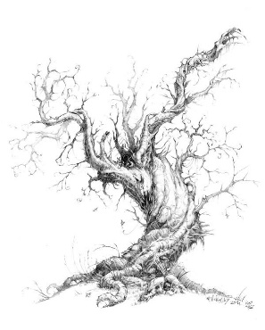
Lark in the Clear Air

A beautiful song with self-explanatory lyrics. This version catches the feelings of the young man as he awaits the return of his true love.
I shall tell her all my love,
All my soul's adoration,
And I think she will hear
And will not say me nay.
It is this that gives my soul
All its joyous elation,
As I hear the sweet lark sing
In the clear air of the day.

Dear thoughts are in my mind
And my soul soars enchanted,
As I hear the sweet lark sing
In the clear air of the day.
For a tender beaming smile
To my hope has been granted,
And tomorrow she shall hear
All my fond heart would say.

Love Farewell
If I should fall in far off battle
Cannons roar and rifles rattle
Thoughts fly homeward - words unspoken
Valiant hearts are oftimes broken
Love Farewell
Oh Judy should I die in glory
In the Times* you'll read my story
But I'm so bothered by your charms dear
I'd rather die within your arms dear
Love Farewell
I thought I heard the Colonel crying
March brave boys there's no denying
Cannons roaring - drums abeating
March brave boys there's no retreating
Love Farewell
Chorus
Will you go or will you tarry
Will you wait or will you marry
Would this moment last for ever
Kiss me now and leave me never
Love Farewell
*The Newspaper established 1785 – called the ‘Times’ from 1798

Salley Gardens

The Salley gardens are gardens planted near a ‘salley port’ or a door from which an attack can be made on a besieging army
In a field by the river
My love and I did stand
And on my leaning shoulder
She laid her snow-white hand.
She bid me take life easy,
As the grass grows on the weirs;
But I was young and foolish
And now am full of tears.
Down by the salley gardens
My love and I did meet;
She passed the salley gardens
With little snow-white feet.
She bid me take love easy,
As the leaves grow on the tree;
But I, being young and foolish
with her did not agree.
Sally Wheatley

A song sung in a ‘Geordie’ accent – from Newcastle upon Tyne in the North East of England.
Chorus:
Oh dear me, Ah divent naa what to dae
Sally's stolen my heart away completely,
An’ Ah'll niver get it back
for she gans wi' Mr. Black
An’ they say he's gan ter marry Sally Wheatley.

Noo Ah'm myest distressed and sad
Tho' Ah once'st was blithe and glad
And cud trip aboot tha toon both trim and neatly
Ah was happy neet and morn but aall soch joys Ah‘m shawn
Since Ah fell sae deep in love wi' Sally Wheatley.

Hoo Ah felt Ah divent naa, the forst time I Sally saa,
In a threesome reel she hopped aboot sae sweetly,
An’ Ah might a stood a chance had Ah asked hor up to dance
But Ah was ower shy ta speak to Sally Wheatley.
Oh dear me......

Noo as often is the case ye'll find someone in yer place
If you fail ta shove ahead and fettle reetly,
For Ah'd scarcely torned me back why an’ there was Mr. Black-
An’ ‘e wuz jiggin' roon’ tha room wi' Sally Wheatly.
Oh dear me......

And he must hev got it reet when he set hor hyem that neet
After work dressed up he gans ta see hor neetly
An’ there's great deanger in deleay and A'd not be sad todeay
If Ah had a hort Ah'd break't for Sally Wheatley
Oh dear me.....

When a man’s in love

1. When a man's in love he feels no cold like a man no long ago
Like a hero bold to see his love he ploughed through frost and snow
The moon it gently shed its light along my weary way
Until I came to that fond spot where all my treasures lay
The simple story of a young man trying to persuade his true love to run away with him.
She is concerned that her parents will not approve but he eventually gets his girl.
2. I came to my love's window saying "My love, are you within?"
Slyly she undid the latch and slyly I crept in
Her hand was soft her breath was sweet her tongue did gently glide
I gave a kiss and nought amiss I asked her to be my bride

3. Take me to your chamber love oh take me to your bed
Take me to your chamber love where I might lay my head
To take you to my chamber love my parents would not agree
So sit you down by yonder fire and I'll sit down by thee

4. Many's the cold and stormy night I came to visit you
Lashed about by cold winter winds and wettened by the morning dew
Tonight our courtship's at an end between my love and me
Fare thee well my favourite girl alas fare well to thee

5. Many's the night I've courted you against your father's will
You never said you'd marry me so now my love be still
Tonight I'm going across the sea to far Columbia's shore
And never, never will I see my own true love evermore

6. Are you going to leave me now whatever will I do
I'll break every bond of love to come along with you
Perhaps my parents they'll forget and maybe they'll forgive
For now I am resolved my love to come with you and live

Wind that shakes the barley
I bore her to some mountain stream
And many's the summer blossom
I placed with branches soft and green
About her gore-stained bosom
I wept and kissed her clay-cold corpse
Then rushed o'er vale and valley
My vengeance on the foe to wreak
While soft winds shook the barley

But blood for blood without remorse
I've taken at Oulart Hollow
And laid my true love's clay-cold corpse
Where I full soon may follow
As 'round her grave I wander drear
Noon, night and morning early
With breaking heart when e'er I hear
The wind that shakes the barley

An Irish song set at a time of conflict with the English. This relates to the rising of the ‘United Irishmen’ (verse 2 United Men) from 1798 to 1804 (during the war with Napoleon)
I sat within a valley green
I sat me with my true love
My sad heart strove to choose between
The old love and the new love
The old for her, the new that made
Me think on Ireland dearly
While soft the wind blew down the glade
And shook the golden barley

Twas hard the woeful words to frame
To break the ties that bound us
But harder still to bear the shame
Of foreign chains around us
And so I said, "The mountain glen
I'll seek at morning early
And join the bold United Men
While soft winds shake the barley“

While sad I kissed away her tears
My fond arms 'round her flinging
The foeman's shot burst on our ears
From out the wildwood ringing
A bullet pierced my true love's side
In life's young spring so early
And on my breast in blood she died
While soft winds shook the barley
Traditional
The songs in this section I call traditional as they have elements which we know folk songs to possess. They are songs which will generally be found in many versions from many parts of Britain and even wider. Many such songs have found their way into the folk music of America and Australasia.
Good King Arthur’s Days

Versions of this old nursery song are seen from Scotland to Sussex. It's hard to say how old it is, but it seems to have first appeared in print in ‘Gammer Gurton's Garland’ at the end of the eighteenth century, though it had been around long before then. This particular version of it comes from Northumberland. [ Roud 130 ; G/D 3:704 ; Ballad Index R112 ; trad.]

1. In good King Arthur’s days, He was a goodly king
Three sons out of four he drove from the door, Because they would not sing
Because they would not sing, because they would not sing
Three sons out of four he drove from the door
Because they would not sing

2. The first he was a miller, The second he was a weaver
The third he was a little tailor, With a broad cloth under his arm
With a broad cloth under his arm, with a broad cloth under his arm
The third he was a little tailor
With a broad cloth under his arm

3. Well the miller was drowned in his dam, The weaver was hung in his yarn
And the devil ran away with the little tailor, With a broad cloth under his arm
With a broad cloth under his arm, with a broad cloth under his arm
And the devil ran away with the little tailor
With a broad cloth under his arm

Greensleeves

A broadside ballad by this name was registered at the London Stationer's Company in September 1580 by Richard Jones, as "A Newe Northen Dittye of ye Ladye Greene Sleves". Six more ballads followed in less than a year, one on the same day, 3 September 1580 ("Ye Ladie Greene Sleeves answere to Donkyn hir frende" by Edward White), then on 15 and 18 September (by Henry Carr and again by White), 14 December (Richard Jones again), 13 February 1581 (Wiliam Elderton), and August 1581 (White's third contribution, "Greene Sleeves is worne awaie, Yellow Sleeves Comme to decaie, Blacke Sleeves I holde in despite, But White Sleeves is my delighte"). It then appears in the surviving A Handful of Pleasant Delights (1584) as A New Courtly Sonnet of the Lady Green Sleeves. To the ‘new’ tune of Green Sleeves.

Alas my love you do me wrong
Alas my love that you should own
A heart of wanton vanity
So must I meditate alone
Upon your insincerity

Ah Greensleeves now farewell, adieu
To god I pray to prosper thee
For I am still thy lover true
Come once again and love me

To cast me out so discourteously
For I have loved you oh so long
Delighting in your company

Chorus:
Greensleeves was all my joy
Greensleeves was my delight
Greensleeves was my heart of gold
Oh but my lady Greensleeves

If you intend thus to disdain
It doth the more enrapture me
And even so I still remain
A lover in captivity
Hal an Tow [ Roud 1520 ; Ballad Index K092 ; trad.]

The green calendar of spring has many songs. dances and shows, particularly around the opening days of May. Here and there are clear traces of old cults and superstitions (well-dressing against droughts, etc.) but generally their original meaning is lost. So the customs are transformed into ritual spectacles, festivities, distractions, opportunities for a good time, such as the old May Games that once comprised four sections: the election and procession of the May king and queen: a sword or Morris dance of disguised men; a hobby horse dance; a Robin Hood play. The Hal-an-Tow song was sung for the procession that ushered in the summer. A variant of it still accompanies the Helston Furry Dance on May 8th.

The Roud Folk Song Index is a database of more than 240,000 references to nearly 25,000 songs that collected from oral tradition in the English language from all over the world.

Take no scorn to wear the horn
What happened to the Spaniards
Who made so great a boast o
It's they shall eat the feathered goose
And we shall eat the roast o

And as for that good knight, St. George
St. George he was a knight o
Of all the knights of Christendom
St. George is the right o

God bless Aunt Mary Moses
In all her power and might o
May she send peace to England
Send peace by day and night o

It was the crest when you were born
Your father's father wore it
And your father wore it to
Chorus:
Hal an tow, jolly rumbalo
We were up
long before the day o
To welcome in the summer
To welcome in the may o
For summer is a comin in
And winter's gone away o

Robin Hood and Little John
Have both gone to the fair o
and we will to the merry green wood
To hunt the buck and hare o

Lovely Joan - (Roud #592)
Come give that ring into my hand
And I will neither stay nor stand
For your ring is worth much more to me
Than twenty maidenheads, said she

And as he made for the pooks of hay
She leapt on his horse and she tore away
He called, he called, but he called in vain
For Joan, she ne'er looked back again

Nor did she think herself quite safe
Until she came to her true love's gate
She'd robbed him of his horse and ring
And she'd left him to rage in the meadows green

I love this song – there’s no real moral, it just shows that a lady can get her own back!
A fine young man it was indeed
Mounted on his milk-white steed
He rode, he rode and he rode all alone
Until he came to lovely Joan

Good morning to you, my pretty maid
And twice good morning, sir, she said
He tipped her the wink and she rolled a dark eye
Says he to himself, I'll be there by and by
Oh don't you think these pooks of hay
A pretty place for us to play
So come with me, my sweet young thing
And I'll give to you my golden ring

So he took off his ring of gold
Says, My pretty fair miss, do this behold
Freely I'll give it for your maidenhead
And her cheeks they blushed like the roses red

Ralph Vaughan Williams, the well known English composer uses ‘Lovely Joan’ in his fantasy ‘The Lark Ascending’. Included in this are many tunes from Norfolk and also ‘Greensleeves’.

Oh No John - (Roud 146)

Alternative titles include "No, Sir", "No, John, No", "No Sir No", "Yes Or No", "Cruel Father", "Ripest Apples", "Twenty Eighteen", "The Spanish Merchant's Daughter", "The Spanish Captain", "Spanish Lady", "Yonder Sits a Spanish Lady", "Yonder Sits a Pretty Creature", and "In Yonder Grove"
Madam in your face is beauty,
In your bosom flowers grow
In your bedroom there is pleasure,
Shall I view it, yes or no
Oh no John, No John, No John, No!

Madam shall I tie your garter,
Tie it a little above your knee
If my hand should slip a little farther,
Would you think it amiss of me
Oh no John, No John, No John, No!

My love and I went to bed together,
There we lay till cocks did crow;
Unclose your arms my dearest jewel,
Unclose your arms and let me go
Oh no John, No John, No John, No!

On yonder hill there stands a creature,
Who she is I do not know
I will court her for her beauty,
She must answer yes or no
Oh no John, No John, No John, No!

On her bosom are bunches of posies,
On her breast where flowers grow
If I should chance to touch that posy,
She must answer yes or no
Oh no John, No John, No John, No!

Madam I am come for to court you,
If your favour I can gain
If you will but entertain me,
Perhaps then I might come again
Oh no John, No John, No John, No!

My husband was a Spanish captain,
Went to sea a month ago
The very last time we kissed and parted,
Bid me always answer no.
Oh no John, No John, No John, No!

Skye Boat Song

The song tells how Bonnie Prince Charlie, disguised as a serving maid, escaped in a small boat after the defeat of his Jacobite rising of 1745, with the aid of Flora MacDonald. The song is a traditional expression of Jacobitism and its story has also entered Scotland as a national legend.

The song was first published in Songs of the North by Boulton and MacLeod, London, 1884, The lyrics to the song were written by Boulton.

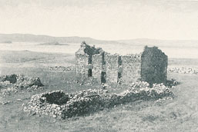
Chorus:
Speed bonny boat like a bird on the wing
Onward the sailors cry
Carry the lad that’s born to be king
Over the sea to Skye

1. Loud the wind howls, loud the waves roar
Thunderclaps rend the air
Battlers of war, stand on the shore
Follow they will not dare

2. Many’s the lad fought on that day
Well the claymore did weald
The house on the Isle of Skye, North Western Scotland, where Flora MacDonald died.
When the night came silently lay
Dead on Culloden’s field

3. Though the waves leap soft shall ye sleep
Oceans a royal bed
Rocked in the deep, Flora will keep
Watch by your weary head
Waly Waly
"The Water Is Wide" (also called "O Waly, Waly" or simply "Waly, Waly") is a folk song of Scottish origin, based on lyrics that partly date to the 1600s.] It remains popular in the 21st century. Cecil Sharp published the song in Folk Songs From Somerset (1906). It is related to Child Ballad 204 (Roud number 87), Jamie Douglas, which in turn refers to the ostensibly unhappy first marriage of James Douglas, 2nd Marquis of Douglas to Lady Barbara Erskine.
The water is wide, I can't cross over
and neither I have wings to fly
give me a boat that can carry two
and both shall row - my love and I
Now love is gentle, and love is kind
the sweetest flower when first it's new
but love grows old, and waxes cold
and fades away like morning dew
I laid my back against an oak
Thinking it was a trusty tree
But first it bended then it broke
And thus did my true love to me

There is a ship, she sails the sea
she's loaded deep as deep can be
but not as deep as the love I'm in
I know not how I sink or swim
Widdicombe Fair
"Widecombe Fair", also called Tom Pearce (sometimes spelt "Tam Pierce"), is a well-known Devon folk song about a man called Tom Pearce, whose horse dies after someone borrows it to travel to the fair in Widecombe with his friends. Its chorus ends with a long list of the people travelling to the fair: "Bill Brewer, Jan Stewer, Peter Gurney, Peter Davy, Dan'l Whiddon, Harry Hawke, Old Uncle Tom Cobley and all." Some research suggests that the names originally referred to real people. As the last name in a long list, "Uncle Tom Cobley" has come to be used as a humorous colloquialism meaning "anyone and everyone". The surname is spelt as "Cobleigh" in some references.

1. Tom Pearce, Tom Pearce lend me your grey mare
All along down along out along lee
I want for to go to Widdicombe Fair
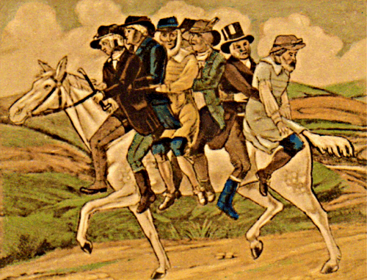
2. And when will I see again my grey mare
All along down along out along lee
By Friday soon or Saturday noon

3. Then Friday came and Saturday noon
All along down along out along lee
But Tom Pearce’s old mare hath not trotted home

4. So Tom Pearce he got up to the top o’ the hill
All along down along out along lee
And he seed his old mare down a makin’ her will

5. So Tom Pearce’s old mare she took sick and died
All along down along out along lee
And Tom he sat down on a stone and he cried

6. But this isn’t the end of this shocking affair
All along down along out along lee
Nor, though they be dead of the horrid career

7. When the wind whistles chill on the moor of a night
All along down along out along lee
Tom Pearce’s old mare doth appear ghostly white

8. And all the long night be heard skirling and groans
All along down along out along lee
From Tom Pearce’s old mare in her rattling bones
Yorkshire

On Ilkley Moor ba’t’at

The first published version of the words appeared in 1916, when it was described as "a dialect song which, for at least two generations past, has been sung in all parts of the West Riding of Yorkshire". Arnold Kellett calculates that the song "could well have originated in the early years of the second half of the [19th] century, and not as late as 1877 ...".
In The Yorkshire Dictionary (Arnold Kellett, 2002) it was said the song (i.e., the lyrics) probably originated from the Halifax area, based on the dialect which is not common to all areas of Yorkshire.

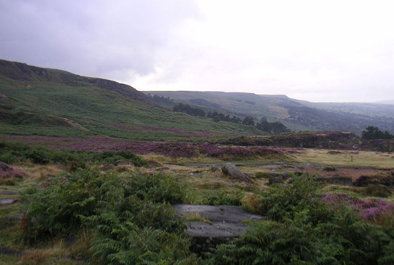
- Where hast thou been since I saw thee
On Ilkley moor ba’t ‘at
Where hast thou been since I saw thee (x2)
Chorus:
On Ilkley moor ba’t ‘at (x3)

- Tha’s been a courtin Mary Jane
- Tha’s gonna catch thee death o’ cold
- Then we shall have to bury thee
- Then t’worms s’ll come an’ eat thee up
- Then ducks’ll come an’ eat up t’worms
- Then we shall come an’ eat up ducks
- Then we shall all have eat’n thee
- That ‘ow we’ll get us ow’en back

Ducks on Ilkley Moor

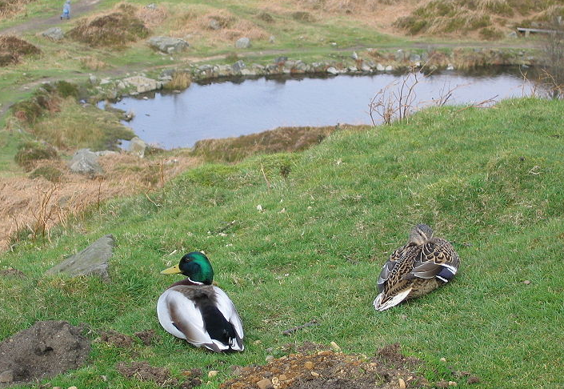

Scarborough Fair

I call this an ‘unlove’ song as his ‘lover’ is asked to do things which are clearly impossible. In fact he’s saying that he wouldn’t marry her if she were the last person on the planet!

Chorus:
Are you going to Scarborough Fair, Parsley, sage, rosemary and thyme
Remember me to one who lives there, For she once was a true love of mine

Tell her to make me a cambrick shirt
Without any seams or needlework

Tell her to wash it in yonder dry well
Where water ne’er sprung nor drop of rain fell

Tell her to dry it on yonder thorn
Which never saw blossom since Adam was born

Tell her to buy me an acre of land:
Between the salt water and the sea strand

Tell her to plough it with a long thorn
And to sow it all over with one peppercorn

Tell her to reap it with a sickle of leather
And tie it all up with one peacock’s feather

Liverpool

Seth Davy - "Whiskey on a Sunday".

Seth Davy, sometimes spelled Seth Davey, was a black street entertainer who worked in Liverpool at the turn of the 20th century, and was immortalised in the folk song "Whiskey on a Sunday". .Little is known of Davy outside of the lyrics of the song, which themselves have been varied over the years, with his location sometimes even changed to Dublin (Beggar's Bush) or London (Shepherd's Bush) from the original Bevington Bush in Liverpool.

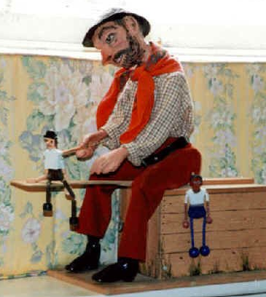
1. He sat on the corner of Bevington Bush
Astride of an old packing case
And the dolls on the end of his plank went on dancing
As he crooned with a smile on his face
Chorus:
Come day go day, Wished in my heart for Sunday
Drinking buttermilk all the week, Whisky on a Sunday

2. His tired old hands tapped the wooden beam
His dolls they danced the gear
A far better show than you ever would see
At the Pivvy or on New Brighton Pier

3. Then in 1908 old Seth Davy died
His song was heard no more
And the three dancing dolls in the jowler bin ended
And the plank went to mend the back door
A very clever marionette which operates a ‘jig doll’ (the dancing dolls in the song).

4. On one stormy night down Scotty Road way
With the wind coming in from the sea
You can still hear the sound of old Seth Davy
As he croons to his dancing dolls three
Other Songs
This is a general section where all of the songs are selected as suitable pub songs.

All for me grog
… is a traditional folk song that was originally popular with sailors and later adopted by folk music performers and pub singers.^{[1]} It tells the tale of a man who sells all his possessions, and even his wife, to pay for drink and tobacco. Although the song is effectively about a man's ruin through drink, it is upbeat and celebratory rather than regretful. It is usually performed as a raucous chorus song. Grog originally referred to a daily ration of rum that used to be given to sailors in the Royal Navy. It later came to refer to all types of drink.
(*) = clap

Well it's all for me grog, me jolly jolly grog
It's all for me beer and tobacco
For I spent all me tin with the lassies drinking gin
Far across the western ocean I must wander

Where are me boots, me noggin', noggin' boots?
They're all gone for beer and tobacco
For the heels they are worn out and the toes are kicked about
And the soles are looking out for better weather

Where is me shirt, my noggin', noggin' shirt?
It's all gone for beer and tobacco
For the collar is all worn, and the sleeves they are all torn
And the tail is looking out for better weather

I'm sick in the head and I haven't been to bed
Since first I came ashore with me slumber
For I spent all me dough on the lassies movin' slow
Far across the Western Ocean I must wander

Where is me bed, me noggin' noggin bed
It's all gone for beer and tobacco
Well I lent it to a whore and now the sheets are all tore
And the springs are looking out for better weather.

Where is me wench, me noggin' noggin' wench
She's all gone for beer and tobacco
Well her (*) is all worn out and her (*) is knocked about
And her (*) is looking out for better whether

The Beggar
3. Sometimes we call at a nobleman’s hall
To beg for ale and beer
Sometimes we are lame sometimes we are blind
Sometimes too deaf to hear

4. Sometimes we lie like hogs in a sty
With a flock of straw on the ground
Sometimes eat a crust which has rolled in the dust
And be thankful that it may be found

A traditional song but seemingly of little recorded history – and not very well known.

1. I’d just as soon be a beggar or a king
The reason I’ll tell you for why
A king can’t swagger nor drink like a beggar
Nor be half so happy as I
Chorus:
Let the back and the sides go bare my boys
Let my hands and feet go cold
But give unto the belly boys beer enough
Whether it be new or old

2. I’ve a sixpence in my pocket and I’ve worked hard for it, Kind landlord here it is
Neither Jew nor Turk will make me work
While beggin’ is as good as it is
The Cutty Wren

The wren is known as the King of the Birds, because there is a fable in which a competition takes place to decide which bird is supreme. It is decided that he that flies highest is the monarch. The wren craftily hitches a ride on the back of the eagle and wins.
Also the wren was sacred to the Druids and the custom of catching and killing wrens at Christmas time would not be incompatible with this history of reverence. It would be protected all year and then ritually slain as a sacrifice at the appropriate time.
As with all possible remnants of ancient religions, their meaning becomes obscured and their enactment trivialized, and so this song until recently was attached to the Christmas tradition of wassailing and the demanding of monies.

“O where are you going?” said Milder to Maulder
“O we may not tell you,” said Festle to Foes
“We're off to the woods,” said John the Red Nose (x2)

“What will you do there?” said Milder to Maulder
“O we may not tell you,” said Festle to Foes
“We'll hunt the Cutty Wren,” said John the Red Nose (x2)

“How will you shoot her?” said Milder to Maulder
“O we may not tell you,” said Festle to Foes
“With bows and with arrows,” said John the Red Nose (x2)

“That will not do then,” said Milder to Maulder
“O what will do then?” said Festle to Foes
“Big guns and big cannons,” said John the Red Nose (x2)

“How will you bring her home?” said Milder to Maulder
“O we may not tell you,” said Festle to Foes
“On four strong men's shoulders,” said John the Red Nose (x2)

“That will not do then,” said Milder to Maulder
“O what will do then?” said Festle to Foes
“Big carts and big waggons,” said John the Red Nose (x2)

“How will you cut her up?” said Milder to Maulder
“O we may not tell you,” said Festle to Foes
“With knives and with forks,” said John the Red Nose (x2)

“That will not do then,” said Milder to Maulder
“O what will do then?” said Festle to Foes
“Big hatches and cleavers,” said John the Red Nose (x2)

“Who'll get the spare ribs?” said Milder to Maulder
“O we may not tell you,” said Festle to Foes
“We'll give them all to the poor,” said John the Red Nose (x2)

“O where are you going?” said Milder to Maulder
“O we may not tell you,” said Festle to Foes
“We're off to the woods,” said John the Red Nose (x2)

The Cobbler
Possibly first seen in print in 1916 in Ireland

Oh me name is Dick Darby, I'm a cobbler
I served me time at the old camp
Some call me an old agitator
But now I'm resolved to repent
Ah it's forty long years I have traveled
All by the contents of me pack
Me hammers, me awls, and me pinches
I carry them all on me back

Oh my wife she is humpy, she's lumpy
My wife, she's the devil, she's black
And no matter what I may do with her
Her tongue it goes clickety clack

It was early one fine summer's morning
A little before it was day
I dipped her three times in the river
And carelessly bade her "Good day"

Chorus:
With me intwing of an ingthing of an idoo
With me intwing of an ingthing of an iday
With me roo boo boo roo boo boo randy
And me lode stone keeps beating away

Now my father was hung for sheep stealing
Me mother was burned for a witch
My sister's a dandy housekeeper
And I'm a mechanical switch

Dance to your Daddy

A song from the North East of England
"When The Boat Comes In" (or "Dance Ti Thy Daddy") is a traditional English folk song, originating in North East England. An early source for the lyrics, Joseph Robson's "Songs of the bards of the Tyne", published 1849, can be found on the FARNE archive; in FARNE's notes to the song, it is stated that these lyrics were written by William Watson around 1826.

Chorus: Dance to your Daddy, my little laddy
Dance to your Daddy, my little man

Thou shalt have a fish and thou shalt have a fin
Thou shalt have a codlin when the boat comes in
Thou shalt have haddock baked in a pan, Dance to your Daddy, …
When thou art a young boy, you must sing and play
Go along the shore and cast your shells away
Build yourself a castle, watch the tide roll in, Dance to your Daddy, …
When thou art a young man, go unto the trades
Find yourself a skill, and wages you’ll be paid
Then with all your wages, buy yourself some land, Dance to your Daddy, …

When thou art a man and go to take a wife
Find yourself a lass and love her all your life
She shall be your wife and thou shalt be her man, Dance to your Daddy, ..

When thou art an old man, father to a son
Sing to him the old songs, sing of all you've done
Pass along the old ways, then let his song begin, Dance to your Daddy, …

Dance to your Daddy 2

Chorus:
Dance to your Daddy, my little laddy
Dance to your Daddy, my little man
You shall have a fishy on a little dishy
You shall have a fishy when the boat comes in
You shall have a fishy on a little dishy
You shall have a haddock when the boat comes in

