There are plants which are commonly associated with Christmas (or Yuletide, winter solstice). The obvious ones are holly, ivy and mistletoe but there are also plants, normally indoor, which are used as decoration as they can be grown indoors and will be decorative throughout the Christmas season. Had our ancestors had such varieties I’m sure they would have been happy to decorate their houses with them.
Holly – family Ilex
There are 400 to 600 varieties of holly, some with leaves with spines, some with leaves that are smooth. The leaves are also waxy, preventing loss of water to the atmosphere. Normally they have red berries and white flowers. Holly is an evergreen which is why it is one of the plants used during the winter season to decorate houses.
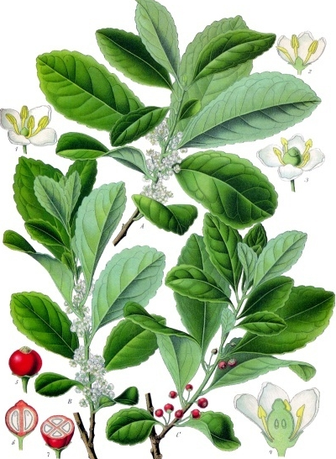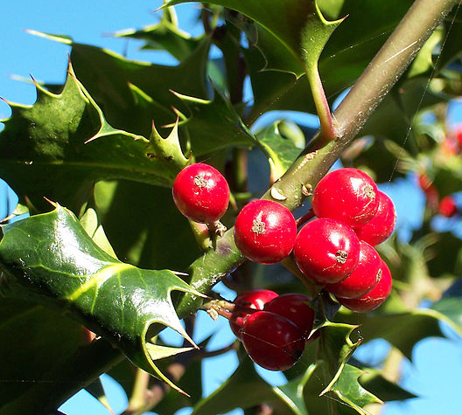
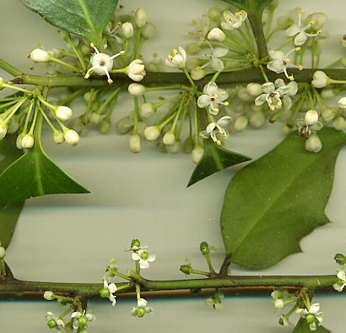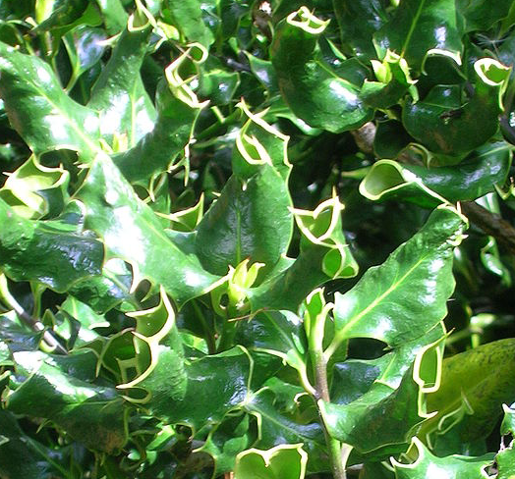

Ivy – family Hedra
An evergreen plant with a wide variety of leaf patterns. Normally found as ground cover or on trees in a symbionic system. The plant is a popular addition climbing on buildings and fences. Boston Ivy also known as Virginia Creeper does not damage buildings as it holds on using small suckers on the stem. Other varieties push stems into the mortar in brickwork doing considerable damage. The flower is white.
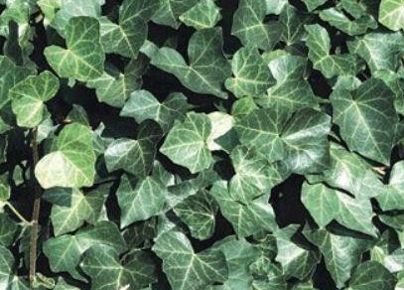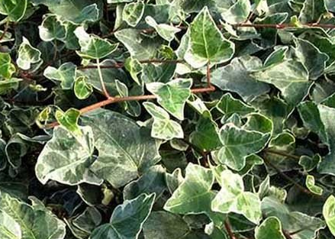
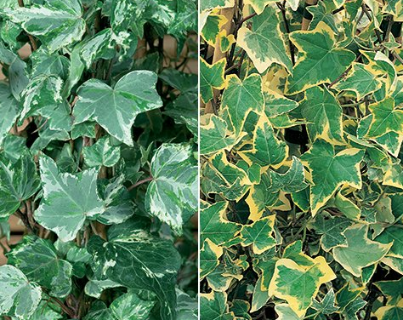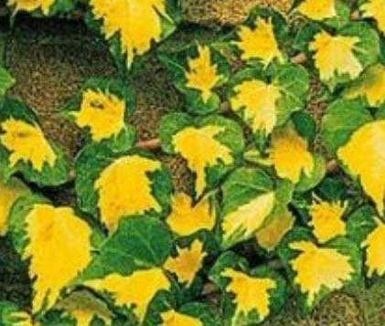
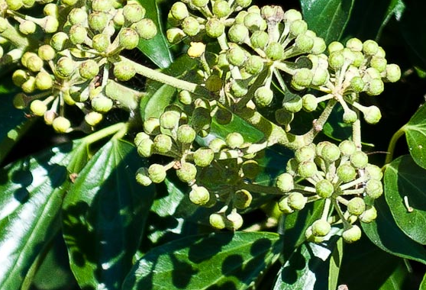

Mistletoe – family Psittacanthus
Mistletoe has been a symbol of fertility throughout the ages. Its flower is seldom seen (below) rather we see the typical white berries and elongated, smooth, waxy curved leaves.
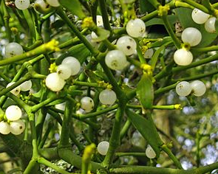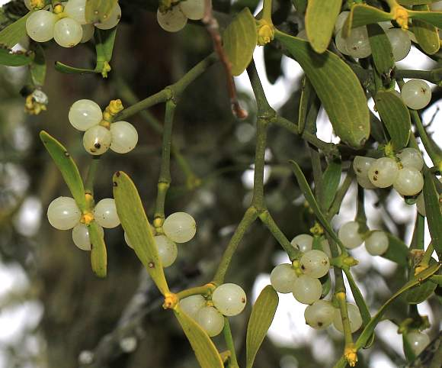
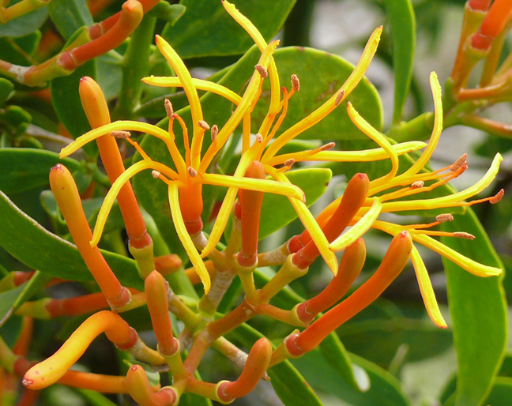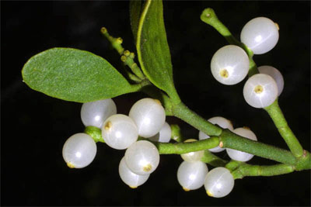
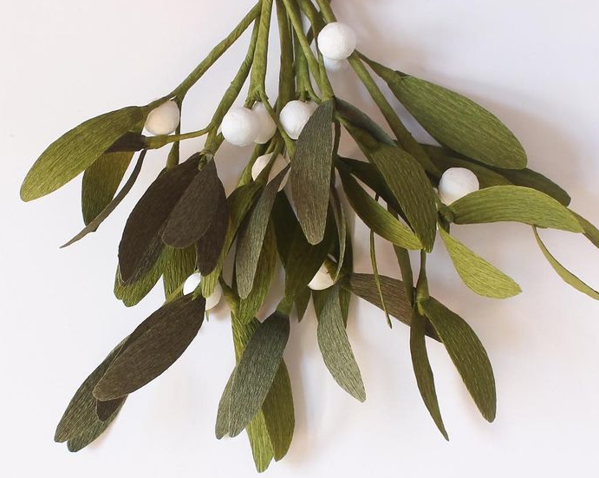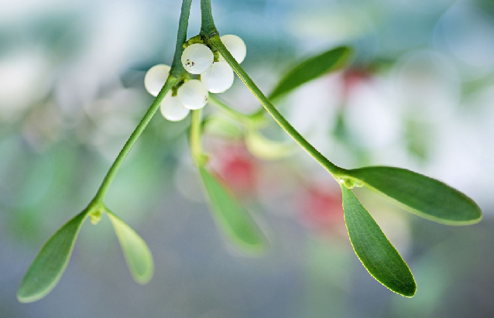

Other Plants used at Christmas
These plants are indoor varieties, imported from warmer climates.
Poinsettia
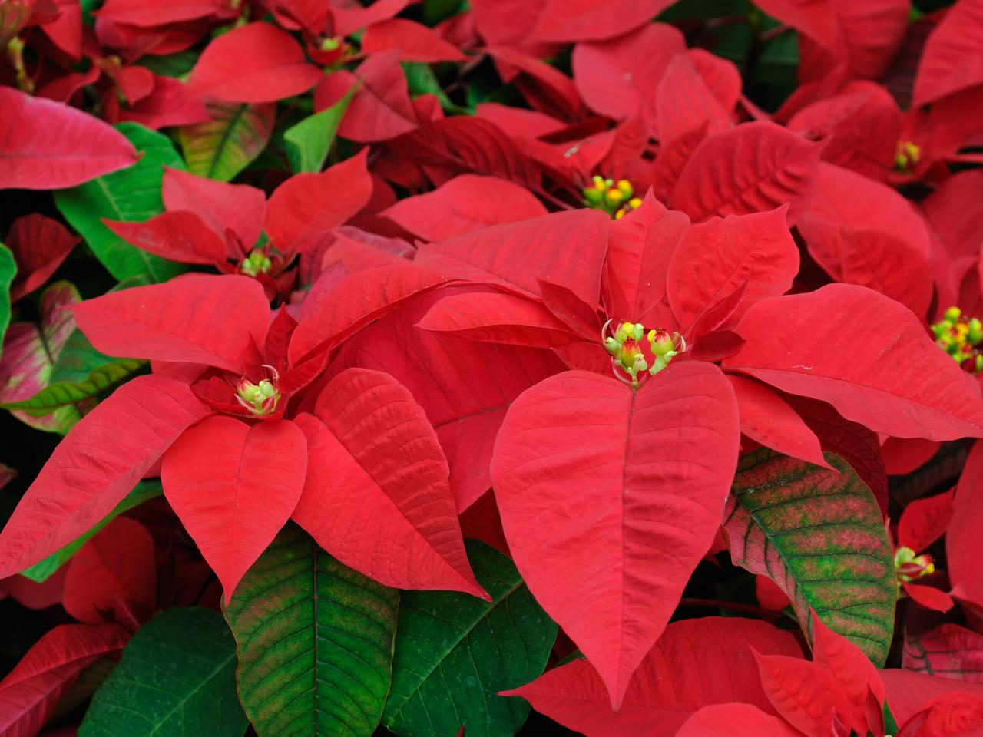
Amaryllis
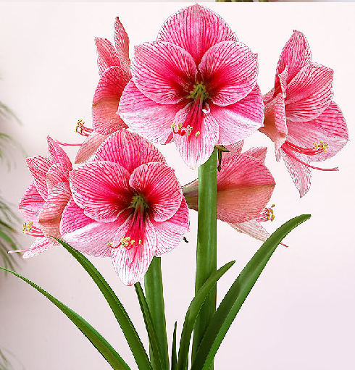
Christmas Cactus – Schlumberger
