**Traditional British**

**Songs sung for at least a hundred years; versions found throughout the UK and America**

**All for me Grog**

Well it's all for me grog, me jolly jolly grog  
It's all for me beer and tobacco  
For I spent all me tin with the lassies drinking gin  
Far across the western ocean I must wander

Where are me boots, me noggin', noggin' boots?  
They're all gone for beer and tobacco  
For the heels they are worn out and the toes are kicked about  
And the soles are looking out for better weather

Where is me shirt, my noggin', noggin' shirt?  
It's all gone for beer and tobacco  
For the collar is all worn, and the sleeves they are all torn  
And the tail is looking out for better weather

I'm sick in the head and I haven't been to bed  
Since first I came ashore with me slumber  
For I spent all me dough on the lassies movin' slow  
Far across the Western Ocean I must wander

Where is me bed, me noggin' noggin bed  
It's all gone for beer and tobacco  
Well I lent it to a whore and now the sheets are all tore  
And the springs are looking out for better weather.

Where is me wench, me noggin' noggin' wench  
She's all gone for beer and tobacco  
Well her (*) is all worn out and her (*) is knocked about  
And her (*) is looking out for better whether

(*) = a clap

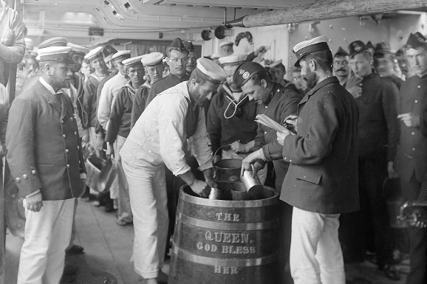All for me grog

… is a traditional folk song that was originally popular with sailors and later adopted by folk music performers and pub singers. It tells the tale of a man who sells all his possessions, and even his wife, to pay for drink and tobacco. Although the song is effectively about a man's ruin through drink, it is upbeat and celebratory rather than regretful. It is usually performed as a raucous chorus song.

The word originally referred to a drink made with water and rum, which British Vice Admiral Edward Vernon introduced into the naval squadron he commanded in the West Indies on 21 August 1740. Vernon wore a coat of grogram cloth and was nicknamed *Old Grogram* or *Old Grog*.

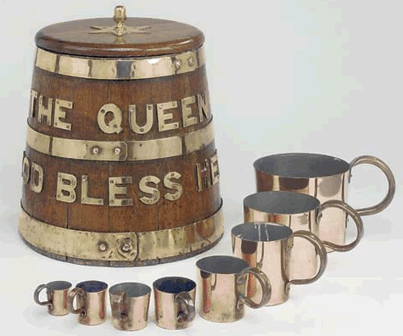Grog originally referred to a daily ration of rum (half pint – ¼ litre) that used to be given to sailors in the Royal Navy (4 parts water to 1 part rum). It later came to refer to all types of drink.

The word originally referred to a drink made with water and rum, which British Vice Admiral Edward Vernon introduced into the naval squadron he commanded in the West Indies on 21 August 1740. Vernon wore a coat of grogram cloth and was nicknamed *Old Grogram* or *Old Grog*.

**Country Boy**

1.   Now do I be a fair young country boy

3. I’m gonna buy us our own farm

When I’ve put by some money

We’ll put bees in sacks of corn

And they’ll make us bread and honey

We’ll have oats in all the fields

And a big oast house to dry ‘em

We’ll brew the best ale in the land

A country boy like I am

4.   Now Mary her wants family

And I will not oppose it

She's got one of 'em on the way

And I don't think that she knows it

We'll get married in a church

Before its lambing time

And settle down to raise some girls

And country boys like I am

My father came from Fareham

He had another six just like I

By Christ how he could rare 'em

Now do my mum makes dumplings nice

I'd bet you'd like to try 'em

I've never found me a better one

A country boy like I am

Chorus:

I can plough and milk a cow,

I can reap and sow

I'm fresh as a daisy which grows in the fields

And they calls I Buttercup Joe

2.   Now there's a pretty girl that I love

They calls her our Mary

Her works busy as a bumble bee

Down in old Jones's dairy

Now her can cook and her can sew

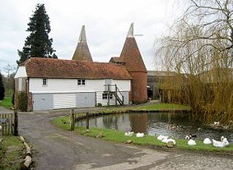And use a smoothing iron

I'm gonna take for a wife

A country boy like I am

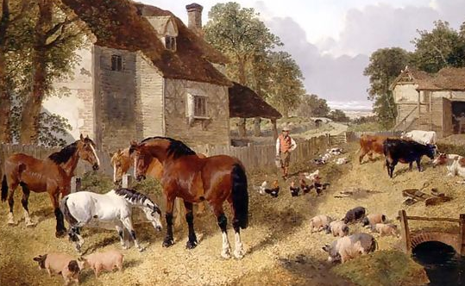

An Oast House

Originally this is a traditional British folk song common in the South West of England and East Anglia. An ‘oast house’ is where hops are dried for making beer and ale.

**Mrs McGrath**

Oh then were ye drunk, or were ye blind  
That ye left your two fine legs behind?  
Or was it walkin' upon the sea  
Wore your two fine legs from the knees away?

Oh, I wasn't drunk and I wasn't blind  
But I left my two fine legs behind.  
For a cannon ball, on the fifth of May,  
Took my two fine legs from the knees away.  
   
Oh, Teddy, me boy, the old widow cried,  
Yer two fine legs were yer mammy's pride,  
Them stumps of a tree wouldn't do at all,  
Why didn't ye run from the big cannon ball?  
   
All foreign wars I do proclaim  
Between Don John and the King of Spain  
And by herrins I'll make them rue the time  
That they swept the legs from a child of mine.

Oh, Mrs. McGrath, the sergeant said,  
Would you like to make a soldier out of your son, Ted?  
With a scarlet coat, and a three-cocked hat,  
Now Mrs. McGrath, wouldn't you like that?  
Wid yer too-ri-aa, fol de diddle aa  
Too-ri-oo-ri-oo-ri-aa.  
  
Oh Mrs. McGrath lived by the seashore  
For the space of seven long years or more;  
Till she saw a big ship sail into the bay,  
Here's my son, Ted, wisha, clear the way!   
  
Oh, Captain, dear, where have ye been  
Have you been in the Meditereen?  
Will ye tell me the news of my son, Ted?  
Is the poor boy livin', or is he dead?   
  
Ah, well up comes Ted without any legs  
An in their place he had two wooden pegs,  
She kissed him a dozen times or two,  
Saying, Holy Moses, 'tisn't you.

Sea battles produced most of the amputees seen in England in the 18th and 19th Centuries. Surgeons on ships were skilled in removing damaged limbs because of the practice they had during and after the battle. Without anaesthetic and antibiotics speed was essential. Around 50% of amputees died on the surgeon’s table or later due to infection.

The most common injuries, however, were broken arms and legs from falls (from the rigging) and strains and sprains due to the hard work they carried out. By the time of the Napoleonic wars the problems of scurvy (lack of vitamin C) had been solved, but not the fevers and infections which killed many of the ships’ crews.

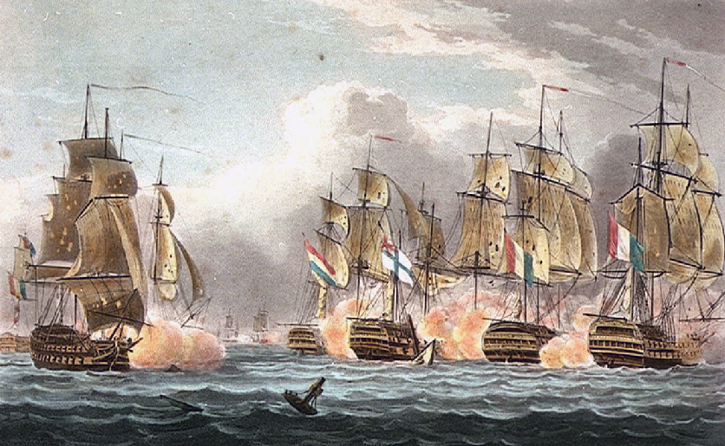

HMS Bellerophon (centre) at Trafalgar

**Oh No John**

Alternative titles include "No, Sir", "No, John, No", "No Sir No", "Yes Or No", "Cruel Father", "Ripest Apples", "Twenty Eighteen", "The Spanish Merchant's Daughter", "The Spanish Captain", "Spanish Lady", "Yonder Sits a Spanish Lady", "Yonder Sits a Pretty Creature", and "In Yonder Grove"

Madam in your face is beauty,  
In your bosom flowers grow  
In your bedroom there is pleasure,  
Shall I view it, yes or no  
Oh no John, No John, No John, No!

Madam shall I tie your garter,  
Tie it a little above your knee  
If my hand should slip a little farther,  
Would you think it amiss of me  
Oh no John, No John, No John, No!

My love and I went to bed together,  
There we lay till cocks did crow;  
Unclose your arms my dearest jewel,  
Unclose your arms and let me go, Oh no John, No John, No John, No!

On yonder hill there stands a creature,   
Who she is I do not know  
I will court her for her beauty,  
She must answer yes or no  
Oh no John, No John, No John, No!

On her bosom are bunches of posies,  
On her breast where flowers grow  
If I should chance to touch that posy,

She must answer yes or no  
Oh no John, No John, No John, No!

Madam I am come for to court you,  
If your favour I can gain

If you will but entertain me,   
Perhaps then I might come again  
Oh no John, No John, No John, No!



My husband was a Spanish captain,  
Went to sea a month ago  
The very last time we kissed and parted,  
Bid me always answer no.  
Oh no John, No John, No John, No!

**Widdicombe Fair (Widecome Fair)**

6. But this isn’t the end of this shocking affair

All along down along out along lee

Nor, though they be dead of the horrid career

7. When the wind whistles chill on the moor of a night

All along down along out along lee

Tom Pearce’s old mare doth appear ghostly white

8. And all the long night be heard skirling and groans

All along down along out along lee

From Tom Pearce’s old mare in her rattling bones

1. Tom Pearce, Tom Pearce lend me your grey mare

All along down along out along lee

I want for to go to Widdicombe Fair

Chorus:

With Bill Brewer, Jan Stewer

Peter Gurney, Peter Davey

Dan’l Widden, Harry Hawke

Old Uncle Tom Cobley an’ all

Old Uncle Tom Cobley an’ all

2. And when will I see again my grey mare

All along down along out along lee

By Friday soon or Saturday noon

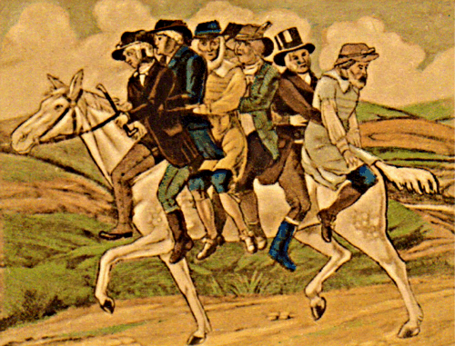

3. Then Friday came and Saturday noon

All along down along out along lee

But Tom Pearce’s old mare hath not trotted home

4. So Tom Pearce he got up to the top o’ the hill

All along down along out along lee

And he seed his old mare down a makin’ her will

5. So Tom Pearce’s old mare she took sick and died

All along down along out along lee

And Tom he sat down on a stone and he cried

**American**

**Songs from America; specialised subjects relating to American life and culture**

**Blood on the Saddle**

Chorus:

The cowboy doesn’t die as a hero in a shootout but falls off his horse and the horse crushes him – a quite understandable situation, especially after drinking!

There's blood on the saddle and blood all around,  
And a great great big puddle of blood on the ground;

A cowboy lay in it all covered with gore  
And he never will ride on his bronco no more.

Oh, pity the cowboy all bloody and red,  
A bronco fell on him and smashed in his head.

**The Cat Came Back** *– after using up some of his 9 lives*

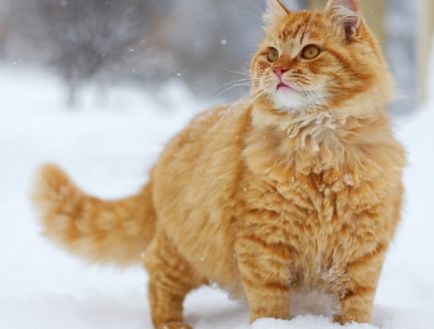

1. Well old Mr. Johnstone had troubles all his own

Had an old yellow cat that wouldn’t stay home

Tried everything he knew to get the cat to stay away

Even took him up to Canada and told him for to stay

Chorus:

But the cat came back the very next day

Thought he was a gonner but the cat came back

‘Cause he wouldn’t stay away

2. Well the farmer on the corner said he’d shoot the cat on sight

He loaded up his gun full of rocks and dynamite

The gun went off heard all over town

And little pieces of the man was all that they found

3. Well they gave him to a man goin’ up in a balloon

Told him for to leave him with the man in the moon

The balloon got busted and back to earth it sped

And seven miles away they picked the man up dead

4. Well they took him to Cape Canaverel* and they put him in a place

Put him in a US rocket goin’ way out in space

Finally thought the cat was out of human reach

Next day got a call from Miami Beach (* now Cape Kennedy)

**Draft Dodgers Rag**

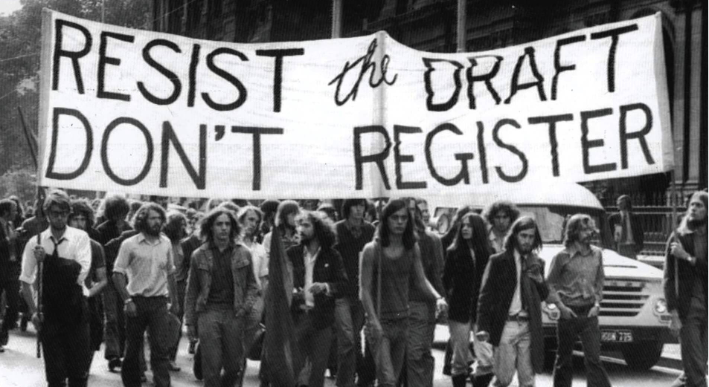These demonstrations took place during the 1960s and 1970s due to the drafting of young men into the US army to fight in Vietnam. At the same time as the Civil Rights protests, they found the same supporters. Many young American men moved abroad to avoid the draft, to countries like Sweden, where they could not be retrieved by the US government.

The war in Vietnam, beginning in 1954 with the defeat of the French at Dien Bien Phu (General Giap), was very unpopular, particularly as US forces suffered setback after setback with losses eventually reaching 60,000 dead and 150,000 wounded. Over 1 million Vietnamese became casualties by the time the conflict ceased in 1974 with the American withdrawal.

1. I’m just a typical American boy from a typical American town

I believe in God and Senator Dodd and in keeping old Castro down

But when it came my time to serve I knew “better dead than red”

And when I go to that old draft board buddy this is what I said

Chorus:

Sarge I’m only 18 I’ve got a ruptured spleen and I always carry a purse

I’ve got eyes like a bat, my feet are flat and my asthma’s getting’ worse

Think of my career I’ve got a sweetheart dear and a poor old invalid aunt

Sides I ain’t no fool I’m goin’ to school and I’m workin’ in a defence plant

2. I’ve go a dislocated disc and a racked up back I’m allergic to flowers and bugs

And when the bomb shell hits I get epileptic fits and I’m addicted to a thousand drugs

I’ve got the weakness woes I can’t touch my toes I can hardly reach my knees

And when the enemy gets close to me I’d probably start to sneeze

3. Well I hate Chou-en-Lai and I hope he dies but I think you ought to see

That someone’s got to go over there and that someone isn’t me

I wish you well sarge, give ‘em hell, kill me a thousand or so

And if you ever get a war without blood and gore then I’ll be the first to go

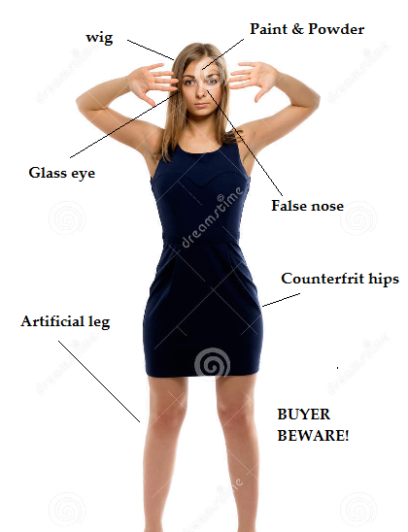**Unfortunate Man**

1. There once was a lawyer they called Mr. Clay

He had but few clients and they wouldn’t pay

At last of starvation he grew so afraid

That he courted and married a wealthy old maid

2. Well she went to the wash stand to bathe her fair face

Thus she destroyed all her beauty and grace

The rose in her cheeks soon grew very faint

And he saw on the towel twas nothing but paint

3. She went to the mirror to take down her hair

When she had done so her scalp was all bare

She said don’t be frightened to see my bald head

I’ll put on my cap when I get into bed

4. She hung her false hair on the wall on a peg

Then she proceeded to take off a leg

The trembling husband thought he would die

When she asked him to come and take out her glass eye

5. The husband was biting his quivering lips

Whilst she was removing her counterfeit hips

Just then her false nose clattered down on the floor

And the poor lawyer screamed and ran out at the door

6. So all you young men who would marry for life

***Best check – try before you buy***

Be sure to examine your intended wife

Remember the lawyer who trusted his eyes

And a little bit later got quite a surprise

**Modern British**

**Songs of the 1970s to the 1990s and ever popular in folk circles**

**Cod Liver Oil – from Glasgow of course! The Gorbbals is a run-down part of the City**

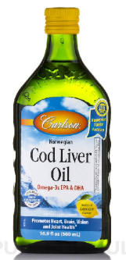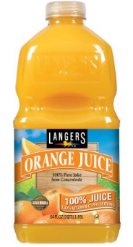1. Out of the East there came a hard man

Oh oh oh, all the way from Brigtown

Oh oh oh glory hallelujah, cod liver oil and the orange juice

2. He went into a pub and come out paralitic

Oh oh oh, VP and cider

Oh oh oh what a hell of a mixture, cod liver oil ……

3. Does this bus go to the Denistown Palais

Oh oh oh, I’m lookin’ for a lumber

Oh oh oh glory hallelujah, cod liver oil …..

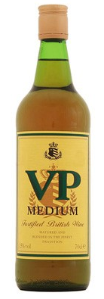

4. In the dancin’ he met hairy Mary

Oh oh oh, the flower o’ the Gorbbals

Oh oh oh glory hallelujah, cod liver oil …..

5. Now then Mary are you dancin’

Oh oh no, its just the way I’m standin’

Oh oh oh glory hallelujah, cod liver oil …..

6. Now then Mary can I run you hame

Oh oh oh, I’ve got a pair of sand shoes

Oh oh oh helluva funny, cod liver oil …..

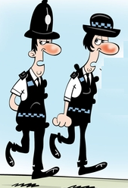

7. Down the backclose and into the dunny

Oh oh oh, it was ne for the first time

Oh oh oh glory hallelujah, cod liver oil ….

8. Out came her mammy she was lookin’ for the cludgie

Oh oh oh, I buggered off sharpish

Oh oh oh glory hallelujah, cod liver oil ….

9. Now hairy Mary she had a little baby

Oh oh oh, her father’s in the army

Oh oh oh glory hallelujah, cod liver oil ……

**Down in Old Invertotty – also Scottish**

4. They went through the usual procedure

Kicked it to make sure it was dead

Went through its pockets and shared out its cash

And took off its boots while it bled

5. Then they carried off the body

One at its head and its feet

Took it up to an alley way

And dumped it on another man’s beat

6. It was four o’clock when they re-found it

Propped up in an old chip shop door

It was naked by now with a note round its neck

Not wanted on beats three or four

1. It was down in old Invertotty

The Gestapo were out on their beat

Looking for murder and arson

And drunks as they rolled down the street

2. One of the Chief Constable’s agents

Had a note book quite full of names

Fourteen women, three men and a dog

For peeing up closes and lanes

3. It was twelve o’clock when they found it

Lying there just like a log

It was a badly bashed about body

With tyre marks scorched up its fizzog

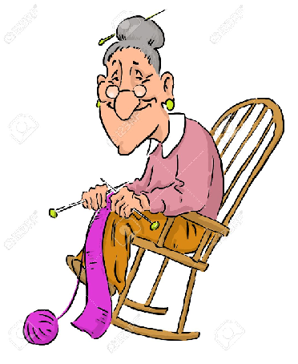**Out In the Backyard**

1. Out in the backyard my granny was sittin’

Hummin’ and rockin’ and casually knittin’

When up to the front door came big Jock McLennon

The local police force and another man with him

2. Oh father dear father oh father lord save us

The local police force has come to enslave us

And my big brother Jim started cursin’ and spittin’

Whilst out in the backyard my granny was knittin’

3. Of father dear father pray tell us what’s cookin’

The local police force says “ach we’re just lookin’

We’re lookin’ for things like heroin and morphia

And if you’ve got any onna ya, we’ll take it offa ya

4. They looked in the kitchen they raked through the midden

But they couldn’t find where the hemp was all hidden

The looked in the lavvy, dismantled the bog chain

But couldn’t yet find not a trace of the cocaine

This appears to be from Scotland – Jock McLennon – but it doesn’t have to.

5. Come 5 o’clock, 6 o’clock they had to go away

The local police force says they’ll get us some day

While out in the backyard my granny was sittin’

Cocaine in her needles with hemp she was knittin’

**The Sick Note**

Dear sir I write this note to you to tell you of my plight

For at the time of writing I am not a pretty sight

My body is all black and blue, my face a deathly grey

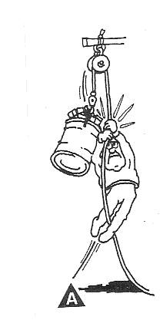And I write this note to say why Paddy's not at work today

Whilst working on the fourteenth floor some bricks I had to clear,

But to throw them down from such a height was not a good idea,

The foreman wasn't very pleased, him being an awkward sod,

And he said I'd have to cart them down the ladders in my hod.

Now clearing all those bricks by hand, it was so very slow,

So I hoisted up a barrel and secured the rope below,

But in my haste to do the job I was too blind to see,

That a barrel full of building bricks was heavier than me.

So when I untied the rope, the barrel fell like lead,

And clinging tightly to the rope I started up instead,

I shot up like a rocket, till to my dismay I found,

That halfway up I met the bloody barrel coming down.

The barrel broke my shoulder as to the ground it sped,

And when I reached the top I banged the pulley with my head,

I hung on tightly, numb with shock from this almighty blow,

And the barrel spilt out half its bricks some fourteen floors below.

Now when those bricks had fallen from the barrel to the floor,

I then out-weighed the barrel, and so started down once more,

Still clinging tightly to the rope, my body wracked with pain,

When halfway down, I met the bloody barrel once again.



The force of this collision halfway up the office block,

Caused multiple abrasions and a nasty state of shock,

Still clinging tightly to the rope, I fell towards the ground,

And I landed on the broken bricks the barrel scattered round.

I lay there groaning on the ground I thought I'd passed the worst,

But the barrel hit the pulley wheel, and then the bottom burst,

A shower of bricks rained down on me, I hadn't got a hope,

And as I lay there bleeding on the ground - I let go the bloody rope.

The barrel then being heavier, it started down once more,

And it landed right across me as I lay upon the floor,

It broke three ribs and my left arm, and I can only say,

I hope you understand why Paddy's not at work today.

**Sister Josephine**

1. Oh Sister Josephine what do all these policemen mean

By coming to the convent in a grim limousine

After Sister Josephine

While you Sister Josephine you sit with your boots up on the altar screen

You smoke one last cigar

What a funny nun you are

The policemen say that Josephine’s a burglar in disguise

Big bad Malcolm thirty years on the run

The sisters disbelieve it no that can’t be Josephine

Just think about her tenderness toward the younger nuns

2. Oh Sister Josephine they’re searching the chapel where you’ve been seen

The nooks and crannies of the nun’s canteen

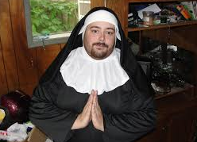After Sister Josephine

While you Sister Josephine you take a farewell sniff of benzadrine

From the convent budgerigar

A right funny nun you are

Well admittedly her hands are big and hairy

And embellished by a curious tattoo

And admittedly her voice is on the deep side

And she seems to shave more often than the other sisters do

3. Oh Sister Josephine founder of the convent pontoon team

They’re looking through your collection of bunny magazines

After Sister Josephine

While you Sister Josephine you take one farewell Benedictine

Before your au revoir

A bloody funny nun you are

Well no longer will her snores ring through the chapel during prayers

Nor her lustful moanings fill the stilly night

No more empty bottles of alter wine come clonking from her cell

No longer will the cloister toilet seat stand upright

4. Oh Sister Josephine sprinting through the suburbs when last seen

Dressed only in your wimple and your rosary

A right funny nun you seem to be

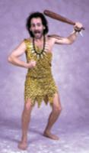**Woad**

What's the use of wearing braces,

coats and ties and shoes with laces

Hats and spats you buy in places

down on Scotty road

What's the use of shirts of cotton,

studs that only get forgotten

These affairs are simply rotten

better far is woad

Woad's the stuff to show them,

woad to beat the foemen

Boil it to a brilliant blue

and rub it on your back and your abdomen

Ancient Britain never hit on

anything as good as woad to fit on

Neck or knees or where you sit on,

tailors you be blowed

Romans came across the channel

all dressed up in tin and flannel

Half a pint of woad per man'll

dress us more than these

We all know of the blue dye used by the ancient Britons. The Romans called them Picts – the painted people. Most lived north of the border in Scotland. The Scotti were a tribe from Ireland!

Romans keep your armours,

Saxons your pyjamas

Hairy coats were meant for goats,

gorillas, yaks, retriever dogs and llamas

Tramp up Snowdon with your woad on

never mind if you get rained or blowed on

Never want a button sewed on,

go it ancient Bs

**British 1950s Rock**

This song is pure fun and so were such shows with lots of songs which everyone knew and sang.

**From the Rock Opera ‘Half a Sixpence**

**Enery the eighth**

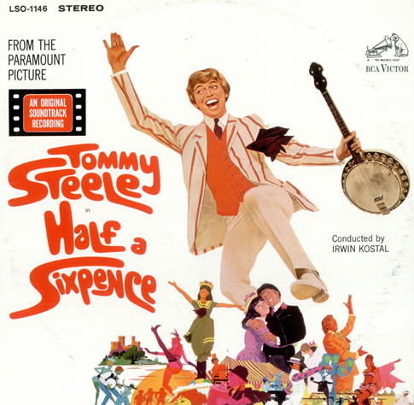I’m ‘Enery the eighth I am

‘Enery the eighth I am I am

I got married to the widow next door

She’s been married seven times before

Now every one was an ‘Enery

She wouldn’t have a Billy or a Sam

I’m her eighth old man named ‘Enery

‘Enery the eighth I am

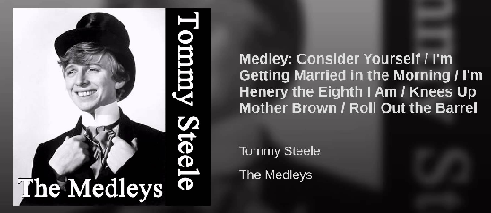

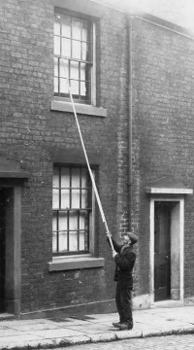**North British**

**Traditional song from Lancashire**

In the days before everyone had a watch and clocks in the house it was essential to get to work on time. So you paid a ‘knocker-up’ to wake you up in time for work each morning – for which you paid! This is another of those jobs which have disappeared in the mists of time – like the barrel maker (cooper), the lamplighter (lit the gas street lights in the evening and turned them off in the morning which even I can remember) and the arrow and bow maker (fletcher from the French fleche for arrow). How long do you think the ‘stationer’, ‘cobbler’ (boot maker and mender) and ‘tailor’ will last. When will we see the first 3D printed shoe, shirt or pair of socks?

**Knocker Up Song**

A pal of mine once said to me,

Will you knock me up at half-past three?"

And so promptly at half-past one,

I knocked him up and said, "O John,

I've just come round to tell ya

I've just come round to tell ya

I've just come round to tell ya

You've got two more hours to sleep!"

**Children’s Song**

**Modern but an old favourite**

Not the tale of the three pigs eaten by the wolf having built houses of straw, wood and brick!! This has a moral – never try to do something which you aren’t really qualified to do!

**Three Little Pigs**

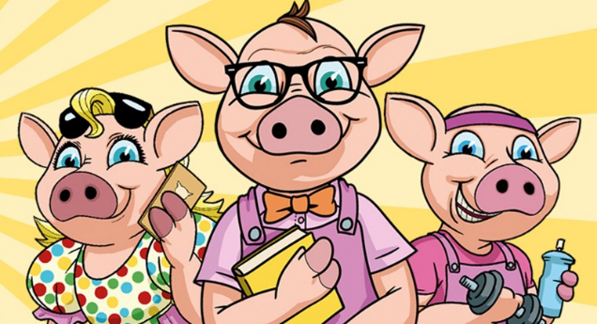1. There was an old sow who had three little pigs

Three little piggies had she

And the old sow always went oink, oink oink

And the piggies went wee, wee, wee

2. One day one of these three little pigs

To the other two piggies said he

Why don’t we try to go oink, oink oink

Its so childish to go wee, wee, wee

3. The three little piggies grew skinny and thin

As skinny as they might be

But they still would try to go oink, oink oink

Instead of going wee, wee, wee

4. The three little piggies they upped and they died – ahh

A terrible sight to see

So don’t you try to go oink, oink oink

When you ought to go wee, wee, wee