Irish Song Types

We have songs here which roughly divide into three types. These are: ‘Songs of War’, ‘Songs of lost love’ and ‘Songs of the more recent era’. Many Irish songs would have been written and sung in Irish Ghaelic but the tunes almost certainly remained and some of the sentiments.

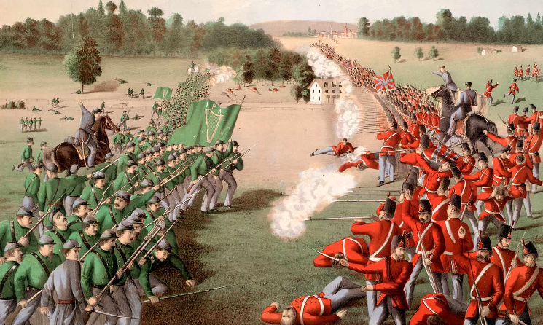
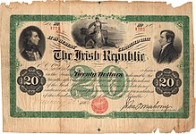
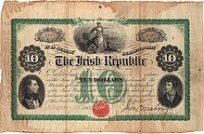
The songs of war include recruiting songs and songs describing the various eras of Irish Rebellion. There was continuous rebellion in Ireland for several centuries including; from 1798 to 1804 a rebellion by the United Irishmen, in 1848 by Young Ireland, when there was rebellion all over Europe, from 1866 to 1885 by the Fenian Brotherhood, founded in the United States in 1858 by John O'Mahony and Michael Doheny The Fenians incited rebellions in Ireland and abroad. The painting shows a rebellion, in Canada in 1866. They raised money by issuing bonds (below). Further, from 1882 to 1883 there were a series of assassinations carried out by the Invincibles.

The Easter Rising
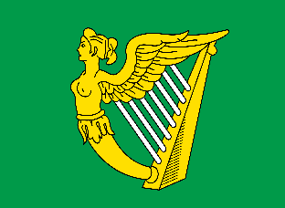
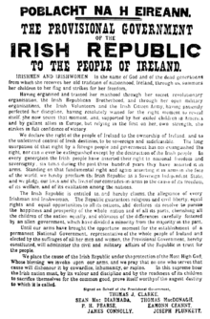
The Easter rising of April 1916 began with a declaration (left) but was unsuccessful. A few hundred people died and there was some damage to property. From 1919 to 1923 the Irish Republican Army (IRA) carried out a guerrilla war against the British Army and administration eventually resulting in the creation of an Irish Republican State – the Republic of Ireland or Eire with its own flag (tricolour) and symbolic identity including the Celtic harp (right).

In 1923, the creation of the new state of Eire left six counties in the north under British rule. These became Northern Ireland and the troubles continued throughout the region for the remains of the 20th Century and even today.

Ireland in the United Kingdom
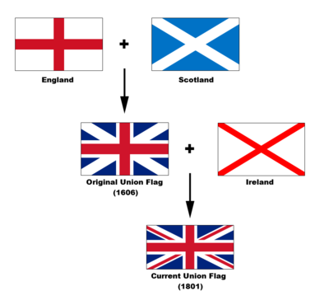
The UK began as two Kingdoms, Scotland and England (the Welsh having been incorporated into the English Kingdom in the 14th Century, with the English Prince of Wales its head) in the Act of Union of 1606.

Two hundred years later in 1801 a further act of Union brought the whole of Ireland into the ‘United Kindom of Great Britain and Ireland’.

When in 1923, Eire was created and the six counties of Northern Ireland remained with the Union the UK became the ‘United Kingdom of Great Britain and Northern Ireland.

The diagram here demonstrates how the Union Flag, as it is known, changed over the last few hundred years. Often in naval paintings of the 17th and 18th centuries when Britain had a huge naval influence you will see the flag without the Irish red diagonal cross included. Although part of Ireland left the Union in 1923 the flag did not change as the red diagonal cross of St Patrick remained for Northern Ireland.

As a result the Irish have a special relationship with the UK. The Southern Irish could work in the UK even before Britain joined the EU.
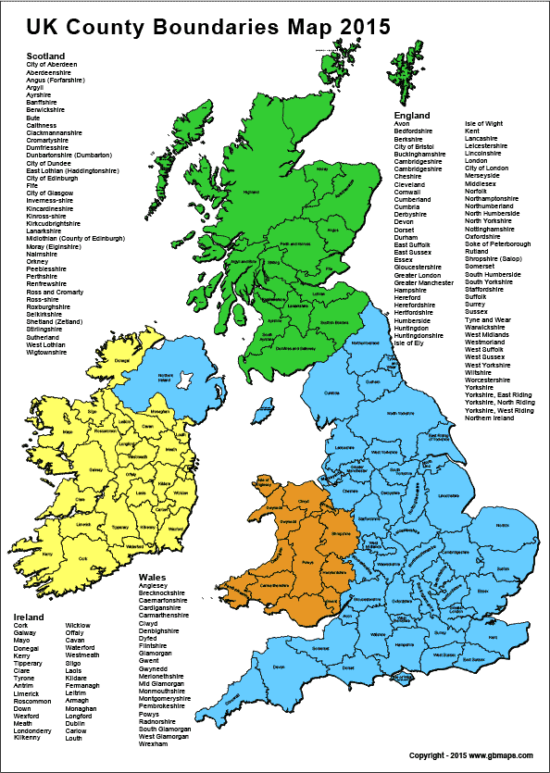
Green: Scotland (Scottish Ghaelic – little spoken)

Blue: England & Northern Ireland (English)

Brown: Wales (English & Welsh commonly spoken)

Yellow: Irish Republic – Eire (Irish Ghaelic)

We have the individual Countries:
England, Scotland, Wales, Northern Ireland, Eire

We have Great Britain:
England, Scotland & Wales

We have the United Kingdom of Great Britain and Northern Ireland – everything except the yellow (Eire)

We have the British Isles – everything

Not shown on the map are Jersey and Guernsey which are self-governing but part of the UK. Also the Isle of Man has its own government – Tynwald – and its own language.

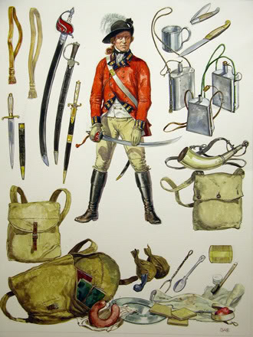
Johnny’s Gone for a Soldier

1. With fife and drum he marched away
He would not heed what I did say
He’ll not come back for many a day
Johnny’s gone for a soldier
Chorus:
Shule, shule shule agra
Sure and sure and he loves me
When he comes back he’ll marry me
Johnny’s gone for a soldier

2. I’ll go up to Portland Hill
And there I’ll sit and cry my fill
And every tear would turn a mill
Johnny’s gone for a soldier

3. I’ll sell my rod I’ll sell my reel
I’ll likewise sell my spinning wheel
To buy my love a sword of steel
Johnny’s gone for a soldier

4. I’ll dye my petticoat crimson red
And through the world I’ll beg my bread
I’ll find my love alive or dead
Johnny’s gone for a soldier

Irish redcoats – members of the British Army were very numerous. Ireland was a small country, poor and with a large population, continually expanding.
Many Irish joined the Army to avoid starvation but also many joined to avoid being forced to marry a girl back home. If the soldier had a girl, to whom he would expect to return, at home she would want to give him the best chance of survival – a good sword!
The song’s chorus is originally Ghaelic and was suggested to be from the late 17th, early 18th century. The first line = Súil a Grá means ‘walk with me, my joy’. It is known all over the United States but the original words have been mangled into, in one case, ….
Shale, shale, shale-a mac-a-me,
Shule-a mac-a-rac-stack Sally Bobby cue
Shule-a mac-a-rac-stack, Sally Bobby Lee
Come bibble un-a-boose, said Lora.
The tune is certainly the original Ghaelic though! My version uses just the Ghaelic first line and takes the sense of the rest of the Ghaelic chorus. Everyone can find their own version if they wish.

Arthur MacBride
We have here one of the many recruiting songs. These and marches of course were very common and no one could sing the songs without realising the tricks played by those recruiting. Often a shilling would be put in the bottom of a tankard of beer (Pewter) which some suggest led to many tankards having a glass bottom. You can believe that or not as you wish.
Traditionally recruits were paid a shilling (the King’s shilling) to enlist into the Army. Neither the wages nor the chances of survival were good and recruits had to pay for most of their extras and even some of their essentials out of this.
Victorious soldiers were therefore used to looting the dead (friend and foe) and any civilians to supplement their meagre pay.
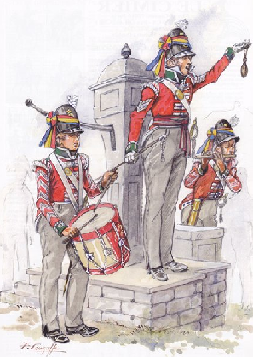
I had a first cousin called Arthur McBride
He and I took a stroll down by the sea side
A seeking good fortune and what might betide
Being just as the day it was dawning
Then after resting we both took a tramp
And met Sergeant Harper and Corporal Cramp
And besides a wee drummer who beat up the camp
With a rowdy-dow-dow in the morning

He said ‘my fine fellows if you will enlist
A guinea you quickly will have in your fist
And besides a crown for to kick up the dust
And drink the King’s health in the morning’
Had we been such fools as to take the advance
With a wee bit of money we’d have to run chance
‘Do ye think it no scruples to send us to France
Where we would be killed in the morning’
The recruiting sergeant with his drummer and his corporal

He says ‘My young fellows if I hear but one word
I instantly now will out with my sword
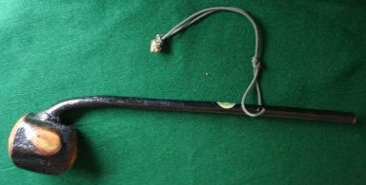
And into your bodies as strength will support
So now my gay devils take warning’
But Arthur and I we took the odds
And we gave them no chance to draw out their swords
Our whacking Shillelaghs came over their heads
And paid them right smart in the morning

As for the young drummer we rifled his pouch
And we made a football of his rowdy-dow-dow
And into the ocean to rock and to roll
And barring the day it’s returning
A modern Shillelagh – it is clear how it is made from a branch of a tree, the solid end being the knot where the branch joins the tree trunk. A serious weapon.
As for the rapier that hung by his side
We flung it as far as we could in the tide
‘To the Devil I pit you’, says Arthur McBride
To temper your steel in the morning

Mrs McGrath
Mrs McGrath contd.

Oh then were ye drunk, or were ye blind
That ye left your two fine legs behind?
Or was it walkin' upon the sea
Wore your two fine legs from the knees away?

Oh, I wasn't drunk and I wasn't blind
But I left my two fine legs behind.
For a cannon ball, on the fifth of May,
Took my two fine legs from the knees away.
Oh, Teddy, me boy, the old widow cried,
Yer two fine legs were yer mammy's pride,
Them stumps of a tree wouldn't do at all,
Why didn't ye run from the big cannon ball?
All foreign wars I do proclaim
Between Don John and the King of Spain
And by herrins I'll make them rue the time
That they swept the legs from a child of mine

Not a song of any great significance!

Oh, Mrs. McGrath, the sergeant said,
Would you like to make a soldier out of your
son, Ted?
With a scarlet coat, and a three-cocked hat,
Now Mrs. McGrath, wouldn't you like that?
Wid yer too-ri-aa, fol de diddle aa
Too-ri-oo-ri-oo-ri-aa.
Oh Mrs. McGrath lived by the seashore
For the space of seven long years or more;
Till she saw a big ship sail into the bay,
Here's my son, Ted, wisha, clear the way!
Oh, Captain, dear, where have ye been
Have you been in the Meditereen?
Will ye tell me the news of my son, Ted?
Is the poor boy livin', or is he dead?
Ah, well up comes Ted without any legs
An in their place he had two wooden pegs,
She kissed him a dozen times or two,
Saying, Holy Moses, 'tisn't you.

Irish Rebellions

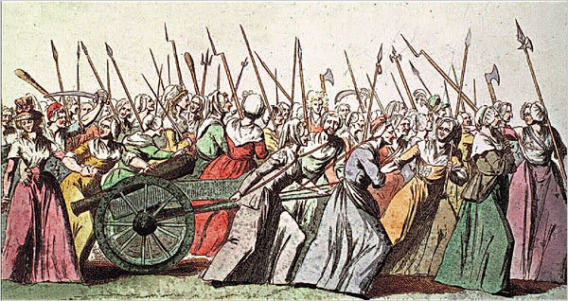

The rising of 1798 shows how the the participants armed themselves with what they could, mainly pikes but with axes clubs, and some swords and muskets.

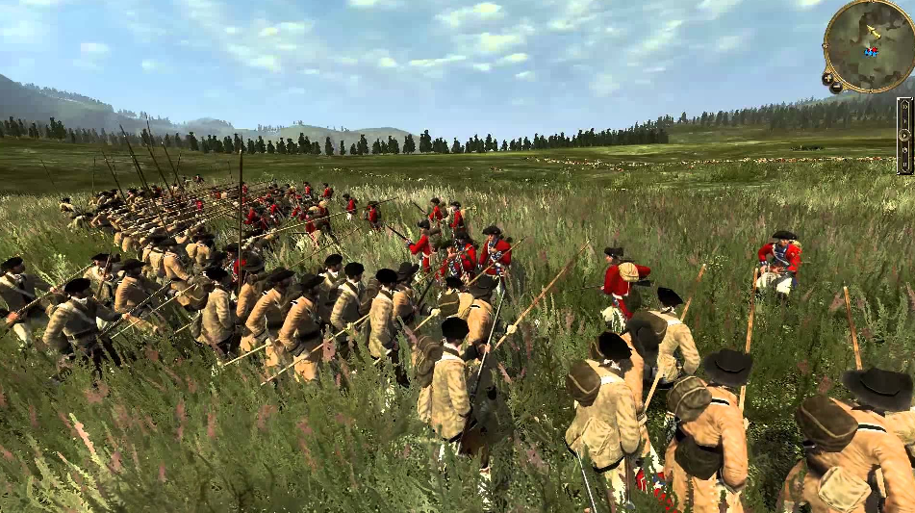

Irish rebels fight red-coat British Soldiers in the fields of barley. How realistic is this as a view of the Irish rebellions?

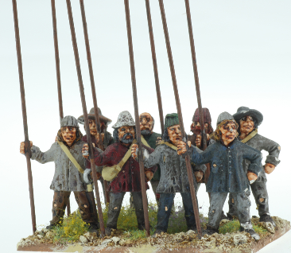
Rising of the Moon

And come tell me Sean O'Farrell tell me why you hurry so
Husha buachaill hush and listen and his cheeks were all a glow
I bare orders from the captain get you ready quick and soon
For the pikes must be together by the rising of the moon
Chorus: By the rising of the moon, by the rising of the moon
For the pikes must be together by the rising of the moon

And come tell me Sean O'Farrell where the gath'rin is to be
At the old spot by the river quite well known to you and me
One more word for signal token whistle out the marchin' tune
With your pike upon your shoulder by the rising of the moon

Out from many a mud wall cabin eyes were watching through the night
Many a manly heart was beating for the blessed warning light
Murmurs rang along the valleys to the banshees lonely croon
And a thousand pikes were flashing by the rising of the moon
Pikes were one of the essential weapons in Medieval battles until muskets and rifles became more common.

The pike is normally of length 5 to 6 metres, basically a wooden shaft with a sharpened end of burnt wood, or iron.

Massed pikes were very effective against both mounted knights and large bodies of infantry but were vulnerable to archers or soldiers armed with muskets or rifles.

Below is a scene resulting from he potato famines of the 19th century. Many families emigrated to the New World to avoid starvation.

All along that singing river that black mass of men was seen
High above their shining weapons flew their own beloved green
Death to every foe and traitor! Whistle out the marching tune
And hurrah, me boys, for freedom, 'tis the rising of the moon ‘
Tis the rising ……

Only Our Rivers Run Free

When apples still grow in November
When blossoms still bloom from each tree,
When leaves are still green in December,
It's then that our land will be free.
I wander her hills and her valleys,
And still through my sorrow I see
A land that has never known freedom
And only her rivers run free.

I drink to the death of her manhood,
Those men who would rather have died
Than to live in the cold chains of bondage,
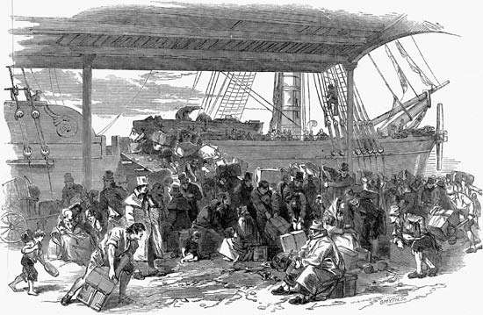
To bring back their rights were denied.
Oh were are you now when we need you,
What burns where the flame used to be,
Are ye gone like the snows of last winter,
And will only our rivers run free.

How sweet is life but we're crying
How mellow the wine that were dry,
How fragrant the rose,but it's dying,
How gentle the wind but it sighs.
What good is in youth when it's aging,
What joy is in eyes that can't see,
When there's sorrow and sunshine and flowers,
And still only our rivers run free.

’Only Our Rivers’ is a modern song but expresses all of the feelings of the Irish from the past centuries.of rebellion. No one can fail to be touched by the haunting tune and well penned words. The Irish have suffered more than most due to famine, occupation by an army and a general lack of compassion and in some cases the brutality of their London masters.

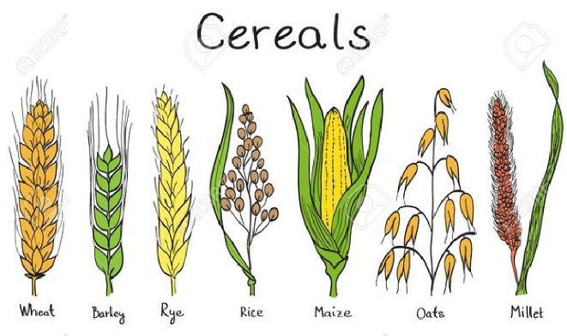
The song ‘Wind that shakes the barley’ concerns the violent death of a civilian during the risings which occurred from time to time against the English landowners, backed by the Red-coat army.

It is interesting how often ‘barley’ is mentioned in songs as it is a native grain, similar to wheat but much more suited to a wet, cold climate. Barley, Rye, Oats and Millet are native to the UK. Wheat, rice and maize/corn were introduced in ancient times.

Wind that shakes the barley
I bore her to some mountain stream
And many's the summer blossom
I placed with branches soft and green
About her gore-stained bosom
I wept and kissed her clay-cold corpse
Then rushed o'er vale and valley
My vengeance on the foe to wreak
While soft winds shook the barley

But blood for blood without remorse
I've taken at Oulart Hollow
And laid my true love's clay-cold corpse
Where I full soon may follow
As 'round her grave I wander drear
Noon, night and morning early
With breaking heart when e'er I hear
The wind that shakes the barley

I sat within a valley green
I sat me with my true love
My sad heart strove to choose between
The old love and the new love
The old for her, the new that made
Me think on Ireland dearly
While soft the wind blew down the glade
And shook the golden barley

Twas hard the woeful words to frame
To break the ties that bound us
But harder still to bear the shame
Of foreign chains around us
And so I said, "The mountain glen
I'll seek at morning early
And join the bold United Men
While soft winds shake the barley“

While sad I kissed away her tears
My fond arms 'round her flinging
The foeman's shot burst on our ears
From out the wildwood ringing
A bullet pierced my true love's side
In life's young spring so early
And on my breast in blood she died
While soft winds shook the barley

Molly Malone
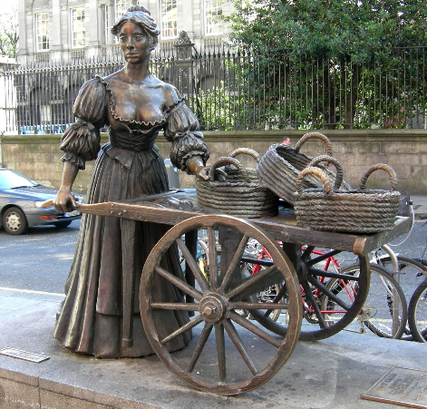
Left:
The Molly Malone sculpture in Dublin, the Capital of the Irish Republic (Eire).

In 1988 the Dublin Millennium Commission endorsed claims about a Mary Malone who died on 13 June 1699, and the 13th June became "Molly Malone day”.

The name ‘Molly’ is short for Mary or Margaret and Malone is a very common name. There is no proof that the song was written about any particular person. It seems that they chose this particular Molly because of her being a chaste street seller, not the street seller by day, prostitute by night type.

Molly Malone
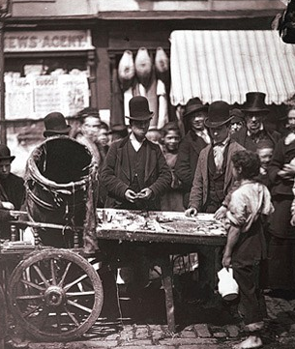
1. In Dublin's fair city, where girls are so pretty,
I first set my eyes on sweet Molly Malone,
As she wheeled her wheelbarrow,
through streets broad and narrow,
Crying, "Cockles and mussels, alive, alive oh"!
Chorus:
Alive, alive oh! alive, alive oh!
Crying, "Cockles and mussels, alive, alive oh"!

2. Now she was a fishmonger, and sure ‘twas no wonder,
For so were her mother and father before,
And they each wheeled their barrow,
through streets broad and narrow,
Crying, "Cockles and mussels, alive, alive oh"!
Chorus:

3. She died of a fever, and no one could save her,
And that was the end of sweet Molly Malone.
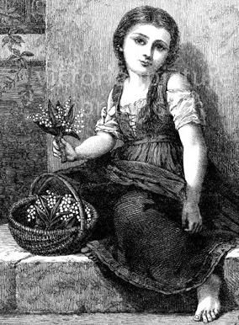
Now her ghost wheels her barrow,
through streets broad and narrow,
Crying, "Cockles and mussels, alive, alive oh"!
Chorus:
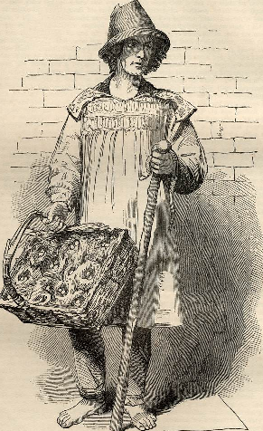
It was common for people to sell their wares (goods) in the street. They would use a barrow or would carry their goods and advertise by singing or shouting of the wares they had to offer.
Much of England throughout the middle ages relied on fairs when they had to buy anything special such as gloves, shoes, hats, tools of all kinds, seeds etc.
Special ‘shops’ were less common but there were always millers and smithies to provide grain and iron tools, essential for the farming fraternity particularly but others too.
Above: A street seller in Victorian England
Top right: Joseph Carney – costermonger – selling fresh herring
Bottom right: The Flower girl
She Moved through the Fair

This is a well known song, usually sung unaccompanied, with a typical Irish Ghaelic tune and sentiments which can be understood by anybody.

It is a young man singing. He hears from his young love in verse 1 that neither her father nor mother are worried that he is poor (lack of kind).
After the meeting in verse 1, in verse 2 she leaves him to go shopping then home in the twilight.
In verse 3 we hear that everyone was saying no two like these have ever married. As she passed him with her purchases he didn’t realise that would be the last time she saw him.
In verse 4 we learn she is dead and he is remembering her last words to him in his dream. We don’t know why she died but it must have been something which was not uncommon.

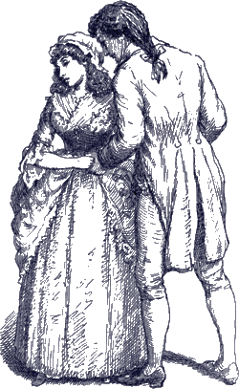
My young love said to me, "My mother won't mind
And my father won't slight you for your lack of kind."
And she stepped away from me and this she did say
It will not be long, love, till our wedding day."

As she stepped away from me and she moved through the fair
And fondly I watched her move here and move there
And then she turned homeward with one star awake
Like the swan in the evening moves over the lake.

The people were saying, no two e'er were wed
But one had a sorrow that never was said
And I smiled as she passed with her goods and her gear
And that was the last that I saw of my dear.

Last night she came to me, my dead love came in
So softly she came that her feet made no din
As she laid her hand on me and this she did say
"It will not be long, love, 'til our wedding day."

Star of the County Down
I've travelled a bit, but never was hit
Since my roving career began
But fair and square I surrendered there
To the charms of young Rose McCann.
I'd a heart to let and no tenant yet
Did I meet with in shawl or gown
But in she went and I asked no rent
From the star of the County Down.
At the crossroads fair I'll be surely there
And I'll dress in my Sunday clothes
And I'll try sheep's eyes, and deludhering lies
On the heart of the nut-brown rose.
No pipe I'll smoke, no horse I'll yoke
Though with rust my plough turns brown
Till a smiling bride by my own fireside
Sits the star of the County Down.

A young man spots a handsome young lady and is doing his best to make sure she sees him and accepts an offer of marriage. He seems very determined – let’s hope he gets his girl!
Near Banbridge town, in the County Down
One morning in July
Down a boreen green came a sweet colleen
And she smiled as she passed me by.
She looked so sweet from her two white feet
To the sheen of her nut-brown hair
Such a coaxing elf, I'd to shake myself
To make sure I was standing there.
From Bantry Bay up to Derry Quay
And from Galway to Dublin town
No maid I've seen like the sweet colleen
That I met in the County Down.
As she onward sped I shook my head
And I gazed with a feeling rare
And I said, says I, to a passer-by
"who's the maid with the nut-brown hair?"
He smiled at me, and with pride says he,
"That's the gem of Ireland's crown.
She's young Rosie McCann
from the banks of the Bann
She's the star of the County Down."

BRIDGET O'MALLEY (Brid Óg Ní Mhaille). Is also known as "Brigid O'Malley," "Donnell O'Daly," "Young Bridie O'Malley". It is a Ghaelic tune with translated words. Without a doubt it is an old Irish ‘Air’ or Ballad but its origins seem to be obscure. The writer is the well known anon.

What is certain is its popularity amongst folk group of all types. I suppose this is not surprising as Ghaelic tunes are very atmospheric and allow lots of leeway for performers. You will find an infinite number of recordings by almost everybody.

Bridgit O’Malley

Oh Bridgit O’Malley, you left my heart shaken
With a hopeless desolation, I’d have you to know
It’s the wonders of admiration your quiet face has taken
And your beauty will haunt me wherever I go.

The white moon above the pale sands, the pale stars above the thorn tree
Are cold beside my darling, but no purer than she
I gaze upon the cold moon till the stars drown in the warm sea
And the bright eyes of my darling are never on me.

My Sunday it is weary, my Sunday it is grey now
My heart is a cold thing, my heart is a stone
All joy is dead within me, my life has gone away now
For another has taken my love for his own.

The day it is approaching when we were to be married
And it’s rather I would die than live only to grieve
Oh meet me, my Darling, e’er the sun sets o’er the barley
And I’ll meet you there on the road to Drumslieve.

Curragh of Kildare
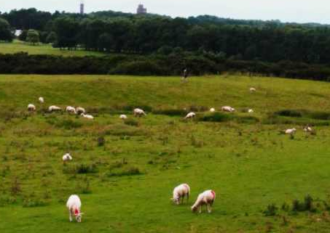
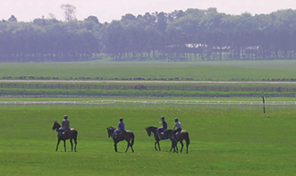
The winter it is past and the summer's come at last
And the small birds are singing in the trees
Their little hearts are glad but mine is very sad
For my true love is far away from me
The rose upon the briar by the water running free
Brings joy to the linnet and the bee
Their little hearts are blessed but mine can find no rest
For my true love is far away from me
A livery I'll wear and I'll comb back my hair
In velvet so green I will appear
Chorus:
And it's straight I will repair to the Curragh of Kildare
For it's there I'll find tidings of my dear
All you who are in love and cannot it remove
I pity the pain that you endure
For experience lets me know that your hearts is full of woe
With a woe that no mortal man can cure
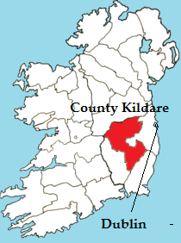

Although the song is Irish, referring to an area of common famous for horses, versions have been found throughout the British Isles. The Curragh is in Eire, not too far from Dublin, inland in County Kildare to the south-west.

In the song a young man thinks of the Curragh and the young woman he is missing so much. He remembers the beauty of the scenery but laments for his girl at the same time.

The same sentiments are expressed in so many songs as families were often split apart by the hard life in Ireland and the ‘troubles’.

Clare to Here

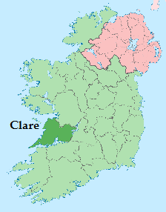
Four of us share this room and we were caught up in the craic
Sleeping late on Sundays and we never get to Mass
Chorus: It's a long way from Clare to here (x2)
It's a long, long way, It get's further by the day
It's a long, long way from Clare to here

When Friday comes around we're only into fighting
My Ma would like a letter home but I'm too tired for writing

It almost breaks my heart when I think of Josephine
I told her I'd be coming home with pockets full of green

The only time I feel alright is when I'm into drinking
It sort of dulls the pain a bit and it evens out my thinking

I sometimes hear the fiddle play, but maybe it's just a notion
I dream I see white horses dance upon that other ocean
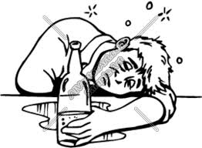
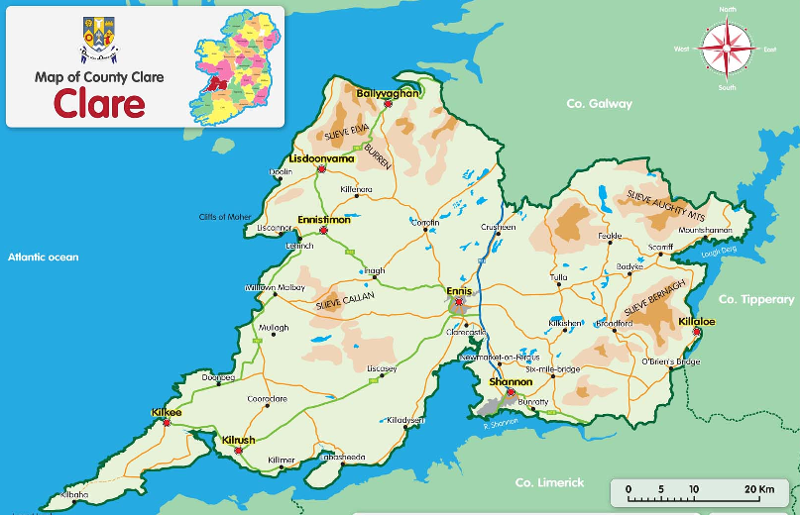
Away from home, which he clearly misses, he solves his problems through a bottle of beer or whisky. He thought he would earn a lot of money – ‘the green’ – dollars, but it isn’t working out for him. Let’s hope Josephine has a lot of patience!
Fields of Athenry
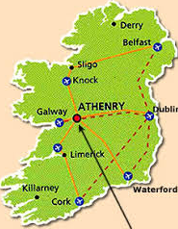
By a lonely prison wall, I heard a young girl calling
"Michael, they have taken you away,
For you stole Trevelyan's corn,
So the young might see the morn.
Now a prison ship lies waiting in the bay.“
Chorus: Low lie the fields of Athenry
Where once we watched the small free birds fly
Our love was on the wing
We had dreams and songs to sing
It's so lonely round the fields of Athenry.

By a lonely prison wall, I heard a young man calling
"Nothing matters, Mary, when you're free
Against the famine and the crown,
I rebelled, they cut me down.
Now you must raise our child with dignity.“
Theft was punishable by transportation (or earlier hanging) so her young man will be in Botany Bay, Australia

By a lonely harbor wall, she watched the last star fall
As the prison ship sailed out against the sky
For she lived to hope and pray for her love in Botany Bay
It's so lonely round the fields of Athenry.

Transportation
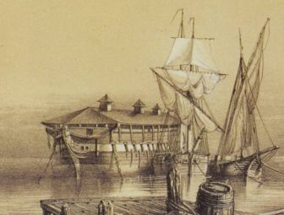

A hulk in the Thames on which convicts were kept until transported. The convicts were transported for anything from theft to murder. Conditions on the hulks was very bad and many died either there or during the passage.

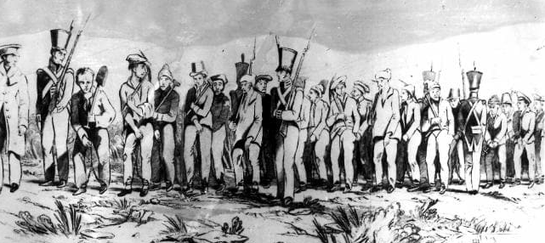
Convicts arrive in Botany Bay (near modern Sydney) after three months at sea. Survival rates were not very good, either for the prisoners or for the sailors and guards.
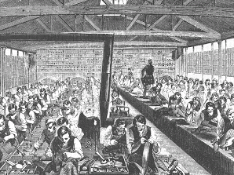

The drawing shows the teaching of convicts to make shoes and boots. When they were released they could set up with their trade

Black Velvet Band
I took a stroll with this pretty fair maid
And a gentleman passing us by
I knew she meant the undoin’ of him
By the look in her roguish black eyes.
A gold watch she took from his pocket
And placed it right into my hand
And the very first thing I said to her
Was a curse to the black velvet band.

Before judge and jury
Next morning I had to appear
The judge, he says to me, "Young man
Your case it is proven clear
I’ll give you seven years penal servitude
To be spent far away from the land
Far away from your friends and relations
Betrayed by the black velvet band

Another transportation ballad. He’ll be transported to Botany Bay and won’t be back in England any time soon!

The young lady was obviously a pick-pocket and he just wasn’t quick enough!. At this time crime was punished but there was no means of ‘detection’.
In a neat little town they call Belfast
Apprenticed to trade I was bound
And many an hour’s sweet happiness
Have I spent in that neat little town
Till sad misfortune came over me
Which caused me to stray from the land
Far away from my friends and relations
Betrayed by the black velvet band
Chorus:
Her eyes they shone like diamonds
They called her the queen of the land
And her hair it hung over her shoulders
Tied up with a black velvet band

Well, I took a stroll down Broadway
Meaning not long for to stay
When who should I meet but this pretty young maid
Come dancing along the highway
She was both fair and handsome
Her neck it was just like a swan’s
And her hair it hung over her shoulder
Tied up with a black velvet band.

Rare Old Times

Raised on songs and stories, heroes of renowned
The passing tales and glories that once was Dublin Town
The hallowed halls and houses, the haunting children's rhymes
That once was Dublin City, in the rare ould times
Chorus: Ring-a-ring-a-rosie as the light declines
I remember Dublin City in the rare ould times
Oh, my name it is Sean Dempsey, as Dublin as can be
Born hard and late in Pimlico in a house that ceased to be
By trade I was a cooper, lost out to redundancy
Like me house that fell to progress, my trade to memory
I courted Peggy Diegnan, as pretty as you please
Oh, a rogue and a child of Mary from the rebel Liberties
I lost her to a student chap, with skin as black as coal
When he took her off to Birmingham, she took away my soul
The years have made me bitter, the gargle dims my brain
For Dublin keeps on changin' and nothing stays the same
The Pillar and the Met are gone, the Royal long since pulled
As this gray unyielding concrete makes a city of our town
Fare thee well sweet Anna Liffey, I can no longer stay
And watch the new glass cages that spring up along the Quay
My mind's too full of memories, too old to hear new chimes
I'm part of what was Dublin, in the rare ould times
Parting Glass

Of all the money e'er I had,
I spent it in good company.
And all the harm I've ever done,
Alas! it was to none but me.
And all I've done for want of wit
To mem'ry now I can't recall
So fill to me the parting glass
Good night and joy be with you all
Oh, all the comrades e'er I had,
They're sorry for my going away,
And all the sweethearts e'er I had,
They'd wish me one more day to stay,
But since it falls unto my lot,
That I should rise and you should not,
I gently rise and softly call,
That I should go and you should not,
Good night and joy be with you all.
If I had money enough to spend,
And leisure time to sit awhile,
There is a fair maid in this town,
That sorely has my heart beguiled.
Her rosy cheeks and ruby lips,
I own she has my heart in thrall,
Then fill to me the parting glass,
Good night and joy be with you all.

A song for the end of any night
Sung unaccompanied.

The ‘Liffey’ is the river flowing through Dublin. A child of Mary is a Roman Catholic. The Liberties is an area of Dublin. A cooper made barrels in which most food and drink was stored and shipped.

I Know my Love
The Old Triangle

Oh! a hungry feeling, it came o'er me stealing
And the mice they were squealing in my prison cell
And the ould triangle, went jingle jangle
All along the banks of the Royal Canal.

To begin the morning, the screw was bawling
Get up you bowsies and clean out your cell
And the ould triangle, went jingle jangle
All along the banks of the Royal Canal.

In the female prison there are seventy-five women
It's among them I wish I did dwell
And the ould triangle, went jingle jangle
All along the banks of the Royal Canal.

I wish to blazes they'd change the wages
from fifty shillings ah to two pounds ten.
Then the ould triangle, could go jingle jangle
All along the banks of the Royal Canal.
All along the banks of the Royal Canal.

Written by Brendan Behan when in prison.

I know my love by his way of walking
And I know my love by his way of talking
And I know my love in a jacket blue
And if my love leaves me what will I do
Chorus:
And still she cried I love him the best
And a troubled mind sure 'twill know no rest
And still she cried bonny boys are few
And if my love leaves me what will I do
There is a dance hall in the Mardyke
And it's there my love he goes every night
And he sits a queer one down on his knees
And don't you know how it vexes me
If my love knew I could wash and wring
And if my love knew I could weave and spin
I would weave a coat of the fines kind
But the want money leaves me behind
I know my love is a handsome Rover
And I know he'll roam the whole world over
And in dear old Ireland no longer tarry
And an English girl sure he's sure to marry

My Little Son

1. Come my little son and I will tell you what we’ll do
Undress yourself and get into bed and a tale I’ll tell to you
It’s all about your daddy he’s a man you seldom see
For he’s bound to roam far away from home
Far away from you and me
Chorus:
Remember daddy he’s still your dad, Though he’s working far away
In the cold and heat all the hours of the week, On England’s motorway

2. When you fall and hurt yourself and get up feelin’ bad
It isn’t any use now, callin’ for your dad
For the only time since you were born he’s had to spend with you
He was out of a job and he hadn’t a bob he was signing on the brew

3. Sure we’d like your daddy here, sure it would be fine
To have him working nearer home and to see him all the time
But beggars can’t be choosers and we have to bear our load
For we need the money your daddy earns workin’ on the road

Chorus 2: Remember daddy he’s still your dad, And he’ll soon be home to stay
For a week or two with me and you, While he builds the motorway

A modern song of an Irishman working away from home on Motorway construction. Both Irish men and women worked on the construction of canals, then railways and then motorways. They were called ‘navvies’ or ‘navigators’ because of the association with canals.

Song for Ireland
Laughing all the day,
With true friends who try to make you stay,
Telling jokes and news,
And singing songs to pass the night away,
We watched the Galway salmon run,
Like silver dancing, darting in the sun,
When living on your Western shore,
Saw the summer sunset, I asked for more,
I stood by your Atlantic Sea,
And sang a song for Ireland

Dreaming in the night,
I saw a land where no man had to fight,
And waking in your dawn,
I saw you crying in the morning light,
Lying where the falcons fly,
They twist and turn all in your air-blue sky,
Living on your western shore,
Saw the summer sunset, I asked no more,
I stood by your Atlantic sea,
And sang a song for Ireland
Walking all the day
By tall towers where falcons build their nests
On silver wings they fly,
For they know the call for freedom in their breasts,
We saw Black Head against the sky
With twisted rocks that run down to the sea
Living on your Western shore,
Saw summer sunsets, I asked for more,
I stood by your Atlantic Sea,
And sang a song for Ireland

Drinking all the day,
In old pubs where fiddlers love to play,
Saw one take the bow,
To play a reel that was so grand and gay,
I stood on Dingle Beach and cast,
In the wild foam for the Atlantic bass,
When living on your Western shore,
Saw the summer sunset, I asked form more,
I stood by your Atlantic Sea,
And sang a song for Ireland

A modern song set to a traditional Ghaelic tune. Galway, the City and County, is on the West coast, the Atlantic coast of Eire. The words do not reach the heights of the music, however.

Muirsheen Durkin

In the days I went a courtin', I was never tired resortin'
To the alehouse and the playhouse or many a house beside,
I told me brother Seamus l'd go off and go right famous
And before l'd return again l'd roam the whole world wide.
Chorus:
So goodbye Muirsheen Durkin, l'm sick and tired of working,
No more I'll dig the praties, no longer I'll be fool.
For as sure as me name is Carney, I'll be off to California,
where instead of diggin' praties, I'll be diggin' lumps of gold.

I've courted girls in Blarney, in Kanturk and in Killarney
In Passage and in Queenstown, that is the Cobh of Cork.
But goodbye to all this pleasure, for l'm going to take me leisure
And the next time you will hear from me
Will be a letter from New York,

Goodbye to all the boys at home, l'm sailing far across the foam
To try to make me fortune in far America,
For there's s gold and money plenty for the poor and gentry
And when I come back again I never more will stray,

Another drinking song. He’s off to America to dig gold instead of potatoes (praties).

I’ll tell me Ma’
Let the wind and the rain and the hail blow high
And the snow comes travellin' through the sky
She's as sweet as apple pie
She'll get her own lad by and by
When she gets a lad of her own
She won't tell her ma when she gets home
Let them all come, as they will
For it's Albert Mooney she loves still

I'll tell me ma when I go home
The boys won't leave the girls alone
They pull my hair, they stole me comb
But that's alright 'till I go home
She is handsome, she is pretty
She is the belle of Belfast City
She is a courtin' one two three
Pray won't you tell me who is she?

I'll tell me ma when I go home
The boys won't leave the girls alone
They pull my hair, they stole me comb
But that's alright 'till I go home
She is handsome, she is pretty
She is the belle of Belfast City
She is a courtin' one two three
Pray won't you tell me who is she?
Albert Mooney says he loves her
All the boys are fightin' for her
They knock at the door and they ring at the bell
Saying, 'Oh me true love, are you well?'
Out she comes, white as snow
Rings on her fingers, bells on her toes
Ould Johnny Morrissey says she'll die
If she doesn't get the fella with the rovin' eye

Although the song is Irish it has strong links with Liverpool. As many Irish travelled through Liverpool to America many never got further than Liverpool itself. Glasgow is similar.

There are therefore two versions of the song – for the majority protestants its this version with Belfst City, but for the Catholic population it is Dublin City in Eire which is majority Catholic.

Belfast, of course was where the Titanic was built (at Harland and Wolff’s shipyard) and Liverpool is the port from which she sailed.

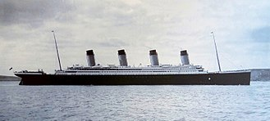

Titanic off Cork 11th April 1912

