Britain has always had close links with the sea, being an island and its dominance of maritime trade in the 18th and 19th centuries meant that people were familiar with the ‘big world’, particularly through the seamen who worked the boats and soldiers who fought to create an empire.
Ships in both merchant ships and warships had crews which were very mixed. Merchant ships trained crews and most seamen would be rated as ‘able’. Those who were not could be rated as landsmen or may have been specialists such as surgeons.
The officers were the ‘captain’ who had overall charge, lieutenants who would deputise for the captain, keep watch etc. The ‘master’ was a non-commissioned officer who organised the work of the crew and was usually also a navigator. The officers had to learn to navigate too.
The men were organised into watches who were on duty or off duty, but being off duty did not mean they had nothing to do. They had other things to do other than be at their ‘duty stations’.
Watches and Bells
In the traditional Royal Navy watch system (a system used by most ther Commonwealth navies), 'watch' refers to a period of time and to a grouping of personnel. Those members of the crew whose work must be done at all times of the day - known as 'watch-keepers' - are assigned to one of two watches: the Starboard or the Port watch. These can be further divided into two parts, e.g. First Port, Second Starboard. These two watches - or more usually the four parts of watches - alternate in working the following watches:
- First watch: 2000 to 0000^{[1]}
- Middle watch: 0000 to 0400^{[1]}
- Morning watch: 0400 to 0800^{[1]}
- Forenoon watch: 0800 to 1200^{[1]}
- Afternoon watch: 1200 to 1600^{[1]}
- First dog watch: 1600 to 1800^{[1]}
- Last dog watch: 1800 to 2000^{[1]}

Bells
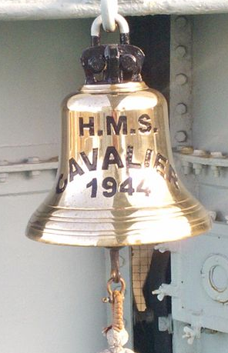
Ordinary seamen didn’t carry watches. Some officers did however, though these were not always reliable.
The men needed to know the time so there was a series of bells. These were sounded every half hour, so in a four hour watch there would be 1, 2 …up to 8 bells sounded in pairs.
This made it easier to count. 7 bells would sound like ‘ting ting (short pause) ting ting (short pause) ting ting (short pause) ting.

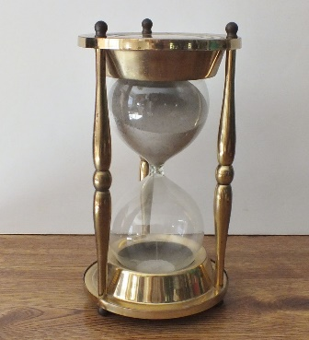
A ‘glass’ – containing sand which ran through a small hole timed the half hour periods. These were checked against an accurate clock on a regular basis. The sand would run faster if the bell was ‘warmed’, even with the hands, so the phrase ‘warming the bell’ would mean artificially speeding up the time to the next bell.
When the bell was wrung the glass would be turned, timing the next half hour. Time checks would be made daily at noon using the ships chronometer and astronomical observations.
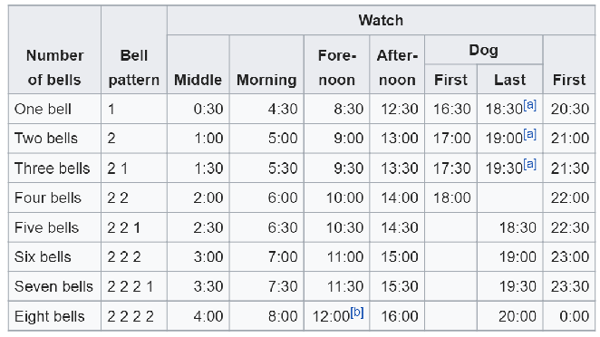
Sea Songs and Shanties
There is a difference, sea songs being those songs sung for pleasure whilst shanties are sung to aid work with a work related tempo and rhythm. The word shanty is of doubtful origin, some saying it comes from the French ‘chanter’ – to sing. There are other suggestions however. Examples are ‘Blow the man down’ and ‘Blood red roses’, the first a capstan shanty – with a regular rhythm, the second for work at the halliards for a concentrated pull, much less rhythmic.
Blow the Man Down
Come all ye young fellows that follows the sea
To me, way hey, blow the man down
Now please pay attention and listen to me
Give me some time to blow the man down

I'm a deep water sailor just come from Hong Kong
You give me some whiskey, I'll sing you a song
When a trim Black Ball liner's preparing for sea
On a trim Black Ball liner I wasted me prime
Blood Red Roses
Our boots and clothes is all in pawn
Go down, you blood red roses, go down!
And its flamin' drafty 'round Cape Horn,
Go down, you blood red roses, go down!
Oh, you pinks and posies,
Go down, you blood red roses, go down!
Sea songs are often based on tales of the sea – piracy, mermaids, Jonah’s – or about members of the ship’s crew but most often about the girls in port. At the same time the song may also be used as a shanty such as ..
Captain Kidd
Oh, my name is Captain Kidd, as I sailed, as I sailed,
Oh, my name is Captain Kidd, as I sailed.
Oh, my name is William Kidd,
Many wicked things I did,
And the law I did forbid, as I sailed, as I sailed.
Oh, I murdered William Moore, as I sailed, as I sailed,
Oh, I murdered William Moore, as I sailed.
Oh, I murdered William Moore
And I left him in his gore
Forty leagues from the shore, as I sailed, as I sailed.
So to Execution Dock I must go, I must go,
Oh to Execution Dock I must go,
So to Execution Dock,
Put my head upon the block
And no more the law I'll mock as I sail, as I sail.
Henry Martin
There were three brothers in merry Scotland
In merry Scotland there were three
And they did cast lots which of them should go
Should go, should go
And turn robber all on the salt sea
The lot it fell first upon Henry Martin
The youngest of all the three
That he should turn robber all on the salt sea
Salt sea, the salt sea
For to maintain his two brothers and he
They had not been sailing but a long winter's night
And a part of a short winter's day
When he espied a stout lofty ship
Lofty ship, lofty ship
Come bibbing down on him straight way
"Hello, hello", cried Henry Martin
What makes you sail so nigh?
I'm a rich merchant ship bound for fair London Town
London Town, London Town
Would you please for to let me pass by?
… and the tale continues with Henry Martin sinking the ship with the loss of all hands and the cargo – not the best result for anyone.
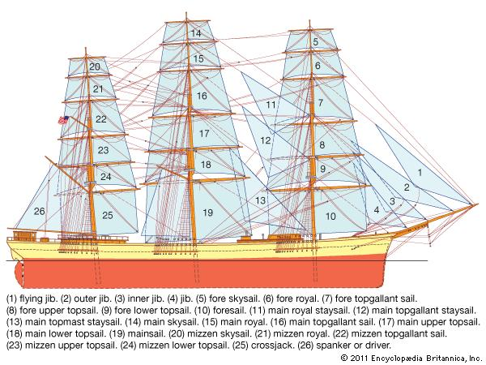
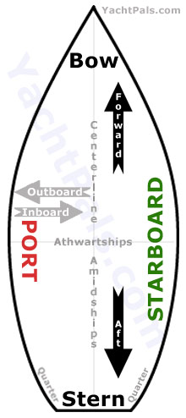
In the songs there are references to the many sea terms: the three masts (fore, main and mizzen – front middle and back), port (or larboard) and starboard – port is the left side looking forwards and starboard is the right.

The sails are ‘square sails’ – those which are hung from a ‘yard’, a heavy timber pole supported at its centre from the mast – and ‘fore and aft’ sails which hang from a rope which is attached to the mast and secured down below in front of the mast. It is important that the ship is balanced, that is that the ship when sailing travels in a straight line without any rudder being applied (the rudder is a wooden steering blade fixed to the after end (back) of the ship.
Headway and Leeway
Normally it is desirable that a ship travels in the same direction as we would wish. We would be making ‘headway’.
Unfortunately this is not achieved without also making ‘leeway’, that is moving sideways driven by the prevailing wind. The windward side of the ship is the side where the wind comes from. Looking from the windward side you would find the wind blowing in your face.
If you stand on the opposite side of the ship, however, the lee side, you would find the wind blowing in your back.
If you are on a ‘lee shore’ the ship would be near to land on the leeward side, a very dangerous situation as the ship could easily be driven onto the coast into shoals (shallow water) or rocks on a rocky coast. More ships were wrecked in this way than sunk in combat!
The Heads
Toilets on a ship are known as ‘heads’. Originally there were no toilets as such as the sea itself provided this service. The reason for the word ‘heads’ was that seamen used the netting and ropes around the bowsprit at the head of the ship for this purpose. This could be a dangerous occupation in heavy seas with waves breaking over the ship!
The captain may well have had his own ‘head’ – a small chute with a seat and hole hidden away in the corner of his cabin.
Phrases used in general language which come from the sea
(link http://www.see-the-sea.org/nautical/naut-body.htm#L )
Learning the ropes: This expression has come to mean generally learning how to perform some specific task or gain skill within some particular field of endeavour. The term comes from the important task of learning the use of the many ropes aboard a sailing vessel.
Letting the Cat out of the bag: This term comes from the old naval punishment of being whipped with a "cat o' nine tails." The whip was kept in a leather bag and when the sailors "let the Cat out of the bag" they had usually done something that would result in punishment. The term is used today to mean that someone has said something that was not to be said or revealed a secret.
Give a wide berth: Today this means to keep a safe distance which is the same as the nautical origination to avoid a collision by giving a large distance between manoeuvring vessels.
Give Leeway: From the practice of allowing extra room off a dangerous lee (downwind) shore in case of error or mishap in order to allow the vessel extra distance to manoeuver in an emergency. Today it is used to describe being more patient with someone or giving a little extra room to manoeuver.
Mind your P's and Q's: Sailors would get credit at the taverns in port until they were paid. The barman would keep a record of their drinks on a chalkboard behind the bar. A mark was made under "P" for pint or "Q" for quart. On payday, the sailors were liable for each mark next to his name, so he was forced to "mind his P's and Q's." Today the term means to remain well behaved.
No room to swing a cat: During the whipping punishment using the "cat o' nine tails," all hands were called on deck to witness. With a full crew, the deck could be so crowded that the cat o' nine tails was difficult to use without hitting other crew members. In other words, there was "no room to swing a cat." Today the expression is used to indicate crowded or packed surroundings.
On the wrong tack: This was originally a nautical term for a sailing vessel which is sailing a bit too close to the wind for that particular tack. The expression is also used to reference someone approaching a task or problem from the wrong direction or continuing in the wrong direction.
Perks: This word comes from the naval abbreviation of the word "perquisites" meaning the allowances or benefits (often money) offered with any specific office or appointment. Today the word is used outside of the navy and is synonymous with benefit or advantage, like getting a company car for ones own use.
Port and Starboard: Port is the nautical term for left and starboard means right. Originally the words come from the old sailing ships that did not have a rudder and were steered using a board on the right side which became known as the "steerboard" side, the other side of the vessel was called the port side as the boat was docked on this side so as to not interfere with the steering board.
Sailing too close to the wind: Originally an expression referring to the risk in sailing when a vessel would get too close into the wind thereby stalling the vessels forward movement. Today the expression is used to mean one is taking risks by defying rules or pushing the limits.
Square meal: This is an expression synonymous with a proper or substantial meal. It originated from the square platters that were used to serve meals aboard ships.

