Mah-Jongg
Simplified Rules
Steve Jones
Table of Contents

The Three Suits 2
Seasons and Flowers 2
The aim of the game 3
A Chow 3
A Pung 3
Start the Game 4
Build the Wall 4
Break the Wall 4
The Deal 4
Playing 5
Calling 5
Scoring 5
Scores 5
Pungs and Kongs 5
Bonus Scores 6
Value of Hand 6
Paying out 7
Wind of Round 7
Odd Rules 7
Playing with Seasons and Flowers 8
Scoring with Seasons and Flowers 8
Special Hands to go Mah-Jongg 9
THIRTEEN ODD MAJORS 9
CALLING NINE TILE HAND 9

The Three Suits

There is a total of 136 (beginners) + 8 (advanced) tiles
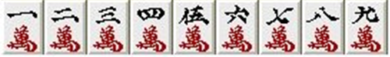
Suit of Characters – 1 to 9
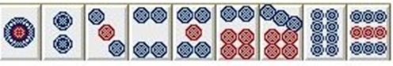
Suit of Wheels – 1 to 9
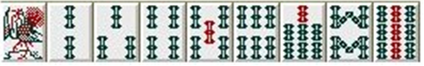
Suit of Bamboos – 1 to 9
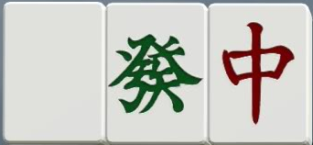 White, Green and Red Dragons
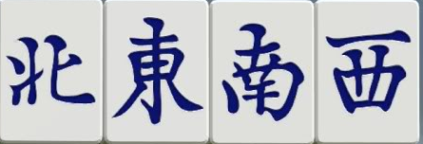 N, E, S and W Winds
There are 4 of each of these tiles making a total of 136 tiles in all.

Seasons and Flowers

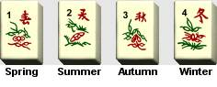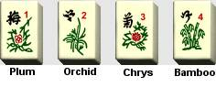
These tiles are only used when players are advanced. The 8 tiles can be removed at the beginning and play no part for the beginner’s game.

The aim of the game
… is to collect a hand of 14 tiles consisting of 4 sets of three and a pair – called Mah-Jongg
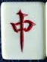
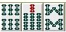
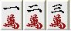
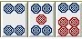
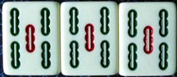

Pung Chow Chow Chow Pair to finish

A Chow
… is a set of 3 consecutive tiles of the same suit.
1,2 & 3 of Characters 6, 7 & 8 of Bamboos 4, 5 & 6 of Wheels

A Pung
… is a set of 3 identical tiles of the same suit.
We can have Pungs in suits (Characters, Wheels, Bamboos) and Honours (Dragons and Winds)
5 of bamboos Red Dragons 3 of Wheels
A Kong
… is a set of 4 identical tiles of the same suit.
We can have Kongs in suits (Characters, Wheels, Bamboos) and honours (Dragons and Winds)

Red Dragons 3 of Wheels Concealed Kong of 3 of Wheels
A Concealed Kong - laid on table when tile is picked up from wall. Two outer tiles face down.

Start the Game
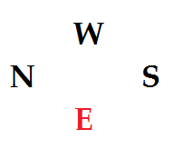
- Remove the four Seasons and Flowers tiles – unless players are experienced
- Each player throws the two dice and the highest becomes East Wind (E)
- The other players are allocated N, S and W
Note: Play is conducted ANTI CLOCKWISE unlike most conventional card games

Build the Wall
The 136 tiles (or 144 if playing with Seasons and Flowers) are placed face down and ‘shuffled’.
Each player creates a wall 17 (18 if using Seasons and Flowers) tiles long, 2 tiles high and pushes his wall to create a square …
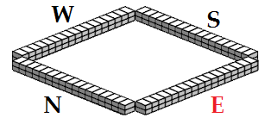

Break the Wall
East Wind throws 2 dice to decide which wall is to be broken. 5, 9 = East. 2, 6, 10 = South. 3, 7, 11 = West. 4, 8, 12 = North.
Selected Wind throws 2 dice to decide where on their wall it is to be breached (added to East Winds throw) counting from the right end. EXAMPLE: East Wind throws 2+6 = 8, then North Wind (selected wall) throws 2+4 = 6 gives a total of 8+6 = 14. The wall is breached 14 tiles from the right of North’s wall.
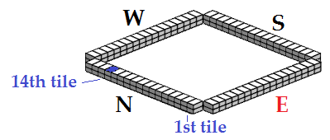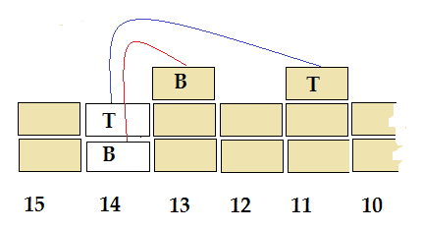
The top tile of the 14th row is placed on top of the wall to the right of the break 11 tiles from the right and the bottom tile 13 from the right. These two tiles are called LOOSE TILES as we see later.

The Deal
Players now take tiles 4 at a time starting with East Wind then S, W, N repeated 3 times until each player has 12 tiles.
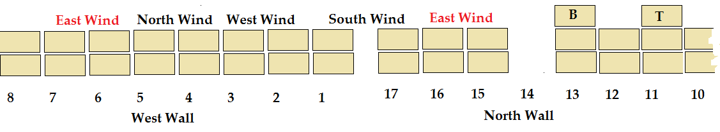
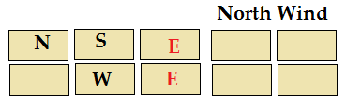
After North Wind has taken his last 4 tiles East Wind takes the next two then S, W and N a single tile giving East 14 tiles and the others 13 each.

Playing
- East wind already has 14 pieces and doesn’t need to draw from the wall. He arranges his hand and discards SAYING OUT LOUD WHAT HE DISCARDS e.g 9 of wheels.
- South Wind looks at the discard. If he has 2 tiles which can make a Chow he can pick it up saying ‘Chow’ (only the player whose turn it is can ‘Chow’ unless the player can make Mah-Jongg). He lays the two pieces he has on the table and adds the discard to make a Chow. If he has two identical pieces he can pick it up saying ‘Pung’ and if he has three identical, saying ‘Kong’, but so can the other players and they lay down the 2/3 pieces and pick up the discard. Otherwise he takes a piece from the wall and discards SAYING OUT LOUD WHAT HE DISCARDS e.g 9 of wheels, and the play passes to West Wind.
- If another player calls ‘Pung’ or ‘Kong’, the play passes direct to them and anybody in between loses their turn.
- The play continues moving anticlockwise

Calling
We have continued to play until at least 1 player says he’s ‘Calling’. ‘Calling’ means that the player needs only one more tile to make Mah-Jongg and win the hand.
The play continues with other players saying ‘Calling’ until a piece is discarded, or the player in turn picks up the piece he needs from the wall and calls ‘Mah-Jongg’. The hand is complete.

Scoring
Exposed & Concealed Hands
Exposed (on the table)
Concealed (in the hand)

Above is the earlier example of a Mah-Jongg hand. Now we need to calculate the scores – each hand separately. EXPOSED hands are those which have been put down on the table after a player has said ‘Chow’, ‘Pung’ or ‘Kong’.
CONCEALED hands are those he has made by picking from the wall or were in his original hand.

Scores

Pungs and Kongs
Chows have no value when adding up scores
Exposed Concealed
Pung 2 to 8 in any suit 2 4
Pung 1, 9, Wind, Dragons 4 8
Kong 2 to 8 in any suit 8 16
Kong 1, 9, Wind, Dragons 16 32
Completing pair
Dragons, player’s own wind or wind of the round 2
Score is doubled for:-
Pung, Kong in any Dragon, Players own Wind and Wind of the Round

Bonus Scores
Going Mah-Jongg 20
Mah-Jongg with piece from wall 2
Mah-Jongg with only possible piece 2
No Chows in hand 10
No scoring value in hand 10
Winning with last piece from wall 10
Winning with loose tile 10
Winning Hand Only:-
Hand all one suit (except winds & dragons) double
Hand of 1s, 9s, Winds, Dragons double
Hand entirely of 1 suit treble
Original hand treble
All winds & Dragons treble

Value of Hand

Exposed (on the table)
Concealed (in the hand)
Exposed Pung of 5 Bamboos 2
Exposed Chow 6, 7, 8 of Bamboos 0
Concealed Chow 4, 5, 6 of Wheels 0
Concealed Chow 1, 2, 3 of Characters 0
Pair of Red Dragons 2
For going Mah-Jongg 20
Total 24

Paying out
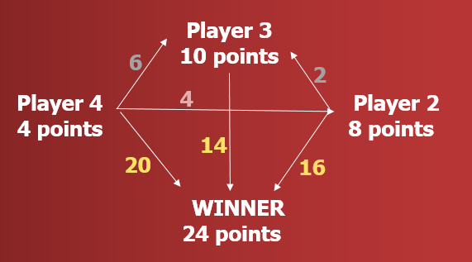
Once the scores have been determined for each hand each hand pays the difference to each other hand.

The winner receives 50 pts pays out 0 pts net +50
Player 2 receives 4 pts pays out 18 pts net -14
Player 3 receives 8 pts pays out 14 pts net -6
Player 4 receives 0 pts pays out 30 pts net -30

Wind of Round
East Wind was decided by a throw of the dice at the start.
If East Wind calls Mah-Jongg, he remains East Wind for the following hand. If not the player on his right becomes East Wind and the hand continues as before.
At first the ‘Wind of the Round’ is East Wind. Once each player has been East Wind, when the player who was first East in becomes East Wind again, then the ‘Wind of the Round’ becomes South wind and similarly, West Wind and North Wind.
This is important as the ‘Wind of the Round’ gives a double score as well as a player’s own wind.

Odd Rules
There are many special rules which inexperienced players will not need.
PRECEDENCE
A player who wishes a piece to go Mah-Jongg takes precedence over other players.
If 2 players both need the same piece to go Mah-Jongg the one whose turn is first takes precedence.
A player who needs a piece for a ‘Kong’ takes precedence over a player who needs a piece for a ‘Pung’ and a ‘Pung’ takes precedence over a ‘Chow’.
Concealed Kong
Because a ‘Kong’ has 4 pieces we have a problem as some hands will need an extra tile to enable the holder to go Mah-Jongg.
If a player calls ‘Kong’, he puts down 3 pieces onto the table and takes up the discarded piece. This is an EXPOSED KONG. He then takes one of the loose tiles to make up his hand to the correct number.
If the player has the same three pieces but picks up the fourth piece from the wall he has a CONCEALED KONG. The problem he has is he has too few pieces as he has not picked up one of the loose tiles. In this case he puts the Kong down on the table but turns over the outer two to indicate that it is concealed and therefore double the value.
Concealed Kong - 3 of wheels – laid on table when tile picked up from wall. Two outer tiles face down.

Playing with Seasons and Flowers
These tiles have no effect on the game other than to add points in scoring. Because these cause scores to be doubled the effect can be enormous. As a result players usually agree a limit to the score.
Individually the tiles score 4 points.
When a Season or Flower is …
… in the original dealt hand
… OR when one is picked up from the wall during play
… OR when one is picked up as a LOOSE TILE …
… it is laid on the table and a LOOSE TILE is taken from the wall. This ensures that the hand has the correct number of tiles.

Scoring with Seasons and Flowers
Individually the tiles score 4 points. These points are added to each hand whether winner or loser.
If you have a your OWN Season or Flower which you have laid on the table - DOUBLE YOUR SCORE ONCE. If you have FOUR Flowers OR FOUR Seasons - MULTIPLY YOUR SCORE BY THREE (TREBLE).
So if you went ‘Mah-Jongg’, are East Wind and have both Spring and Plum (East Wind’s Season and Flower) you score 8 (4 + 4) for the two tiles and you double your score ONCE for your OWN Season and ONCE MORE for you OWN Flower. If you had no other points you would score 20 (Mah-Jongg) + 8 (tiles – Season, Flower) = 28 x 2 = 56 x 2 = 112 etc.

Special Hands to go Mah-Jongg
There are several special hands with which you can go Mah-Jongg

THIRTEEN ODD MAJORS
1 & 9 from each suit (6), one of each Dragon (3), one of each Wind (4) and a pair to any of these.
1 & 9 from each suit + 3 Dragons + each Wind + pair to any
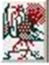
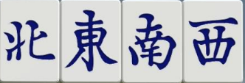
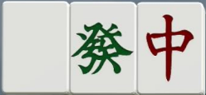
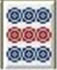
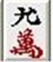
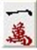

CALLING NINE TILE HAND
- all of the same suit.
3 - 1s + 2 - 8 + 3 - 9s + 1 tile
