What is so special about Children’s Songs?
Most obviously it is the lack of language skills in both the native and other languages. Do they understand the songs? Perhaps, but no more nor less than anyone with an understanding of society and the ways of the world.
What do they like?
- Repetition, something familiar
- Humour, something funny
- Ideas - Something they understand

What don’t they like?
- Complicated words and ideas
- Things they don’t understand
We try to create things which stimulate their minds and create the right atmosphere in which they can develop. With songs we have a medium which aids memory and entertains at the same time.
Most children’s songs have one of two purposes. To entertain or to educate. There are more songs on counting and numbers than anything else. We will look at ‘Ten Green Bottles’, ‘This Old Man’ and ‘One, two, three, four, five’, all counting songs. They add a further ingredient of vocabulary which is extended by songs such as ‘Heads and Shoulders’ and ‘Drunken Sailor’.
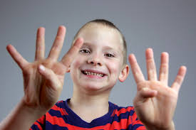
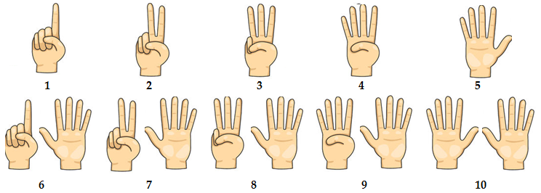
Counting with fingers is common. Everybody does it but in Britain we have to be careful as the sign for two has a different meaning. At the Battle of Agincourt (12xx) English archers made a sign to their opposite numbers. If an archer was captured they would cut off his ‘bow fingers’ (1st and 2nd finger of the right hand). By putting up these two fingers to the French it indicated that they were fully equipped archers. In the UK, therefore, it is normal that the two fingers counting two and the other counting signs, therefore, are signed with the palm outwards as seen in the picture here.
When counting to ourselves we hold the fingers with the palm facing us.
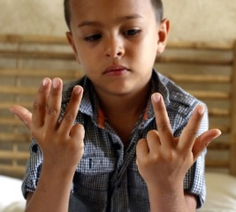
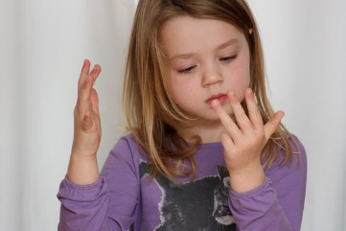
Here are two children using their fingers to count in a way which feels natural.

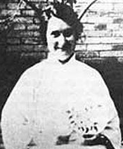
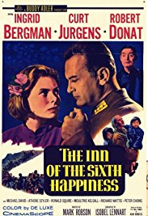
Songs have rhymes and these are often used in songs for Children. ‘This Old Man’ is a song where such rhymes are used.
This old man he played (number 1 to 10) he played knick-knack on my (image 1 to 10)
Left: Poster of the 1958 film and the real Gladys Aylward: This song was used as the theme of the 1958 film called ‘The Inn of the Sixth Happiness’, the true story of a missionary working in China during the Sino- Japanese war 1935-1945. The children (over 100) sang the song throughout their long march across china to the then capital Nanking. Despite being wounded she survived and returned to Britain in 1942.
1 Thumb 2 Shoe
3 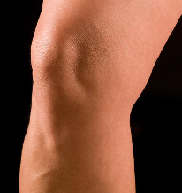 Knee 4 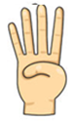 Door
5 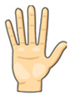 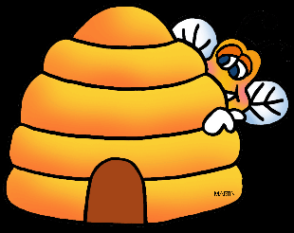 Hive 6 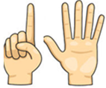 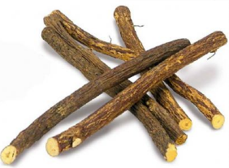 Sticks
7 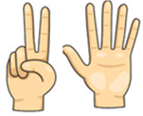 Up in Heaven 8 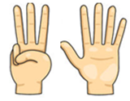 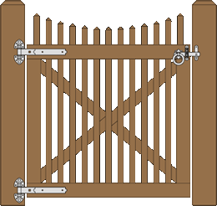 Gate
9 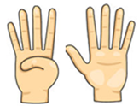 Line 10 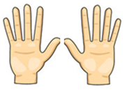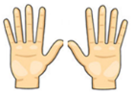 Once again

This Old Man

1. This old man he played one, He played nick-nack on my thumb
Chorus:
With a nick-nack paddy-wack give a dog a bone
This old man came rolling home
2. This old man he played two, He played nick-nack on my shoe
3. This old man he played three, He played nick-nack on my knee
4. This old man he played four, He played nick-nack on my door
5. This old man he played five, He played nick-nack on my hive
6. This old man he played six, He played nick-nack on my sticks
7. This old man he played seven, He played nick-nack up to heaven
8. This old man he played eight, He played nick-nack on my gate
9. This old man he played nine, He played nick-nack on my line
10. This old man he played ten, He played nick-nack once again

Ten Green Bottles
One, two, three, four, five

1. One, two, three, four, five
Once I caught a fish alive
Six, seven, eight, nine, ten
Then I let it go again

2. Why did you let it go
Because it bit my finger so
Which finger did it bite
This little finger on the right
Ten green bottles standin’ on the wall (x2)
And if one green bottle should accidentally fall
There’ll be nine green bottles standin’ on the wall.
Nine green bottles standin’ on the wall
And if one green bottle should accidentally fall
There’ll be eight green bottles standin’ on the wall.
Last verse
One green bottle standin’ on the wall
And if one green bottle should accidentally fall
There’ll be no green bottles standin’ there at all.

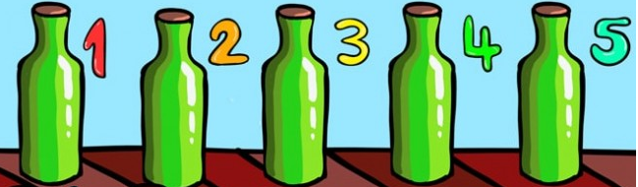
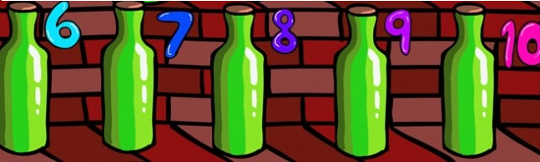

Now for some parts of the body. We start with just these – head, shoulder, knees, toes, eyes, ears, mouth and nose. But there are more and these can be introduced too.

Heads and shoulders knees and toes

Heads and shoulders knees and toes, knees and toes
Heads and shoulders knees and toes, knees and toes
And eyes and ears and a mouth and a nose
Heads and shoulders knees and toes, knees and toes

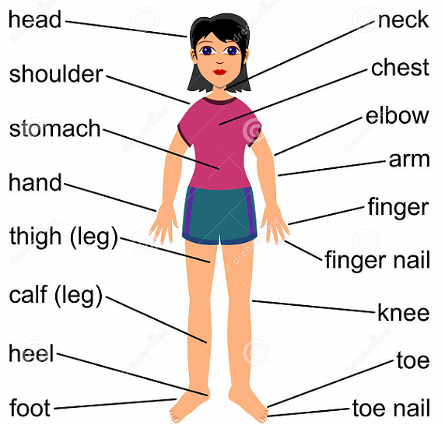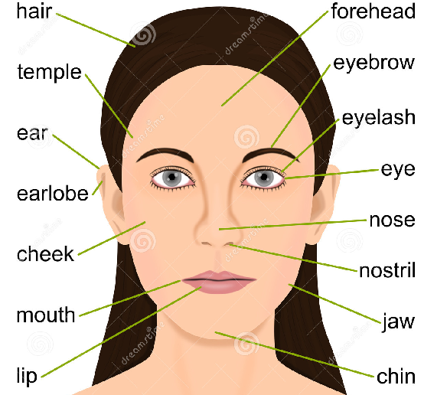

Drunken Sailor
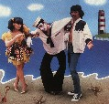
1. What shall we do with the drunken sailor (3x)
Early in the morning

Chorus: Hoo-ray and up she rises (3 x),
Early in the morning
2. Put him in the longboat till he’s sober (3x), Early in the morning
3. Pull out the plug and wet him all over (3x), Early in the morning
4. Shave him on the belly with a rusty razor (3x), Early in the morning
5. That’s what we’ll do with the drunken sailor (3x), Early in the morning

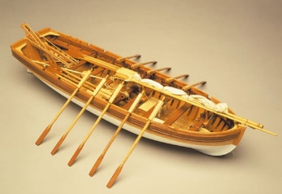
Verse 2
A longboat - a small boat for transferring people/goods to another ship or the shore

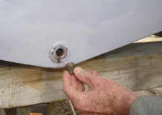
Verse 3
A plug in the bottom of a boat allows sea-water or rain-water to be emptied out before it’s used. A boat full of water’s impossible to launch as it’s very unstable.

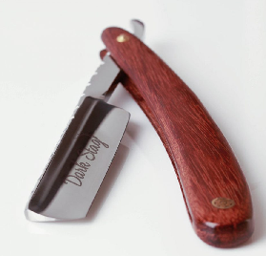
Verse 4
Belly – ‘tummy’ or stomach
A razor is used to shave – it should be very sharp NOT RUSTY

Skip to my Lou
Grand old Duke of York

Oh, The grand old Duke of York,
He had ten thousand men;
He marched them up to the top of the hill,
And he marched them down again.
And when they were up, they were up,
And when they were down, they were down,
And when they were only half-way up,
They were neither up nor down

1. Lost my partner what’ll I do (x3)
Skip to my lou my darling

Chorus:
Lou, lou skip to my lou (x3)
Skip to my lou my darling

2. I’ll find another one prettier than you (x3)
Skip to my lou my darling
3. Flies in the buttermilk shoo, shoo, shoo (x3)
Skip to my lou my darling
4. Cows in the meadow moo, moo, moo (x3)
Skip to my lou my darling

Skip to my Lou is the kind of music you would dance to and the words have no real significance. Children can make up their own verses easily. One pupil decided he liked ‘ I’ve got a pig that’s prettier than you’.
Grand old Duke of York
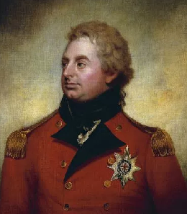
To make the song more fun you can sing the first time with all the words then subsequent verses without the ‘ups’, without the ‘downs’ and without both ’ups and downs’. The can point up and down at the times the words appear in the song, whether sung or not.
Grand old Duke of York

(The portrait left is of the ‘Duke of York and Albany’, around 1800, when he was nominally commander of the British army)

His name was Frederick and he was known by all as ‘Fat Freddy’. His brother, the Prince of Wales, was regent at the time.

George III was King of Great Britain and King of Ireland from 25 October 1760 until the union of the two countries on 1 January 1801, after which he was King of the United Kingdom of Great Britain and Ireland until his death. He was followed by George IV who died in 1830, The Napoleonic wars began in the late 1780s and ended in 1815 at Waterloo.

The first son of the British Monarch holds the title ‘Prince of Wales’ which dates back to the reign of Edward 1 (who built all the Welsh Castles. The second son has the title Duke of York.

This rhyme or song pokes fun at the generals of the time who bought their commissions in the Army and whose rank was not on merit. The family originated in Hanover, Germany but the later Georges were thoroughly anglicised. They changed the name of their house from Hanover to Windsor.
This contrasts with the Navy at the time where all officers were required to pass examinations in seamanship and navigation, many Admirals coming from a non-aristocratic background. The best example is Nelson (Died at Trafalgar 1805) who was the son of a country parson.

