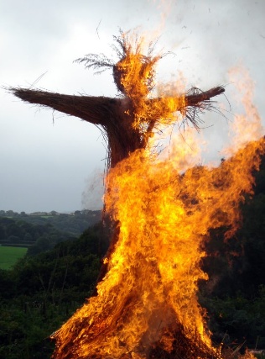
Pagan, North European Symbols and the Solstice
Holly and ivy are both plants, evergreens, used throughout winter in pagan times to brighten up the home. December 21st to January 1st (the winter solstice in the northern hemisphere), otherwise known as Yule or Yuletide ("Yule time") was and is a festival observed by the ancient North Europeans. This has been linked to the celebration of the Wild Hunt, the god Odin, and the pagan Anglo-Saxon Mōdraniht. It is a festival of light and includes processions with torches the burning of Viking boats, the Festival of Beltane (burning of a wicker man)
Terms such as Yule are used in the Nordic countries for Christmas with its religious rites, but also for the holidays of this season. Today Yule is also used to a lesser extent in the English-speaking world as a synonym for Christmas. Present day Christmas customs and traditions such as the Yule log, Yule goat, Yule boar, Yule singing, and others stem from pagan Yule. Today the event is celebrated in Heathenry and some other forms of Modern Paganism.
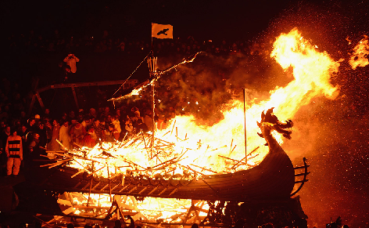
The symbols (holly, ivy, mistletoe etc) were hijacked by Christianity in Roman times, although their association with paganism was too much for many at the time and only gained slow acceptance. Songs such as ‘the Holly and the Ivy’ and ‘the Holly bears a berry’ simply link the plants to Christian ideas. Mistletoe suffers in the same way.
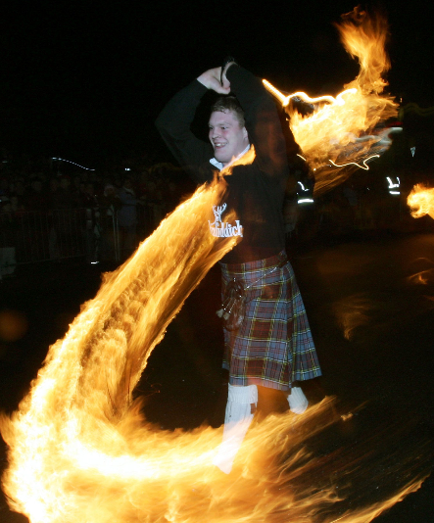
As Christianity developed in the middle east it is hardly surprising that these Northern European species do not feature early on in Christianity.
Many popular customs associated with Christmas developed independently of the commemoration of Jesus' birth, with certain elements having origins in pre-Christian festivals that were celebrated around the winter solstice by pagan populations who were later converted to Christianity.
Today in Scotland and the Shetland Isles much of the old Norse winter solstice traditions are reconstructed such as the fireball swingers, boat burning and fire festivals.
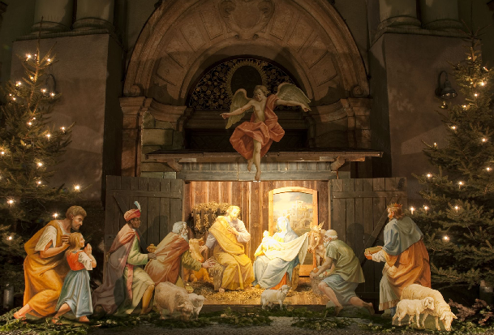
The Birth of Jesus – the Nativity
Most scholars assume a date of birth between 6 and 4 BC, and that Jesus' preaching began around AD 27–29 and lasted one to three years. They calculate the death of Jesus as having taken place between AD 30 and 36.
During Reformation and up until the middle of the 1800s, Christmas was often not celebrated because partying and merry making was seen as unchristian. From about 1840, celebrating Christmas became more widespread. December 25th was declared a federal holiday in the United States in 1870.
Although it is not known why December 25th (January 7th in the Gregorian Calendar) became a date of celebration, there are several factors that may have influenced the choice. December 25th was the date the Romans marked as the winter solstice, the shortest and darkest day of the year, and the first day in which the days would begin to elongate and the Sun would have a longer presence in the sky. The 12 days of Christmas were thus fixed as 25th December to 6th January.
Traditional Food – the Christmas Dinner
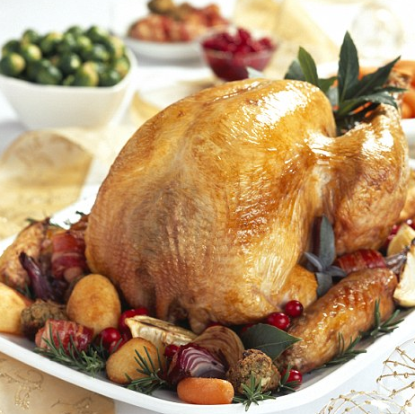
The traditional British Christmas meal is said to be Turkey, with sage and onion stuffing, and vegetables such as roast potatoes, carrots, parsnips and Brussels sprouts. Served with a thick gravy made from the dripping from the turkey, the turkey is eaten sliced.
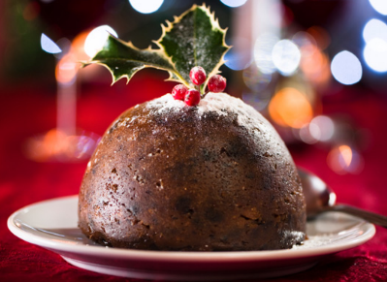
After the dinner (eaten normally at mid-day) comes the Christmas pudding (right) which is normally doused in brandy and set alight

Accompanying Christmas dinner
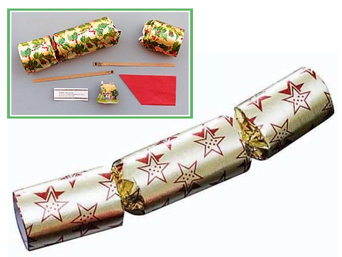
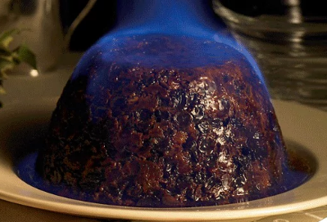
Set out on the table at the dinner are the usual knife, fork and spoon but also a Christmas cracker containing a silly paper hat, a small piece of paper with a joke written on it and a small ‘banger’, a small ‘present’, something cheap and plastic or something much nicer in more expensive ones.

Special Foods eaten after dinner or separately
The Christmas Cake or Yule Log
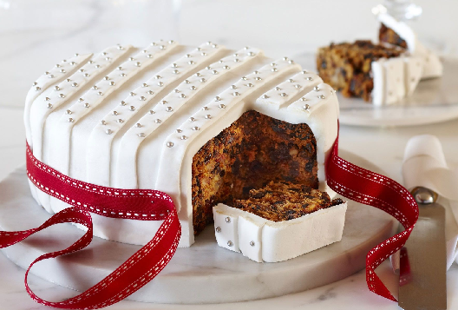
The traditional British Christmas cake is a full fruit cake with a coating of almond paste and Royal icing. It is normal to decorate the cake with ‘piping’ and decorations.
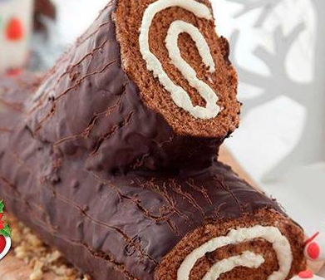
The Yule log is normally chocolate ‘Swiss roll’ coated with chocolate.
These are eaten over the Christmas holiday and into the new year, often instead of a full meal when the family has already over indulged.
Mince Pies
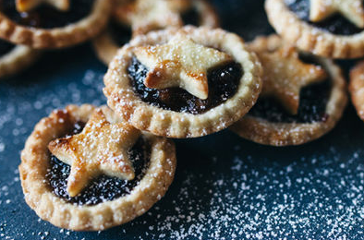
Mince pies are sweet pies of British origin, filled with a mixture of dried fruits and spices called "mincemeat", that is traditionally served during the Christmas season in the English-speaking world. Its ingredients are traceable to the 13th century, when returning European crusaders brought with them Middle Eastern recipes containing meats, fruits and spices.
Mincemeat is thought to have originated from the left-over meat to which spices were added to cover the taste of the meat as it went off. Gradually there were more spices than meat over the days. The pie is made with sweet pastry used in confectionaries (sweets).

Father Christmas and the Chimney!
When Father Christmas (or Santa Claus – diminutive of Saint Nicholas) arrives on the evening of Christmas Eve or early Christmas day, he does so by coming down the chimney flue (traditionally) though there are problems nowadays with the more normal use of central heating in houses.
The focus of the room, therefore is the fireplace and surround with its mantle-piece. On the mantle-piece will be decorations – candles, lights, etc – and hanging along the mantle will be Christmas stockings, one for each member of the house.
It is traditional to leave a glass of brandy and some mince pies for Father Christmas to eat when he arrives. He will not visit, however, if children are about. Amazingly the brandy and mince pies are always found eaten in the morning and in their place there will be full stockings of presents and maybe some larger packages too.
Beside the fire there will often be a Christmas Tree following the North European tradition of bringing in greenery at the winter solstice, In Britain this tradition only came in around 1850 when Prince Albert (Saxony - Saxe-Coburg) married the young Queen Victoria.
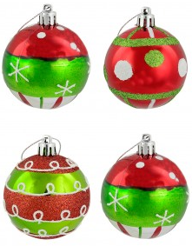
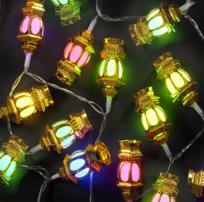
The tree is normally covered with lights (electric nowadays but candles in the past), decorated glass balls and other decorations.

The image we see of Santa Claus comes from the 1930s, a Coca Cola advert, however there are more traditional images

