Contents

Aim of the Game 1
Selecting the SETTER 1
Starting the Game 1
The Setter 2
The First Hand 2
Judging a Dispute 3
The New Setter 4
Future Rounds 5
Continuing the game 5
The end of the game 5

Aim of the Game

The game is designed to adapt the game of Scrabble but to include the need for conversation, making it far more interactive. It combines the best aspects of Scrabble with the TV game of Countdown.

Selecting the SETTER

Unlike Scrabble, Scrabbledown uses a single hand of 9 tiles which each player can see. The selection is made in turn. Each player draws a tile. The highest tile becomes the setter for the first round. The other players will play in the first round. The setter misses the round he sets up.

Starting the Game

To begin the game the setter selects 9 tiles ready to display to the other players. He will not play in this round

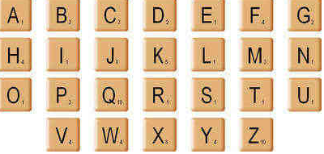

The Setter

The setter reveals the 9 tiles to the other players and times 1 minute.

In this minute the players have to create the LONGEST word they can and write it down. The player who creates the longest word (the play winner) now places it on the board and receives the number of points equal to the number of letters in his word (or with a bonus of 10 points for using all of the letters). If two players make words of the same length, the one with the highest Scrabble score wins and if the Scrabble scores are the same the one with the letter nearest the Z wins. The other players receive points equal to the number of letters in their word if the word is accepted (under the normal scrabble rules – no names etc.)

The First Hand

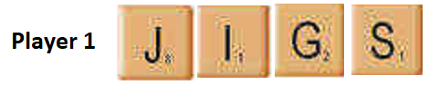
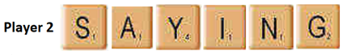
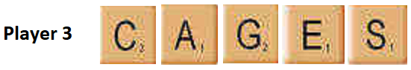
Player 2 has the longest word and gets 6 Countdown points. The word ‘saying’ is then placed on the board.
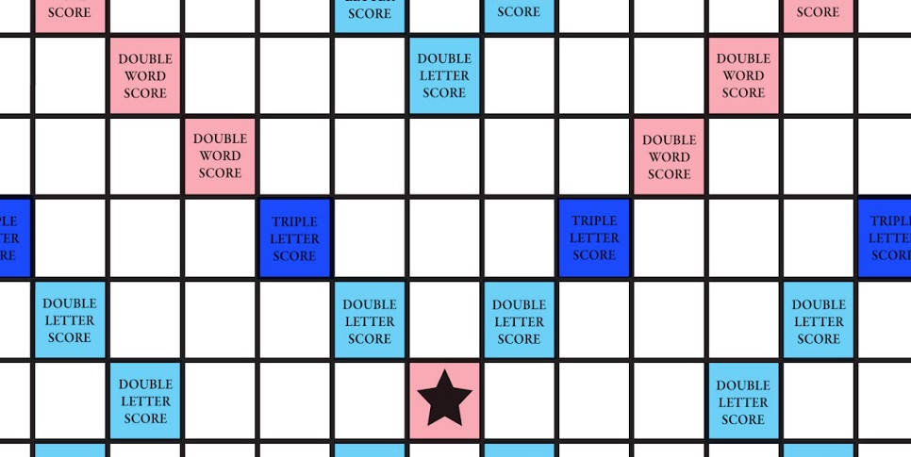

This word is now placed to make the maximum Scrabble score possible which the winner also receives. This score takes account of double and treble word and letter scores as shown on the board.

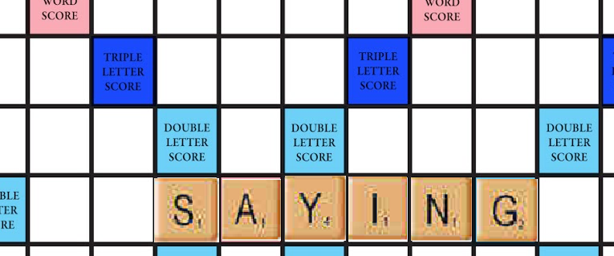

Player 2’s scrabble score is 1 + 1 + 4 + 1 + 1 + 2x2 (double letter score) = 12 x 2 = 24 (double word score). He also has his 6 points from his longest word score, a total of 30 points. Player 1 scores 4 points, player 3 scores 5 points. Player 4, who was the setter in this round scores 0 points but will be a player in the next round. Player 2, who won this round, becomes the setter for the next round.

Judging a Dispute

The setter is the judge in any dispute in that play in which he is not participating.

The New Setter

The play winner now becomes the setter. He selects sufficient tiles to make 9 in total without the other players seeing and reveals them to the other players as in the first play.

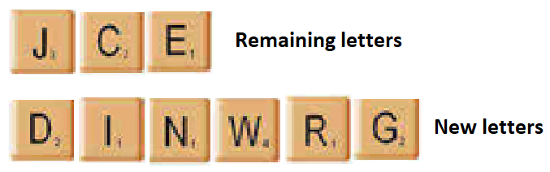

This time and for all subsequent plays the word created can include words or letters already on the board and the count of letters includes the number of letters included in any word(s) created. If the same letter is used in two words created it is counted twice. Using all of the tiles gains a bonus of 10 points as before.

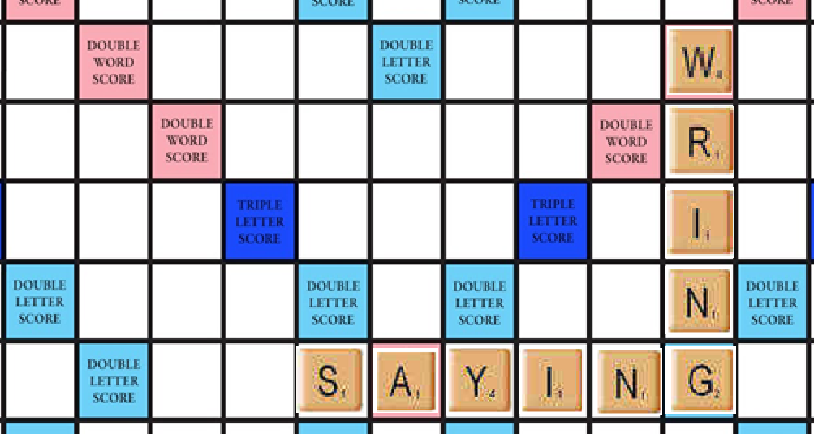

The player whose word was ‘wring’ (to remove water from an object by twisting it), gets the score for his word 4 + 1 + 1 + 1 + 2 x 2 (double letter score) = 11 x 2 (double word score) = 22 + 5 (Countdown longest word) = 27 points.

Future Rounds

The winner puts his selection on the board, gets the Scrabble score and becomes the setter for the next round. This ensures that every competitor has an opportunity to participate at every level.

Continuing the game

We continue with the winner as the new setter until all of the tiles are used up. The person completing the board gains a bonus of 10 points.

The end of the game

The GAME CHAMPION is the person with the highest number of points overall.

