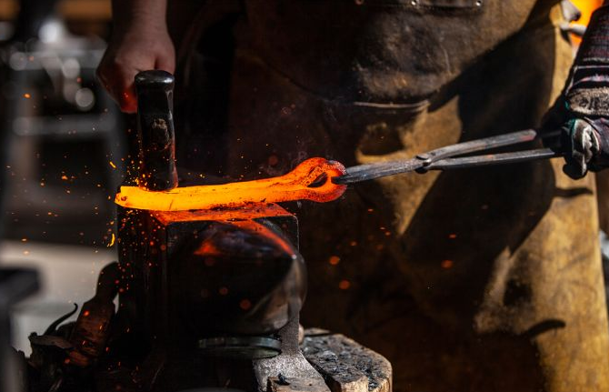
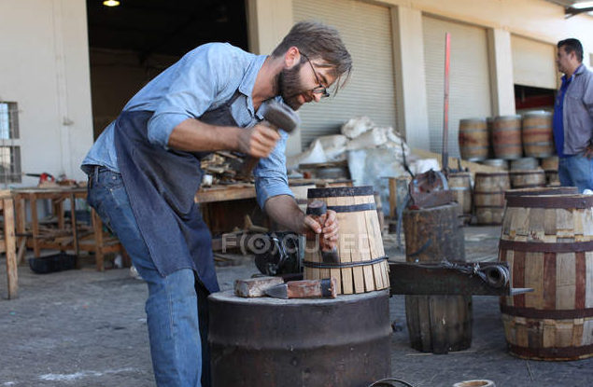
Which is which?
Fletcher
Wheelwright
Cartwright
Cooper
Blacksmith

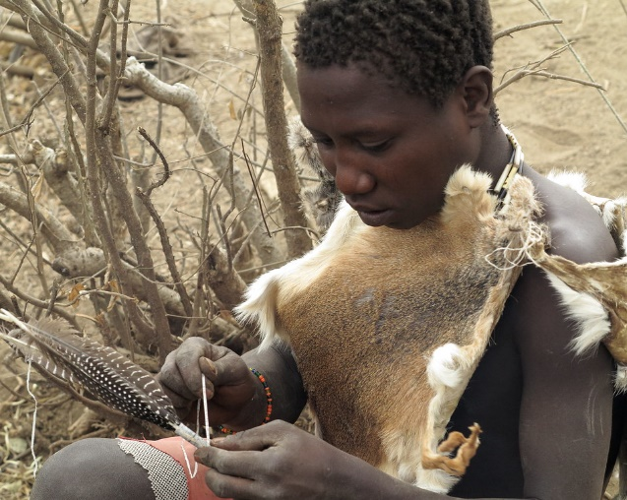
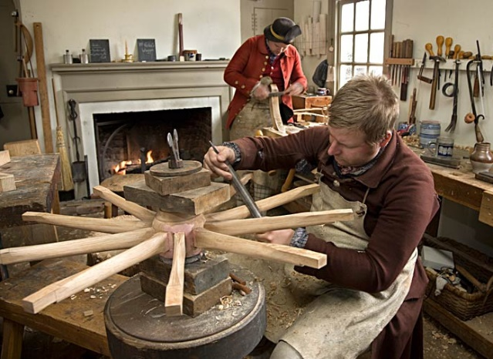

Carpenter
Joiner
Glazier

OCCUPATIONS
Archer
Barber
Bishop
Bowman
Butcher
Butler
Chandler
Constable
Cook
Cutler
Cooper
Falconer
Farmer
Fisher
Forester
Fletcher
Fuller
Gardiner
Glazier
Glover
Goldsmith
Hawker
Hunter
Judge
Keeper
Knight

Mariner
Mason
Miller
Painter
Parsons
Ploughman
Purser
Porter
Sadler
Sawyer
Seaman
Sellers
Shearer
Shepherd
Shoemaker
Steward
Smith
Tanner
Thatcher
Tiller
Tinker
Turner
Tyler
Waggoner
Weaver
Yeoman
UK Names relating to Colour

BLACK English
Means either "black" (from Old English blæc) or "pale" (from Old English blac). It could refer to a person with a pale or a dark complexion, or a person who worked with black dye.

BLAKE English
Variant of BLACK. A famous bearer was the poet and artist William Blake (1757-1827).

BLUE English
From a nickname for a person with blue eyes or blue clothing.

BRONSON English
Patronymic form of BROWN.

BROWN English
Originally a nickname for a person who had brown hair or skin. A notable bearer is Charlie Brown from the 'Peanuts' comic strip by Charles Schulz.

GRAY English
From a nickname for a person who had grey hair or grey clothes.

GREEN English
Descriptive name for someone who often wore the colour green or someone who lived near the village green.

GREY English
Variant of GRAY.

ROSE (1) English, French, German, Jewish
Means "rose" from Middle English, Old French and Middle High German rose, all from Latin rosa. All denote a person of a rosy complexion or a person who lived in an area abundant with roses. As a Jewish surname it is ornamental, from Yiddish רויז (roiz).

SCARLETT English
Denoted a person who sold or made clothes made of scarlet, a kind of cloth, possibly derived from Persian سقرلاط (saghrilat).

WHITE English
Originally a nickname for a person who had white hair or a pale complexion, from Old English hwit "white".

Top Surnames in UK countries

England

- Smith
- Jones
- Taylor
- Brown
- Williams
- Wilson
- Johnson
- Davies
- Robonson
- Wright
- Thompson
- Evans
- Walker
- White
- Roberts
- Green
- Hall
- Wood
- Jackson
- Clarke

Scotland

1. Smith
2. Brown
3. Wilson
4. Campbell
5. Stewart
6. Thomson
7. Robertson
8. Anderson
9. Macdonald
10. Scott
11. Reid
12. Murray
13. Taylor
14. Clark
15. Ross
16. Watson
17. Morison
18. Paterson
19. Young
20. Mitchell

Wales
- Jones (5.75)
- Williams (3.72)
- Davies (3.72)
- Evans (2.47)
- Thomas (2.43)
- Roberts (1.53)
- Lewis (1.53)
- Hughes (1.23)
- Morgan (1.16)
- Griffiths (0.96)
- Edwards (0.93)
- Smith (0.85)
- James (0.82)
- Rees (0.81)
- Jenkins (0.69)
- Owen (0.67)
- Price (0.67)
- Phillips (0.65)
- Moss (0.63)
- Driscoll (0.53)
- Collins (0.48)
- Lloyd (0.34)

Ireland
1. Murphy
2. Kelly
3. Byrne
4. Ryan
5. O'Brien
6. Walsh
7. O'Sullivan
8. O'Connor
9. Doyle
10. McCarthy
11. O'Neill
12. Lynch
13. O'Reilly
14. Dunne
15. McDonagh
16. Brennan
17. Fitzgerald
18. Daly
19. Kavanagh
20. Nolan

