Aircraft Carriers
Model No | Date | Type | Name | Number
784 | 1941 | Aircraft Carrier | Dasher | 15
785 | 1942 | Aircraft Carrier | Archer | 1
788 | 1940 | Aircraft Carrier | Victorious | 2
793 | 1980 | Aircraft Carrier | Invincible | 10
794 | 1938 | Aircraft Carrier | Ark Royal | 3
855 | 2018 | Aircraft Carrier | Queen Elizabeth | 9
1271 | 1912 | Aircraft Carrier | HMS Campania | 7
1294 | 1939 | Aircraft Carrier | Argus | 8
1295 | 1944 | Aircraft Carrier | Furious (recon) | 5
1296 | 1918 | Aircraft Carrier | Furious | 4
1297 | 1914 | Seaplane Carrier | Ark Royal | 8
1709 | 1945 | Aircraft Carrier | Melbourne ex Majestic | 13
1711 | 1941 | Aircraft Carrier | Victorious (recon) | 12
1712 | 1946 | Aircraft Carrier | Theseus | 14
1713 | 1959 | Aircraft Carrier | Hermes | 11

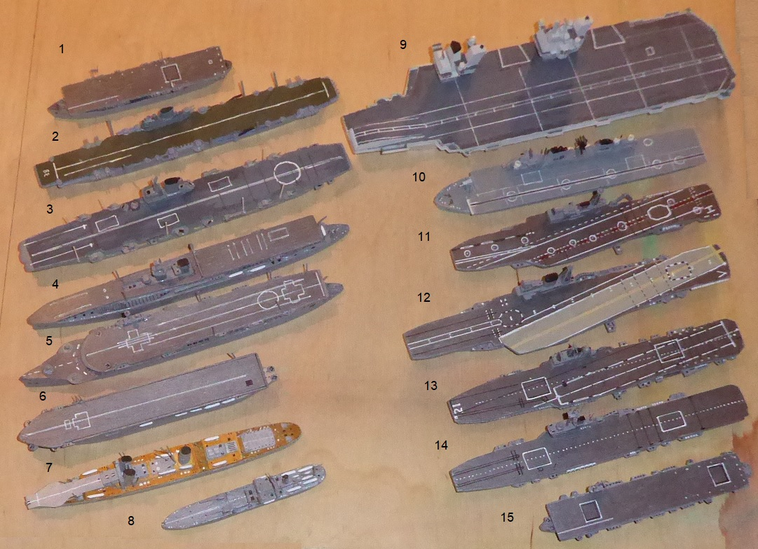
Aircraft originally went to sea as seaplanes, usually catapulted off large warships for spotting fall of shot in action. They had to be seaplanes as they could not be recovered other than by landing on water and that had to be comparatively smooth. The Ark Royal (model number 748) of 1914 was a seaplane carrier and was little more than a cargo ship with catapults. HMS Campania ex Campania (Cunard), 1912, (model number 1271) had launching facilities from ramps but was still only able to recover seaplanes.
Wheeled aircraft would require a landing platform which required the ship involved to be long enough for the aircraft to slow to a stop. By the 1920s several such ships had been built. The British Argus (model number 1294) was the first to have a through flat deck and other nations created similar ships. Italy had the Sparviero and Aquila and the US had the Ranger.
There were problems. The exhaust from the ships engines interfered with air flow for landing on if it was exhausted at the stern or on either side. It was, therefore, the ‘island’ which solved most of this problem. The ‘island’ was a piece of superstructure standing above deck level but set at the extreme edge, normally on the starboard side (one or two Japanese Carriers had the ‘island’ on the port side). As aircraft developed in size, speed and capability they required a longer landing deck or a means of stopping the planes. Arrester wires were set across the flight deck and a hook on the rear of the plane could catch onto these which brought them quickly to a stop. If they missed they could go around again, but the deck had to be kept clear. This was the state of most carriers during WW2, most completed in the late 30s and early 40s. Ark Royal (model number 794) and Eagle of the Royal Navy, the American carriers Lexington, Wasp and Ranger and the Japanese Akagi and Hiryu and Shokaku were of such a design which continued in the Formidable (UK), Essex (US) and Shinano (Jap) during WW2 with one or two carriers built by Germany (Graf Zepellin) and Italy but never completed.
During WW2 it was essential to supply air cover for convoys and for amphibious landings and smaller ‘escort carriers’ were built in huge numbers to cover this deficiency. The US Commencement Bay class was one of the most numerous and were active as a stop gap until 1945. The Royal Navy had escort carriers such as the Archer (model number 785) and Dasher (model number 784).
By the end of WW2 carriers had to change with the introduction of Jet powered planes. carriers became even larger and the flight decks had to change also. The Royal Navy modified the carrier Victorious (model number 1711, unreconstructed 788), giving it an angled deck so that the deck protruded over the port side allowing aircraft to make a loop around without the danger of running into parked aircraft.
In the 1970s and 80s the Royal Navy introduced the Invincible (model number 793) and Ark Royal, often referred to as ‘through deck cruisers’ to satisfy government strategy, designed to operate the VSTOL Harrier. At the same time they introduced the ‘ski jump’ a deck which angle up to aid the take-off of these aircraft. These were smaller than the Victorious and eventually, with the withdrawal of the Harrier, they were phased out.
The United States, in the meantime, had developed ever larger carriers, adding the angled deck and more catapults, culminating in the massive nuclear powered carriers of the Nimitz class and the most modern Gerald R Ford. The Royal Navy’s two new carriers Queen Elizabeth (model number 855) and Prince of Wales are the largest warships ever built in the UK. They will operate VSTOL aircraft from a flight deck with a ski jump and catapults, when the aircraft, a development of the Harrier, are delivered.

