Battleships  Model | Date | Name
795 | 1916 | Battleship | Resolution | 2
796 | 1916 | Battleship | Malaya | 19
797 | 1915 | Battleship | Barham | 17
798 | 1916 | Battleship | Valiant | 18
799 | 1915 | Battleship | Warspite | 1
800 | 1915 | Battleship | Queen Elizabeth | 20
809 | 1960 | Battleship | Vanguard | 21
811 | 1925 | Battleship | Rodney | 15
812 | 1920 | Battle-cruiser | Hood | 16
814 | 1860 | Battleship | Warrior | 9
815 | 1765 | Line of Battle ship | Victory | 12
914 | 1900 | Battleship | Canopus | 6
915 | 1906 | Battleship | Dreadnought | 5
919 | 1908 | Battle-cruiser | Invincible | 4
925 | 1914 | Battleship | Agincourt | 3
1291 | 1939 | Battleship | Prince of Wales | 14
1353 | 1869 | Battleship | Captain | 11
1354 | 1871 | Battleship | Cyclops | 8
1355 | 1871 | Battleship | Devastation | 7
1356 | 1875 | Battleship | Dreadnought | 10
1357 | 1918 | Monitor | Erebus | 13
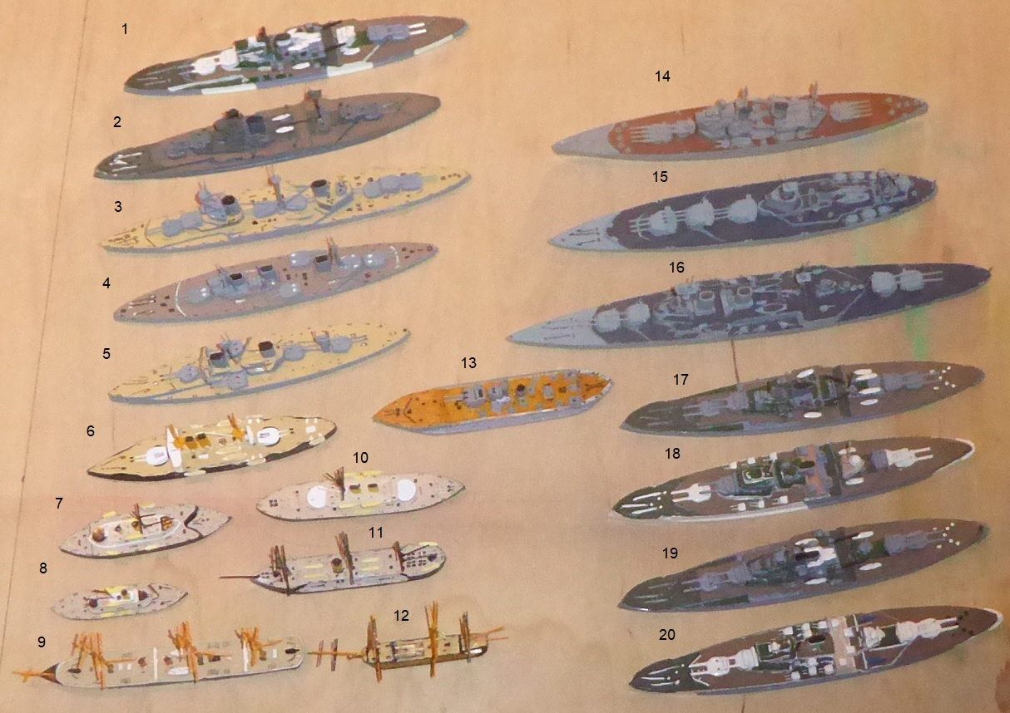
The name of this class of ship – the Battleship – comes from the term ‘Line of Battle Ship’ denoting ships of 74 guns or more which could fight in the ‘Line of Battle’ indicating how the ships were supposed to fight. The guns on such ships were on 2 or 3 decks, the lowest deck carrying the heaviest (32 pounders), the middle deck 24 pounders and the top deck 18 pounders. The strength in the ship was its broadside though as Nelson’s flagship Victory (model number 815) demonstrated cutting the enemy’s line and fighting at close quarters tended to bring about a more definite result.
The design of battleships did not change a great deal from the mid-1600s right through to the mid-1800s where sailing warships were in use during the Crimean War. In the mid 19th century the introduction of steam power (using paddles or a screw propeller) threatened to change the nature of sea warfare altogether. In response to the French armoured ship ‘Gloire’ the Royal Navy introduced the biggest, fastest and heaviest gunned ship of all, the Warrior (model number 814). In Nelson’s day ships were constructed entirely of wood and the danger during battle was from splinters as solid iron shot crashed through the sides of the ship. Iron armour was effective to some degree, however the iron was liable to disintegrate too, creating iron splinters. Warrior had an outer skin of wrought iron 4.5 inches thick with 18 inches of teak behind it as protection. It retained its masts for general use and had engines as auxiliary power. Engines were rather unreliable at the time and expensive on coal which had to be carried.
Throughout the rest of the 19th century there were many experiments made on gunnery. Even the Warrior retained its broadside though with much heavier guns which could be rotated. The next stage was to develop ships with guns in barbettes or turrets, placed along the centre line giving greater flexibility. There were many different developments as seen in the Captain (model number 1853), Cyclops (model number 1854), Devastation (model number 1855) and the 1875 Dreadnought (model number 1856) with various arrangements of armament until a more or less standard pattern was arrived at, an example is the Canopus (model number 914) which carries 4 12 inch breach loading guns in 2 turrets on the centre line, one forward and one aft. Additionally, there was usually a secondary armament of 6 inch or 9 inch guns for protection from smaller faster vessels at close quarters.
The biggest jump was in 1906 when the Dreadnought (model number 915) was completed with an armament of 10 12 inch guns in 5 turrets and a 6 inch secondary armament. Three of the turrets were on the centreline being able to fire on either side with one further turret on each side giving a broadside of 8 12 inch guns on either side. Later, the guns were mounted one turret superimposed above the other using only 4 turrets (two fore and two aft) once issues of stability had been addressed. This arrangement became standard in later ships such as the Agincourt (model number 925) and the Resolution (model number 795) class and the Queen Elizabeth class consisting of the Queem Elizabeth (model number 800), Warspite (model number 799), Barham (model number 797), Valiant (model number 798) and Malaya (model number 796) which were to survive through to the end of World War 2 though each after several refits.
At the same time battle cruisers had been built and the Invincible (model number 919) of 1908 which were supposed to be fast and heavily armoured. They proved to be too frail to work with the battlefleet and most of the big ship losses in battle were such ships. The final development of this class of warship were the Repulse, Renoun and Hood (model number 812) and both the Repulse and the Hood were sunk, the Hood by the German Battleship Bismarck in 1941 and the Repulse by Japanese aircraft also in 1941.
After the First World War most of these larger ships were scrapped after the Washington agreement and Britain retained only the Queen Elizabeth class, heavily refitted, the Resolution class but without modification and one or two other individual ships for training purposes. Many battlecruiser hulls were converted into aircraft carriers, the Glorious, Courageous and Furious (see Aircraft Carrier Development).
Monitors were small ships with a shallow draught and usually a pair of very heavy guns, 12 inch or 15 inch for bombardment. Erebus (model number 1357), with her 2 15 inch guns, was such a ship which was used throughout World War 2, her sister ship Terror being sunk in 1941. She was scrapped in 1946 and this class of ship was discontinued.
In the 1920s with tonnage restricted to 35,000 tons Britain built two capital ships, the Nelson and the Rodney (model number 811). These ships had there guns mounted in 3 turrets all on the foredeck in triple turrets (16 inch). Both of these ships survived World War 2 and were heavily engaged throughout. They were given a heavy anti-aircraft armament to supplement their main armament and secondary 6 inch turrets. They were heavily used in bombardment during amphibious landings, a role at which they were very effective. They were joined by the five ships of the King George V class, King George V, Prince of Wales (model number 1291), Duke of York, Anson and Howe. Only the Prince of Wales did not survive the war being sunk by Japanese aircraft in 1941 when in company with the Repulse. These ships carried 10 14 inch guns in 3 turrets, 2 quadruple turrets fore and aft and a twin turret superimposed on the forecastle.
By the end of World War 2, the battleship had become obsolete and the Navy only built a single battleship after the war, the Vanguard (model number 809). Her guns were 15 inch calibre from World War 1 and she was completed in 1946. She was the last battleship to be launched by any nation and was scrapped in 1960.

