Transatlantic Liners
829 | 1938 | Liner | Queen Mary |  | Cunard | 12
841 | 2004 | Liner | Queen Mary 2 |  | Cunard | 10
842 | 1912 | Liner | Titanic |  | White Star | 16
844 | 1949 | Liner | Caronia |  | Cunard | 6
846 | 1939 | Liner | Queen Elizabeth |  | Cunard | 11
862 | 1957 | Liner | Sylvania |  | Cunard | 18
876 | 1960 | Liner | France | Fra | CGT | 13
877 | 1951 | Liner | United States |  | U S Lines | 15
879 | 1937 | Liner | Nieuw Amsterdam | Hol | Holland America | 34
880 | 1930 | Liner | Empress of Scotland | Can | Canadian Pacific | 5
881 | 1960 | Liner | Empress of Canada | Can | Canadian Pacific | 4
1090 | 1935 | Liner | Normandie |  | CGT | 14
1092 | 1912 | Liner | Berengaria (ex Imperator) |  | Cunard | 31
1093 | 1929 | Liner | Bremen |  | NDL | 30
1113 | 1902 | Liner | Carpathia |  | Cunard | 1
1114 | 1902 | Liner | Californian |  | Leyland | 27
1203 | 1947 | Liner | Athenic |  | Shaw Saville | 22
1205 | 1902 | Liner | Ionic |  | Shaw Saville | 26
1226 | 1843 | Liner | Great Britain |  | GWR | 28
1227 | 1838 | Liner | Great Western |  | GWR | 29
1257 | 1927 | Liner | Ile de France |  | CGT | 35
1266 | 1907 | Liner | Adriatic |  | White Star | 9
1267 | 1902 | Liner | Corinthic |  | White Star | 25
1273 | 1892 | Liner | Campania |  | Cunard | 17
1276 | 1906 | Liner | Mauretania |  | Cunard | 36
1277 | 1899 | Liner | Oceanic |  | White Star | 8
1370 | 1910 | Liner | France |  | CGT | 37
1371 | 1897 | Liner | Kaiser Wilhelm der Grosse |  | Nord DL | 39
1372 | 1901 | Liner | Kronprinz Wilhelm |  | Nord DL | 38
1724 | 1959 | Liner | Rotterdam |  | Holland America | 33
1725 | 1901 | Liner | Rijndam |  | Holland America | 19
1726 | 1898 | Liner | Statendam |  | Holland America | 20
1727 | 1929 | Liner | Statendam |  | Holland America | 7
1724 | 1959 | Liner | Antilles |  | French line | 2
1736 | 1922 | Liner | Bretagne |  | French line | 21
1737 | 1932 | Liner | Champlain |  | French line | 3
1738 | 1916 | Liner | Lafayette |  | French line | 23
1739 | 1930 | Liner | Liberte (ex NDL Europa) |  | French line | 32
1740 | 1936 | Liner | Ville d'Oran |  | French line | 24
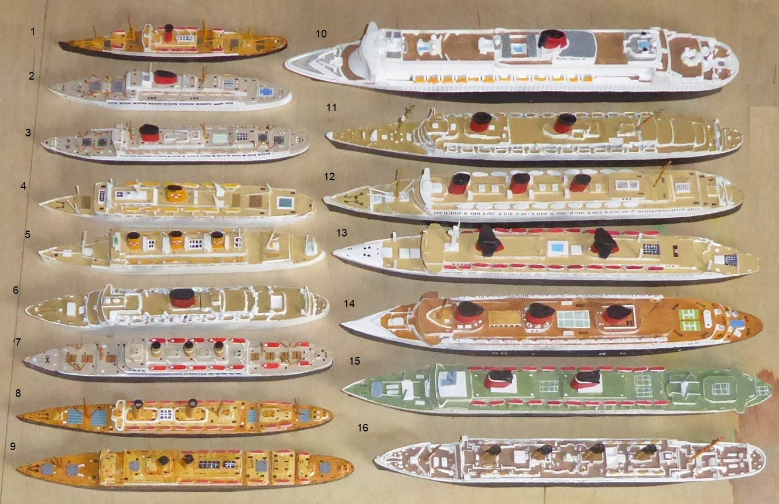
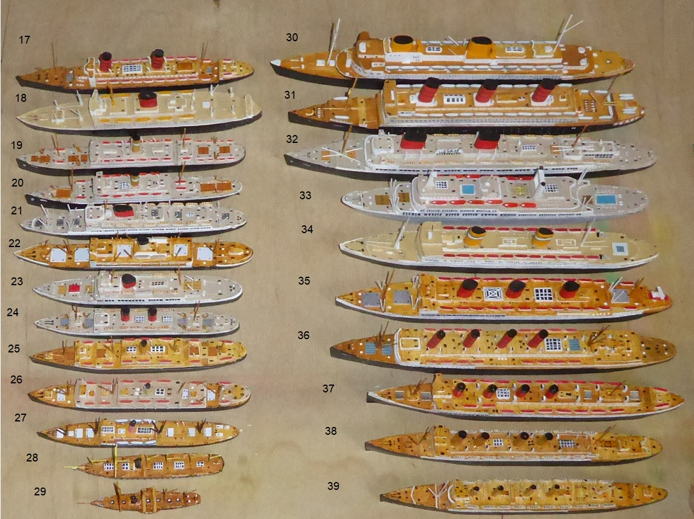

Travel to America from the UK, France, Germany or Holland became important in the early 19th century. Originally sailing ships took part in what was an incidental trade, set up to supplement income from cargo by carrying a small number of passengers. They travelled in the same discomfort as the crew in general and faced the dangers of a very stormy North Atlantic.
This changed with the introduction of steam ships, normally with a full set of sails, which could guarantee a swift passage (average speed of 8.5 knots) in some sort of comfort. Brunel’s two ships Great Western, 1838 (Model number 1227) and the even larger Great Britain 1845 (Model number 1226) transformed the trade with larger ships, specialising in the passenger trade and with steam power as well as sails. Great Western had paddle wheels but Great Britain changed to screw propulsion which was a great advantage especially in rough weather (paddle steamers rolled and the paddles came out of the water making control difficult).
Ships continued to grow in size and comfort and by the turn of the century the Cunard Line’s Campania, 1892 (Model number 1272) and White Star Line’s Oceanic, 1899 (Model number 1227) were competing for the transatlantic trade. The German liner Kaiser Wilhelm der Grosse, 1897 (Model number 1371) set the transatlantic speed record at 22 knots. In 1906 Cunard introduced the Mauretania (Model number 1276) which set the speed record for a crossing, which it held for over 20 years, of 23.69 knots. At such a speed it was possible to run a weekly transatlantic service with just 2 ships, Mauretania with sister ship Lusitania.
The Atlantic continued to be the site of the competition between the Great Powers, as Germany, France, the UK and the USA, through White Star line. Speed and luxury were the issues. Titanic 1912 (Model number 842) with White Star’s Corinthic (Model number 1267), and Adriatic (Model number 1266), Shaw Saville’s Ionic, 1902 (Model number 1205) the German Imperator (longest liner at the time), which was passed to Cunard in 1918 as Berengaria (Model number 1092) and Kronprinz Wilhelm 1901 (Model number 1372), the French France 1910 (Model number 1370) the Cunarders Lusitania and Mauretania, and the older Dutch Rijndam 1901 (Model number 1725) and Statendam 1898 (Model number 1726) competed for the transatlantic trade. The 1912 disaster to the Titanic with the loss of 1,500 lives, involving the Californian 1902 (Model number 1114) and Carpathia set back the trade but the approach of World War 1 set it back more. These large liners were seen as strategic investments by governments which was seen later in the century with the development of even larger liners.
At the end of WW1 the large German liners were given to allied nations as reparation and the trade continued to expand. The crash in the 1920s left many shipping lines short of a market and the introduction of ‘Booze Cruises’ from the USA during prohibition was a godsend for the shipping lines. Ships such as the Dutch Statendam, 1929 (Model number 1726), the French Bretagne 1922, (Model number 1736) and Lafayette, 1916 (Model number 1738) joined the transatlantic trade until, at the end of the 20s and beginning of the 30s serious competition erupted.
Germany with Nord Deutsche Lloyd’s Bremen, 1929 (Model number 1090) and Europa (after WW2 Liberte), 1930 (Model number 1739), France’s Normandie, 1935 (Model number 1090), Ile de France, 1927 (Model number 1257), Champlain, 1932 (Model number 1737) and Ville d'Oran, 1936 (Model number 1740), Holland’s Nieuw Amsterdam, 1937 (Model number 879), the United States’ America, 1939 (Model number 857) and Britain’s Empress of Scotland (ex Empress of Japan), 1930 (Model number 880), the new Mauretania, 1938 (Model number 974) Queen Mary, 1938 (Model number 829) and Queen Elizabeth, 1939 (Model number 846) joined the liners plying the North Atlantic alongside those already in the trade. During WW2 these huge ships transported troops at high speed safely across the Oceans (Queen Mary carried over 15,000 troops on one trip). Air conditioning was essential on trooping voyages and the older Aquitania, whilst having the capacity was known to be hot and uncomfortable.

After WW2 the remaining liners continued to ply their trade but now in competition with air travel. Some ships were built including Shaw Saville’s Athenic, 1947 (Model number 1203), Cunard’s Caronia, 1949 (Model number 844) and Sylvania, 1957 (Model number 862), United States line’s United States,1951 (Model number 877), Canadian Pacific’s Empress of Canada, 1960 (Model number 881) the Dutch Rotterdam, 1959 (Model number 1724), the French France, 1960 (Model number 876) and finally the Queen Mary 2, 2004 (Model number 1227). Many of these ships were adapted for cruising, particularly the Caronia and Sylvania which were painted in Cunard cruising green. Even so they were still designed for the transatlantic trade. Larger passenger ships were built but they were designed for cruising rather than as transport from one place to another.

