Container ships and Roll on roll offs
816 | 2013 | Container ship | Maersk McKinney Moller | 2
873 | 1984 | RoRo | Atlantic Compass | 4
874 | 1970 | RoRo | Atlantic Conveyor | 6
930 | 1998 | Container ship | Pantonia | 9
931 | 2004 | Container ship | OOCL Belgium | 13
961 | 1995 | Container ship | CMA CGM Marco Polo | 1
963 | 2014 | RoRo | Atlantic Star | 5
1243 | 1973 | Container ship | Remuera Bay | 14
1274 | 1967 | RoRo | Atlantic Song | 8
1463 | 1943 | Container ship | Gateway City | 10
1464 | 2015 | RoRo | Grande Dakar | 12
1486 | 1976 | Container ship | Anna Maersk | 15
1720 | 2013 | Container Ship | NYK Helios | 3
2111 | 1976 | RoRo | Skulptor Konenkov | 7
2135 | 2019 | RoRo | Red Kestrel | 11

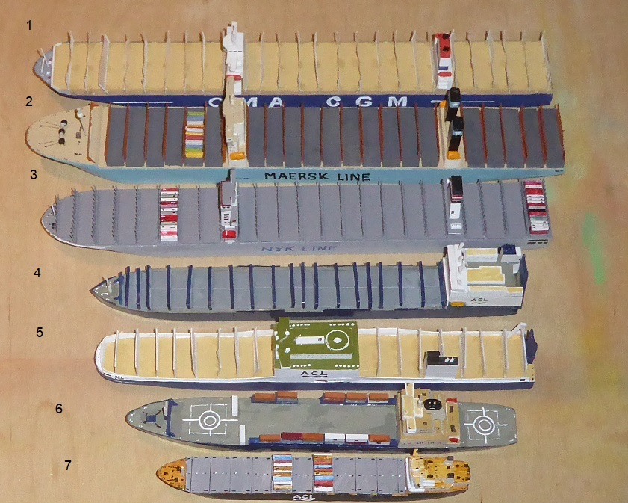
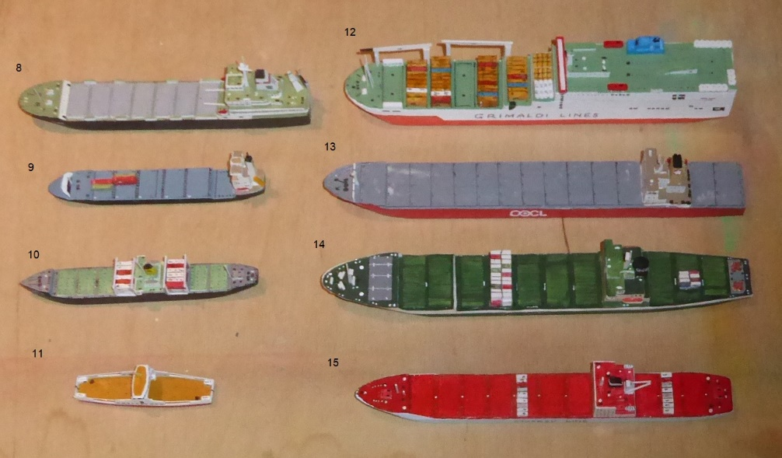
Roll on roll off container ships
RoRo ships have been essential when transporting wheeled vehicles across water. Car ferries have always been part of this technology but today they are combined with container capacity to transport a useful mixture making the ships ever more profitable.
During WW2 the need for such capacity led to the creation of LCTs (Landing Ships Tank) and, post war, there was an expansion in this sector. Atlantic Song, 1967 (Model number 1274) is an early version of this mixed role ship, rapidly followed by Atlantic Conveyor, 1970 (Model number 874), lost to an Exocet missile during the Falklands War of 1982. Skulptor Konenikov, 1976 (Model number 2111) is a Soviet version of the same technology but with a strengthened hull to break through ice.
After the loss of the Atlantic Conveyor, ACL ordered a new group of RoRos to be built of which Atlantic Compass, 1984 (Model number 873) is one. Finally these ships have been replaced by Atlantic Star, 2014 (Model number 963), which was built to access the locks into ACL’s RoRo facility in Liverpool’s Seaforth dock. These ships have reached their maximum size due to the size of the entrance locks from the Mersey. Loading such ships involves a complicated series of calculations involving the weights of the vehicles and their positioning. The vehicles are used, to some degree, as ballast thus increasing the efficiency of the vessels. Containers make up the balance of the ships’ cargo.
An alternative design is Grande Dakar, 2015 (Model number 1464) which can also use the same facilities as the ACL RoRos. Access to the RoRo decks on all of these ships has become a ramp at the starboard side aft. It has to be remembered that such ships require special facilities at the destination ports.
An example of the use of RoRo is Red Kestrel, 2019 (Model number 2135), which, like many similar local car ferries enable vehicles to navigate the road system in areas crossed by narrow strips of water. This is a modern design based on a design which has existed for years if not centuries.

Container ships
The containers we refer to here are 12m by 2.5m or 6m by 2.5m with strengthened frames which allow stacking and the locking of the containers together. The contents of a container can vary depending of the requirements of a shipper. The container itself weighs 4 tons and its contents up to 26 tons normally. The problem as far as shipping is concerned is the variation of weight in objects identical in appearance. As containers enter a port they are weighed and when loaded a computer system takes account of which containers have to be unloaded first and their weights. With the largest ships taking in excess of 18,000 containers it is clear that manual calculation for loading is impossible.
Gateway City, 1943 (Model number 1463) of WW2 vintage is a very early version of a container ship with a deck cargo of containers. By the 1970s ships such as Remuera Bay, 1973 (Model number 1243), Anna Maersk, 1976 (Model number 1486) were becoming common and such ships were capable of carrying cargos several times larger than the conventional cargo ship alongside which they were working. Their advantage was their ability to carry a large mixture of cargos in one load. This led to the development of special ships – bulk carriers – which nowadays transport oil, grain, biofuel, coal and other fluid materials in ever larger quantities up to 400,000 tons at a time.
These ships have reached huge proportions and have a maximum length around 400 metres with a beam of 60 metres, drawing 15 metres. These figures are dictated by the dimensions of the Panama canal and the depth of channels into ports. Such ships also require specialist facilities such as Liverpool 2, recently completed. Most of these ships examples being Maersk’s Maersk McKinney Moller, 2013 (Model number 816), CMA CGM’s Marco Polo, 1995 (Model number 961) and NYK’s (Nippon Yusen Kaisha) Helios, 2013 (Model number 1720) all of the dimensions indicated.
Travelling between smaller facilities are feeder container ships such as OOCL Belgium, 2004 (Model number 931) seen commonly in Liverpool and the much smaller Pantonia, 1998 (Model number 930) and a host of other very much smaller feeder ships which ply the waters around the British Isles and the Continent of Europe.
Containerisation is on the rise as transfer to road or rail creates a simple solution to the transport of goods generally. We see these containers either on the back of articulated lorries or on trains on our motorways and railways.

